

**FPT ACADEMY INTERNATIONAL**

**FPT – APTECH COMPUTER EDUCATION**

**EProject:**

*ITM COLLEGE PROJECT*

|  |  |  |  |
| --- | --- | --- | --- |
| **Center** | | ACE-HCMC-2-FPT | |
| **Instructor** | | Mr. Ngo Phuoc Nguyen | |
| **Class** | | T1.1908.E0 | |
| **Group** | | 1 | |
| **Group members** | | **Name** | **Student ID** |
| Vu Duc Huy | Student1215608 |
| Le Nguyen Minh Ngoc | Student1226455 |
| Huynh Quoc Huy | Student1208501 |
| Luong Vinh Hien | Student1204494 |
| **Assignment** | **Start date** | 28Dec2020 | |
| **End date** | 28Jan2021 | |

**This is to certify that**

1. Vu Duc Huy
2. Le Nguyen Minh Ngoc
3. Huynh Quoc Huy
4. Luong Vinh Hien

**have successfully designed & developed**

eProject: ITM College – Online College Management

**Submitted by:**

Vu Duc Huy

**Date of issue:** 07JAN 2021

**Authorized Signature:**

TABLE OF CONTENTS

Acknowledgement 5

Problem Statement 6

**Introduction** 6

**Project Requirement** 6

**Project Designing** 6

**Functional Logic** 8

Hardware / Software Requirements 10

TASK SHEET REVIEW 1 12

Architecture & Design of the Project 14

1. Presentation Tier: 15

2. Business Logic Tier: 15

3. Data Access Tier: 15

Algorithms - Data Flowchart 16

1. Main data flow for guest 17

2. Login Function 18

3. Logout Function 19

4. Insert Data Function (Admin only) 20

5. Update Data Function (Admin only) 21

6. Delete Data Function (Admin only) 22

7. Admission Function 23

8. Confirmed Admission 24

9. Registration Function 25

Data Flow Diagram 26

1. Context Diagram: 27

2. Level 0 DFD 28

3. Level 1 DFD 29

3.1 Department Management 29

3.2 Faculty Management 29

3.3 Facilities Management 30

3.5 Admission Management 31

3.6 Events Management 31

3.7 Feedback,Admission Management 31

Use Case Diagram 32

1. Administrator Use Case 33

Entity–Relationship Design 35

1. Entity–Relationship Diagram 35

2. Entities and Properties 36

2.1 Admission Entity & Properties 36

2.2 Feedback Entity & Properties 37

2.3 Stream Entity & Properties 37

2.4 Field Entity & Properties 37

2.5 Admin Entity & Properties 37

2.6 Optional Subject Entity & Properties 38

2.7 Specialized Subject Entity & Properties 38

2.8 Course Entity & Properties 38

2.9 Event Entity & Properties 39

2.10 Department Entity & Properties 39

2.11 Faculty Entity & Properties 39

2.12 Facility Entity & Properties 40

2.13 Admission Status Entity & Properties 40

Task sheet review 2 41

Database Design 43

1. Database Design Diagram 43

2. Database Structure 44

GUI Design – Front-end: 49

1. Home page: 49

2. Courses: 50

3. Admission: 50

4. Department: 57

5. Faculty: 58

6. Facilities: 59

7. Contact Us(Feedback) 60

8. Register 61

9. Login 63

10. Forgot Password 66

11. Reset Password Form 67

12. User 69

12.1 User Profile 72

12.2. User Admission 74

12.3. After Submit Admission successfully 75

Gui Design-Back end 78

1. Admin Login 78

2. Course Management 79

3. Field Management 83

4. Subject Management 85

5. Faculty Management 88

6. Department Management 89

7. Facilities Management 90

8. Student Account Management 93

Task sheet review 3 94

**REVIEW 1**

# **Acknowledgement**

We would like to acknowledge all those who have given support and help us make the project a success.

We wish to express our deep gratitude to all teachers who have been devoting their lives to teach us how to stand-alone and walk ahead.

We are grateful to our families who take care and encourage us even though we are successful or failed, also to our friends who are always care of us. They never leave us alone and always look forward to us when we are on any road of the life.

We are much thankful to the entire staff and chairpersons at the Head Office of Aptech Worldwide, Aptech – Vietnam, and FPT – Aptech Center who have been organizing and looking after our studying course.

There are no words to show our appreciation for teachers of FPT Aptech Centre who have been organizing and looking after us during our studying course to finish this project. Our special thanks Mr Ngo Phuoc Nguyen who works day by day to teach and guide us, e-Project Team at the Head Office who instruct and help us.

Finally, we would like to offer many thanks to all our schoolfellows for their valuable suggestions.

We would like to thank sincerely!

# **Problem Statement**

## **Introduction**

As of today world all the manual paper work like accounting, maintaining records are computerized. Even the college and school admission, result declaration is performed online today. Due to which all the school and colleges felt the need of making the website of their organization. The main purpose of making website is to attract the masses and advertisement of the school, colleges, and their achievements to the people leaving in any area (near or remote). The **ITM** College wants the website of the college to be developed and they have approached you for the same.

## **Project Requirement**

The College had provided all the content details they want to add in the website. The details of the information and what link the Home page must contain? Name of the links required in the website for navigation. There should be section in the Home Page for Upcoming events in the college, Achievements, New course, Merit list. The Link like **HOME, COURSES, STUDENT REGISTRATION, DEPARTMENTS, FACULTY, FACILITIES, ONLINE ADMISSION, CONTACT US, FEEDBACK, ADMIN LOGIN**.

## **Project Designing**

**HOME PAGE:** Here there should be an introduction of the college with hyperlink at the top (for navigation) and various sections to highlight the important features of the college. There should be separate section for the Admin Login (where the details of website can be modified and updated).

**COURSES:** Here the details of all the courses must be stated which are available in the college.

**ADMISSION:** Here there will admission form for the students. All the admission form related to the particular subject must be there. Students can download the form or can also fill the form online and submit. Once the online form is submitted then the student will get a unique registration number and this number must be used to check the admission status. If the student status is accepted then they can proceed the online submission *by clicking proceed* button or link and complete the further details like selection of subjects.

**DEPARTMENTS:** Here the details of the entire department must be added (like chemistry, French, Economics, Psychology, Geology and Mathematics).

**FACULTY:** Here it should state the details of the entire faculty (should be categorized according to their departments).

**FACILITIES:** Like what all Facilities are provided in the college such as college canteen, hostel, placement center, gymkhana, college library, administrator office)

**STUDENT REGISTRATION:** here the student can register themselves with the help of their ID (unique) so that they can get the updates of their colleges, assignments, exam time table. If the same student tries to register again with the same ID then an error message must be thrown.

**CONTACT US:** It should state the contact details of the college (must cover all the branches).

**FEEDBACK FORM:** Here the feedback is taken from the end user.

**ADMIN LOGIN:** There should be separate section for login. The admin person will be able to update the data of the website.

## **Functional Logic**

**ADMISSION PROCEDURE:**

* The Admin will have the responsibilities of checking which student is eligible for the admission.
* When an Online admission form is filling by the student they will provide all the details of the previous education. In the first level of form filling the student is supposed to provide personal details like:
  + Name
  + Father Name
  + Mother Name
  + Date of Birth (as per the certificate)
  + Gender
  + Residential Address
  + Permanent Address
  + Admission for (selecting a stream, field)
  + In tabular format (details of previous exam)
    - University
    - Enrollment number
    - Center
    - Stream
    - Field
    - Marks secured
    - Out of
    - Class Obtained
  + Sports details (if any)
  + Submit (for submitting the details)

Once the candidate click on the submit button a Unique number must be provided to them.

* With the help of the Unique ID they can check the status of the admission like whether waiting, accepted.
* Once the status is confirmed, they can provide further details like specialized subject, optional subject and finally can print the form for seeking admission in the college.

# **Hardware / Software Requirements**

1. **Server Requirement**

* Hardware

|  |  |
| --- | --- |
| **Component** | **Requirement** |
| **CPU** | Processor type:  Pentium IV-compatible processor or faster  Processor speed:  Recommended: 2.0 GHz or faster |
| **OS** | Microsoft Windows Server 2012 with IIS |
| **Memory (RAM)** | RAM:  Minimum: 512 MB  Recommended: 2 GB or more |
| **Hard Drive** | Free space:  Minimum: 200 MB  Recommended: 50 GB or more  Maximum: Operating system maximum |

* Software

|  |  |
| --- | --- |
| **Component** | **Requirement** |
| **ASP.NET Core MVO** | Version 5.01 |
| **RDBMS** | Microsoft SQL Server 2017 |

1. **Client Requirement**

* Hardware

|  |  |
| --- | --- |
| **Component** | **Requirement** |
| **CPU** | Processor type:  Pentium III-compatible processor or faster  Processor speed:  Recommended: 1.0 GHz or faster |
| **OS** | All OS (Window, Linux, Android, Mac OS …) |
| **Memory (RAM)** | RAM:  Minimum: 512 MB  Recommended: 1 GB or more  Maximum: Operating system maximum |
| **Hard Drive** | Free space:  Minimum: 10 MB |

* Software

|  |  |
| --- | --- |
| **Component** | **Requirement** |
| **Web Browser** | Chrome |
| **Angular** | Version 9.1.13 |

# **TASK SHEET REVIEW 1**

|  |  |
| --- | --- |
| **Date:** | |
| Signature of Instructor:  **Mr. Ngo Phuoc Nguyen** | Signature of Team Leader:  **Vu Duc Huy** |

|  |  |  |  |  |  |
| --- | --- | --- | --- | --- | --- |
| Project Ref. No:1 | Project Title:  ITM College – Online College Management | Date of Preparation of Activity Plan | | | |
| No. | Task | Actual Start Date | Actual Days | Team Member Names | Status |
| 01 | Acknowledgment | Jan 07,2021 | 2 | All Members | Completed |
| 02 | Problem Definition | All Members | Completed |
| 03 | Customer Requirement | All Members | Completed |
| 04 | Hardware/Software | All Members | Completed |
| 05 | Task sheet | All Members | Completed |

**REVIEW 2**

# **Architecture & Design of the Project**

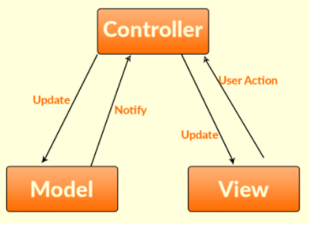

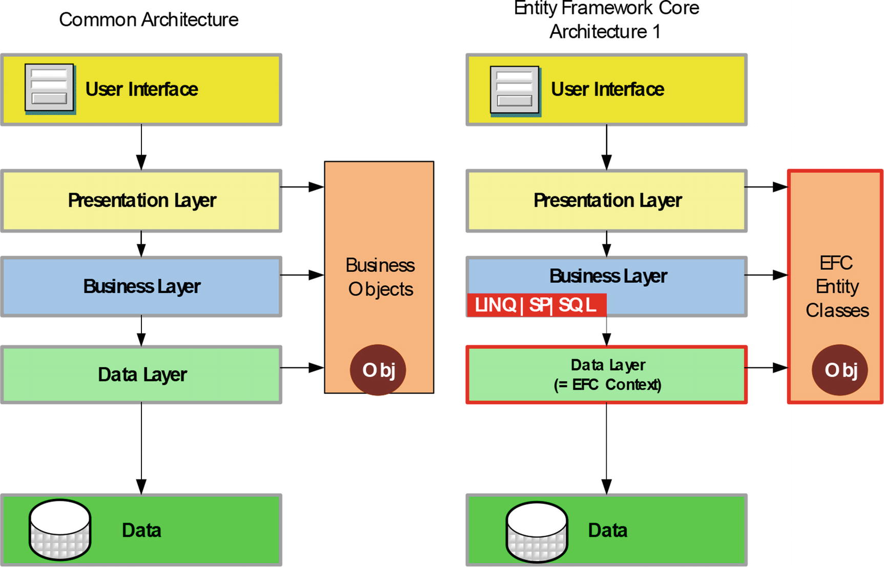

Architecture of the Project

## Presentation Tier:

Is the tier in which the users interact with application. Presentation Tier contents Model, View, Controller used to receive a request and response to User.

Technology: ASP.NET MVC5, Razor, HTML, CSS, JavaScript, Ajax, JQUERY, Twitter Bootstrap

## Business Logic Tier:

Is mainly working as the bridge between Data Tier and Presentation Tier. All the Data passes through the Business Tier before passing to the Presentation Tier.

Technology: ASP.NET

## Data Access Tier:

Is basically the server which stores all the application’s data .Data tier contents Database Tables, Database Views and other means of storing Application Data.

Technology: SQL Server, LINQ

# **Algorithms - Data Flowchart**

Symbol generates:

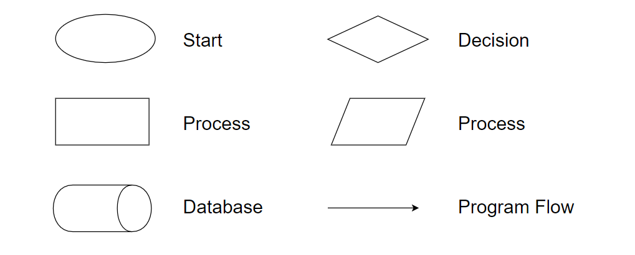

## Main data flow for guest

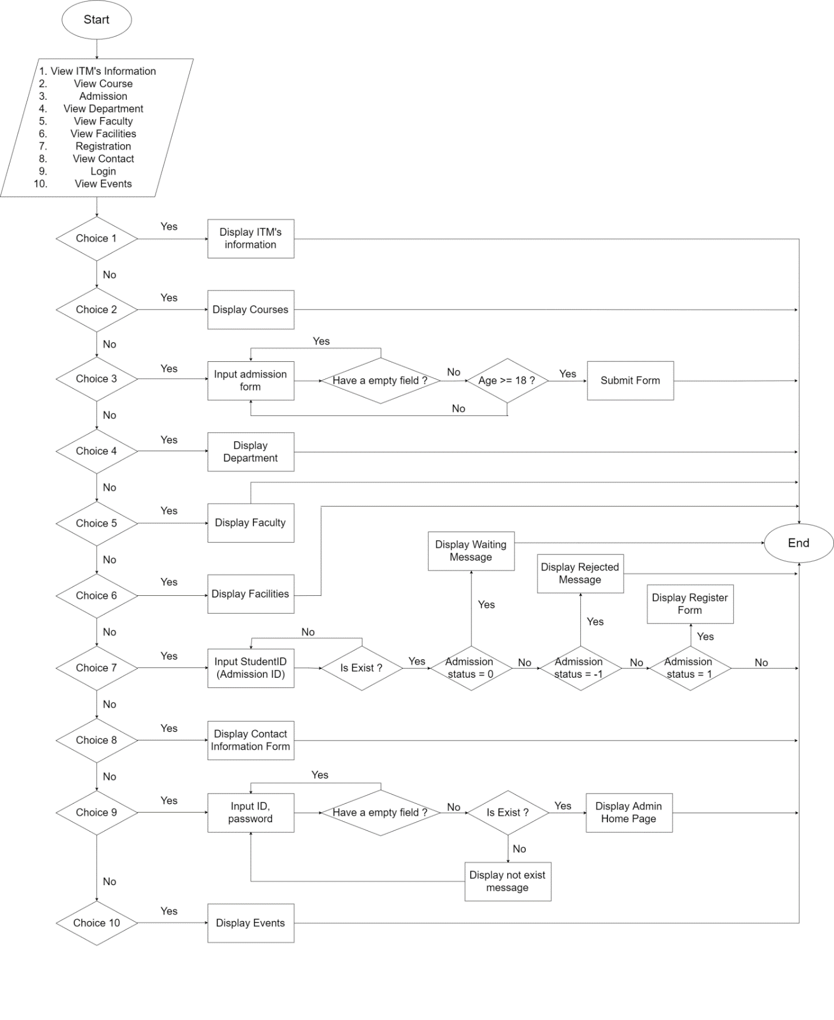

## Login Function

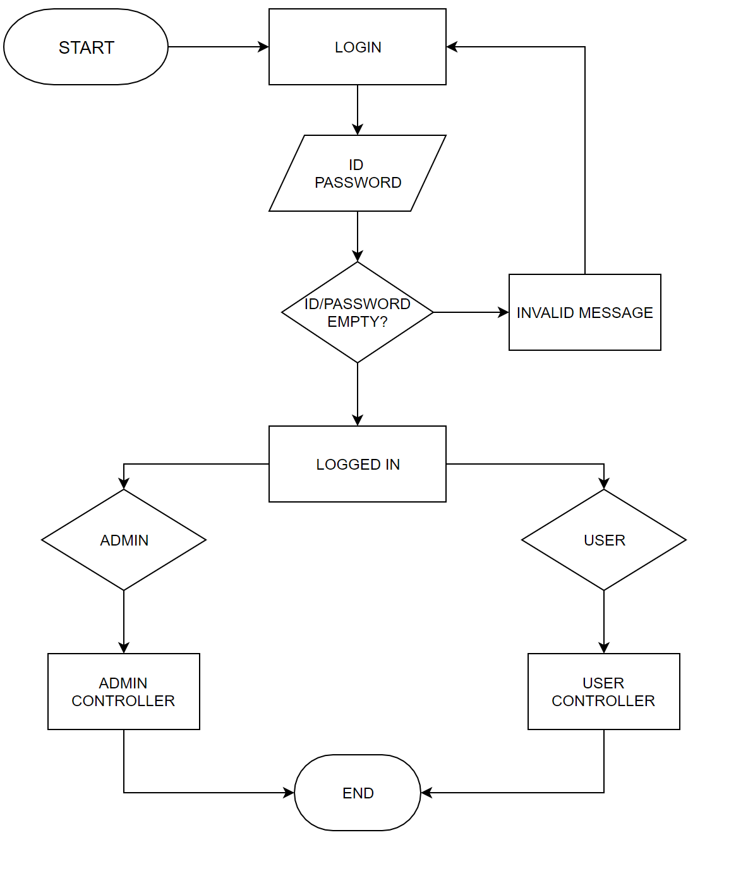

## Logout Function

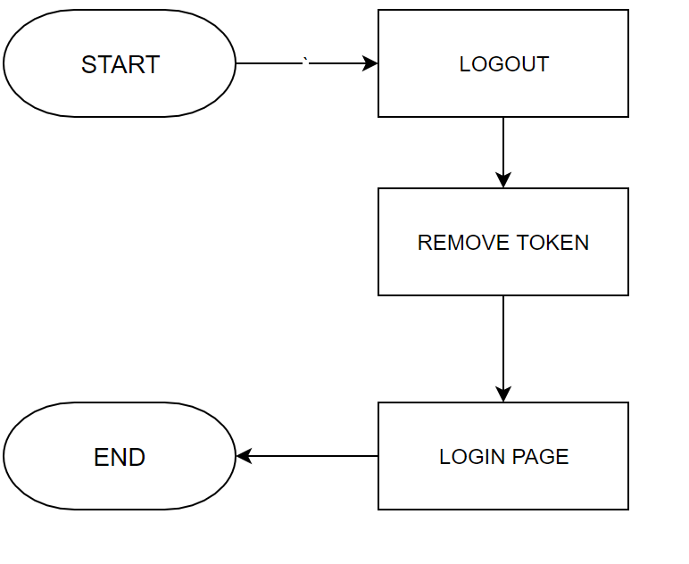

## Insert Data Function (Admin only)

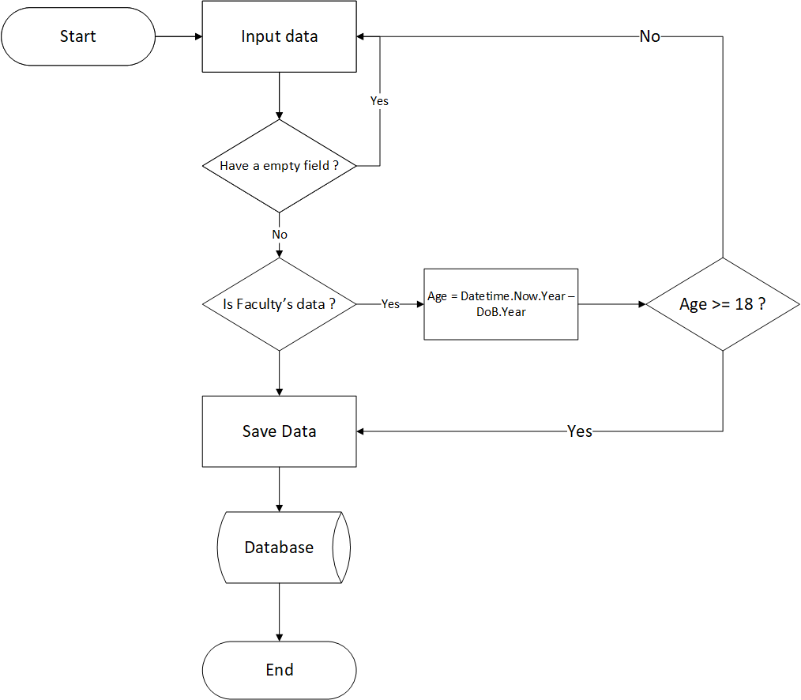

## Update Data Function (Admin only)

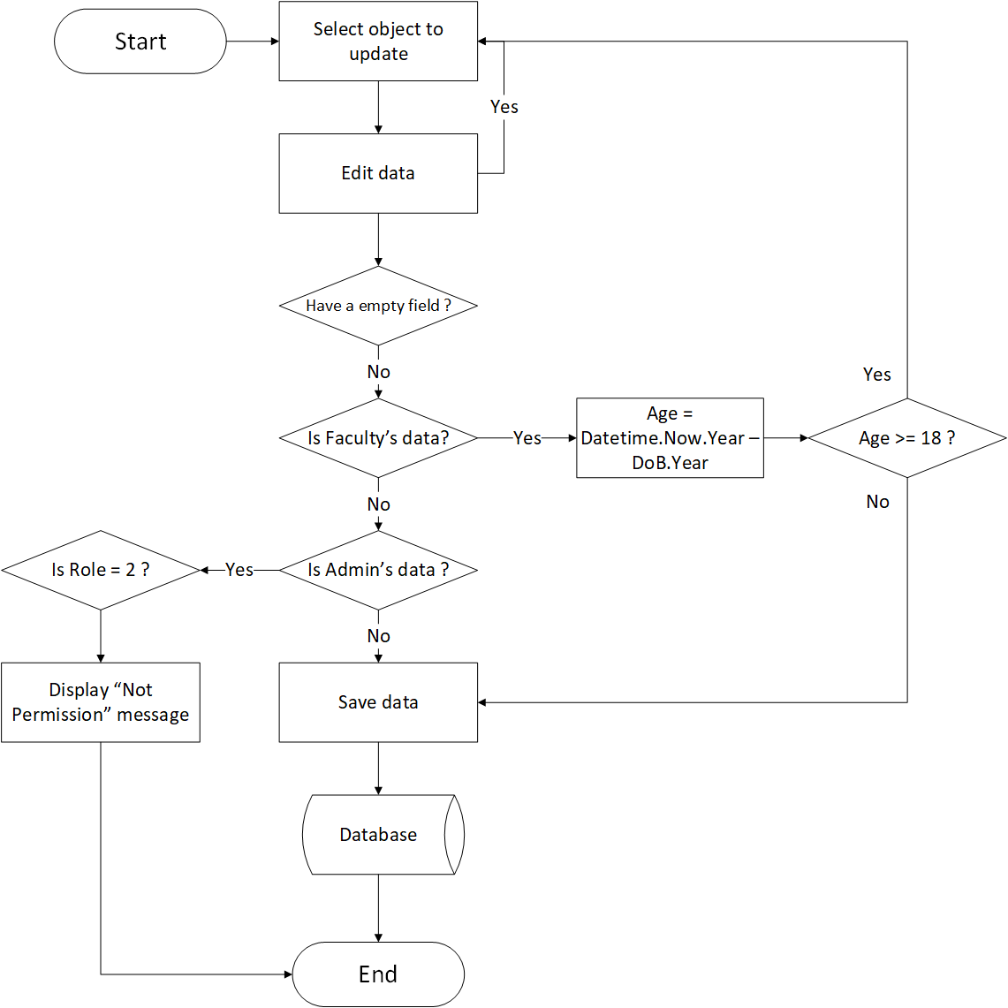

## Delete Data Function (Admin only)

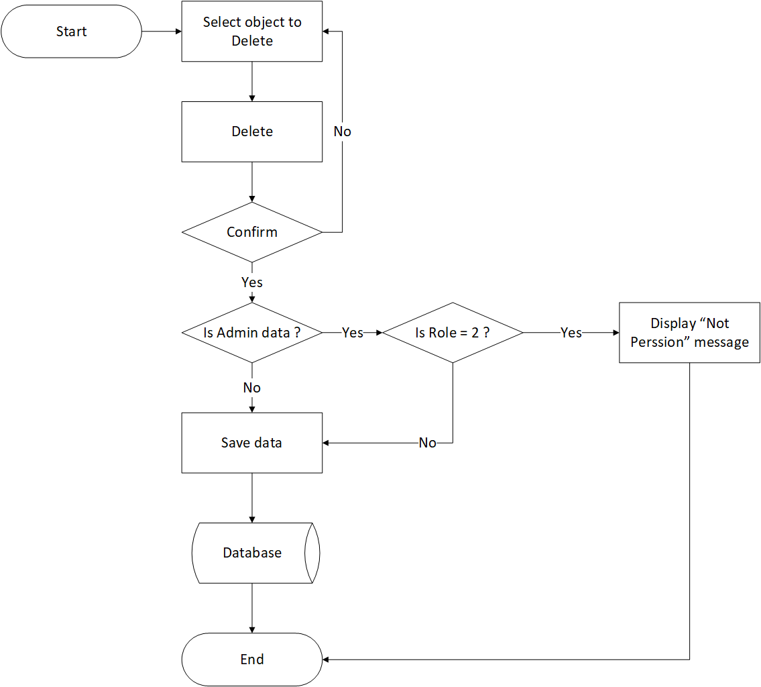

## Admission Function

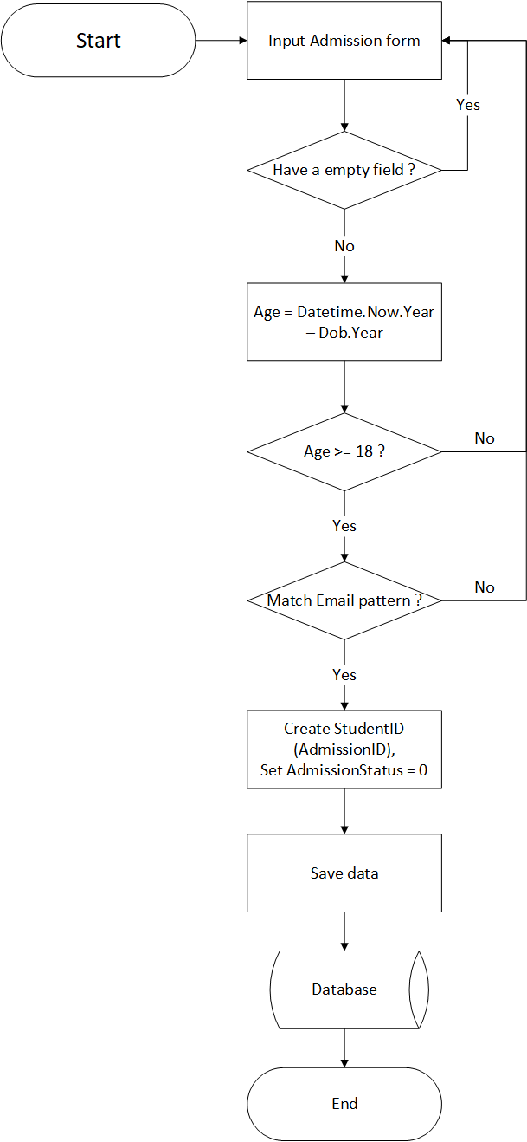

## Confirmed Admission

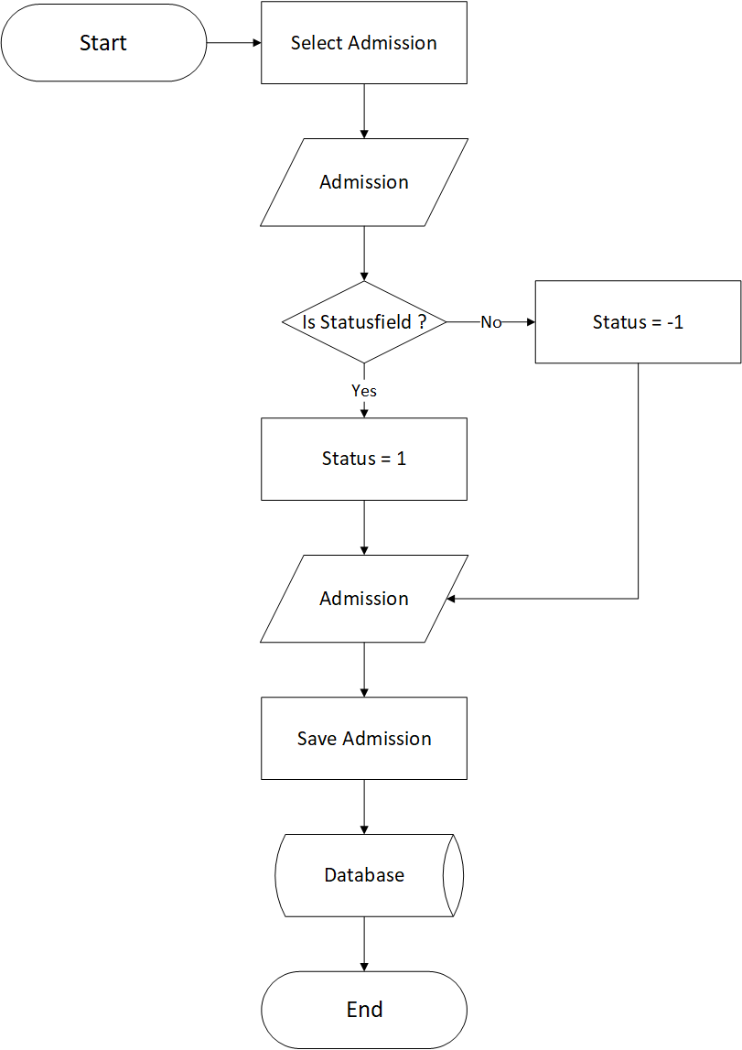

## Registration Function

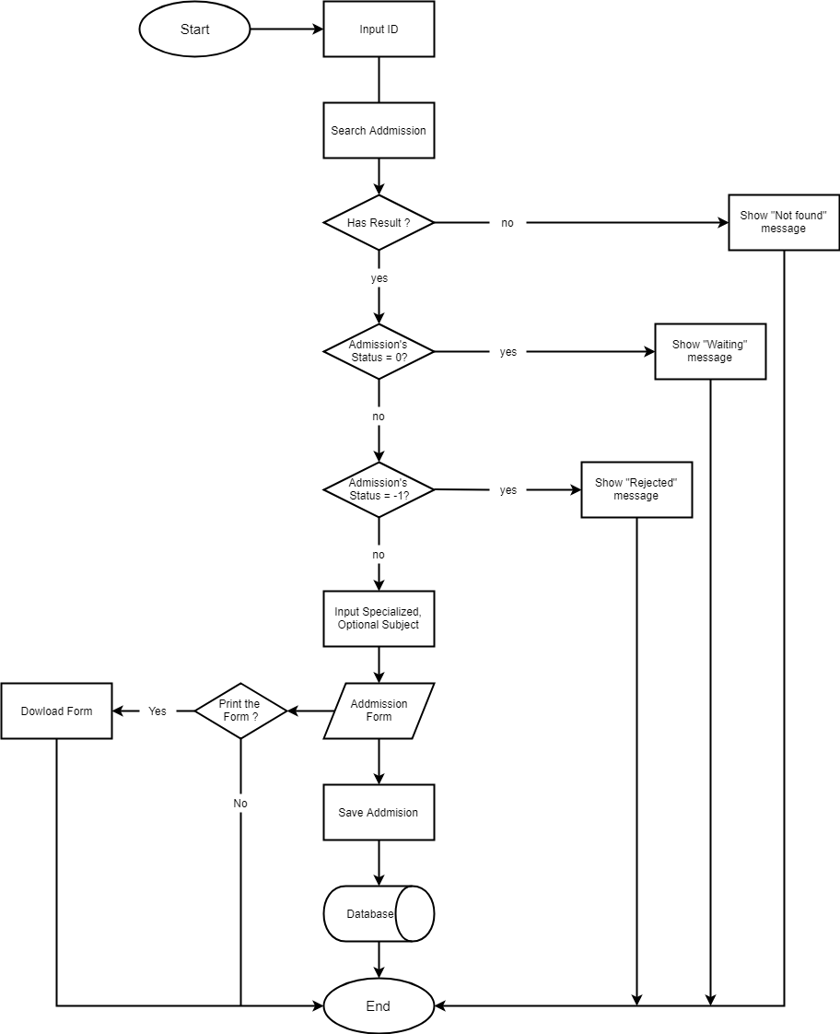

# **Data Flow Diagram**

**Define:** Data Flows Diagram (DFD) describes the information flow in the system. The next step of system analysis is to consider in detail the information necessary for the implementation for functions discussed above and the one necessary for the improvement of the functions. Modelling tool frequently used for this purpose is DFD. DFD will support 4 main activities:

* **Analysis**: DFD is used to determine requirement of users.
* **Design:** DFD is used to map out plan and illustrate solution to analysis and users while designing a new system.
* **Communication:** One of the strength of DFD is its simplicity and ease to understand to analysts and users.
* **Document:** DFD is used to provide special description of requirement and system design. DFD provide an overview of key functional components of the system but it does not provide any detail on these components. We have to use other tools like database dictionary, process specification to get an idea of which information will be exchanged and how.

**The main components of Context Diagram:**

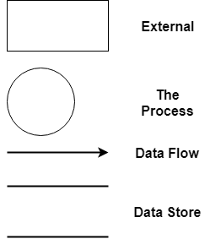

The external factors: External factors can be a person, a group of persons or an organization that are sources of information for the systems and are where system products are transferred to.

The process: Shows the common function of system

The data flow: Describe the movement of information from one part of the system to another.

The data store: The Data Store is used to model a collection of data packets at rest. A store is represented graphically by two parallel lines. The name of a Data Store that identifies the store is the plural of the name of the packets that are carried by flows into and out of the Data Store.

## Context Diagram:

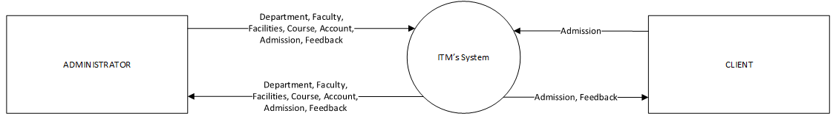

## Level 0 DFD

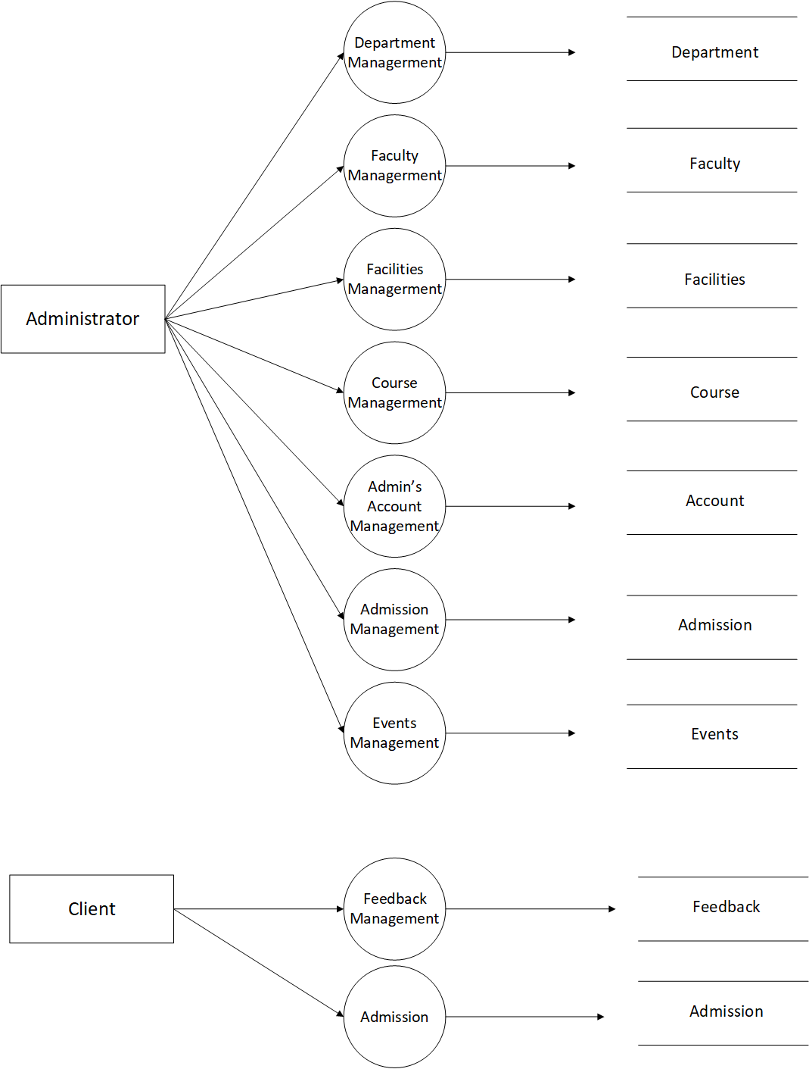

## Level 1 DFD

### 3.1 Department Management

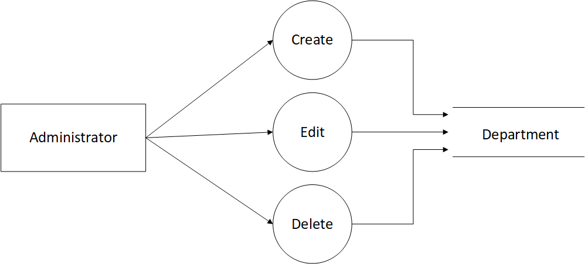

### 3.2 Faculty Management

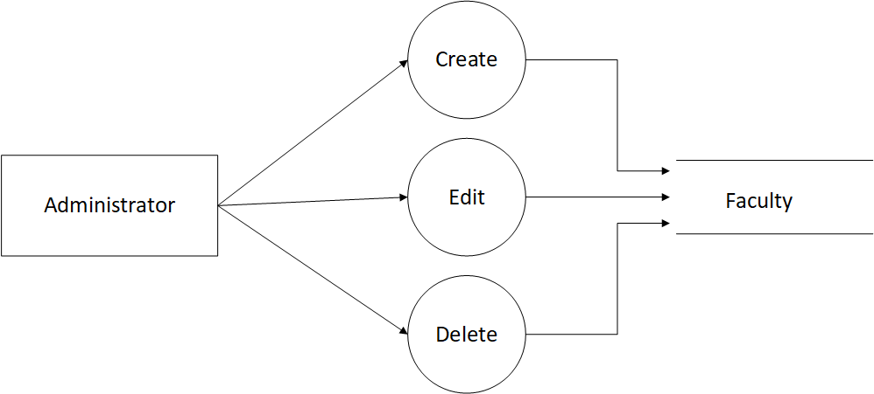

### 3.3 Facilities Management

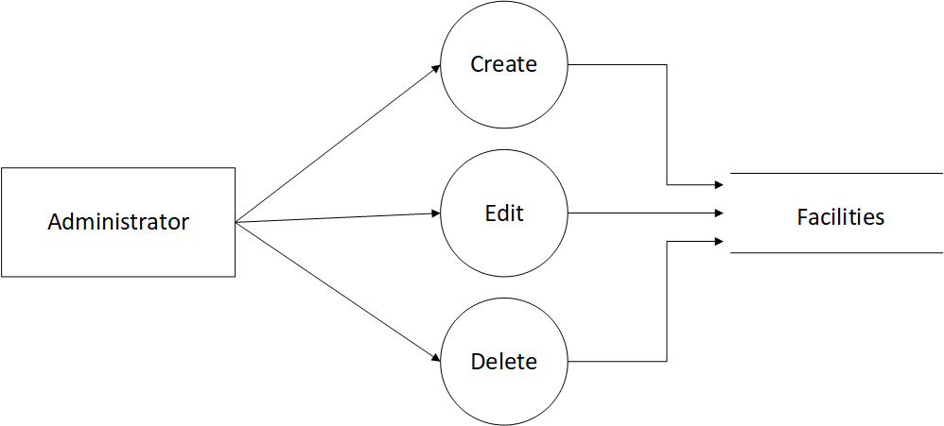

3.4 Course Management

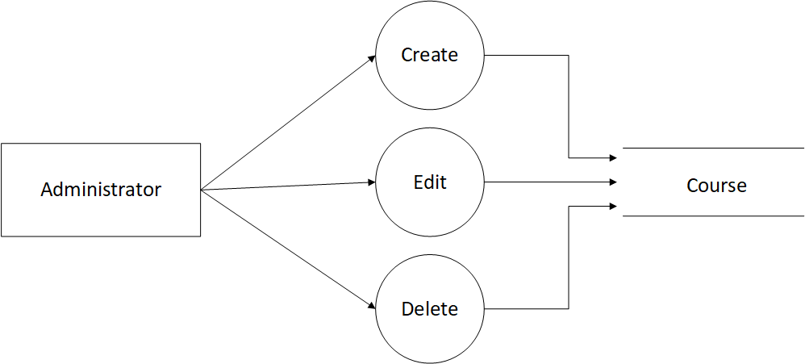

### 3.5 Admission Management

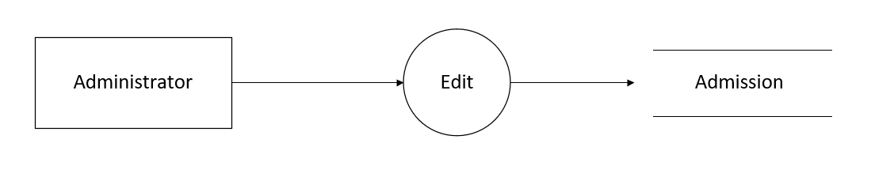

### 3.6 Events Management

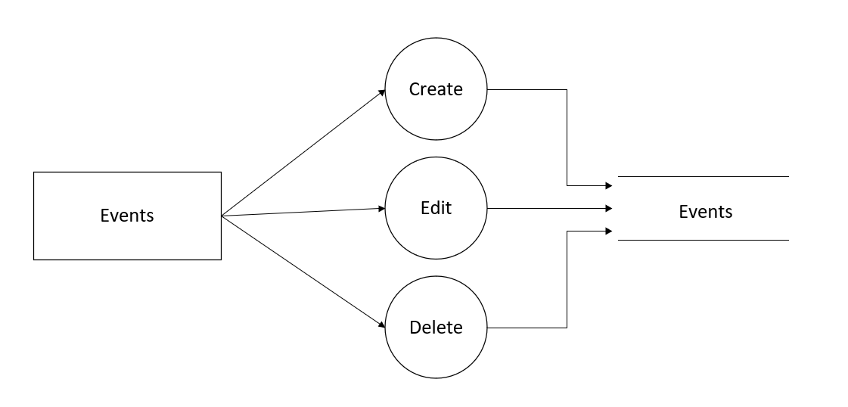

### 3.7 Feedback,Admission Management

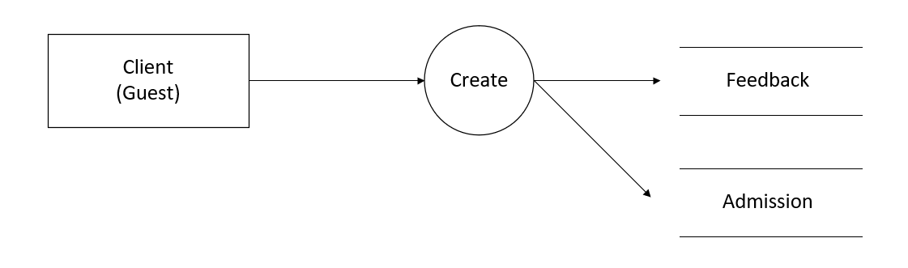

# **Use Case Diagram**

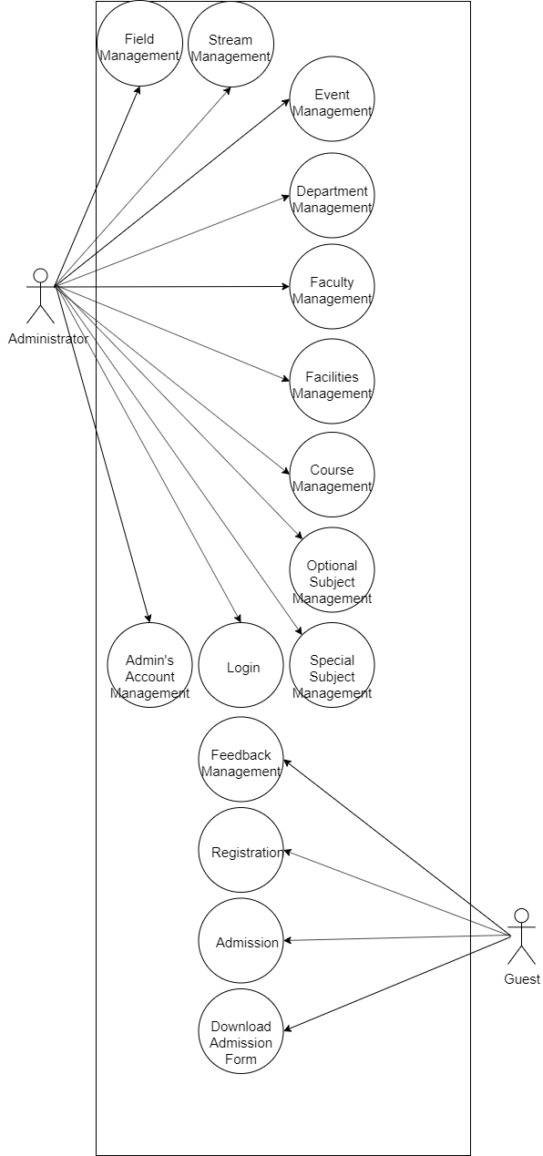

## 1. Administrator Use Case

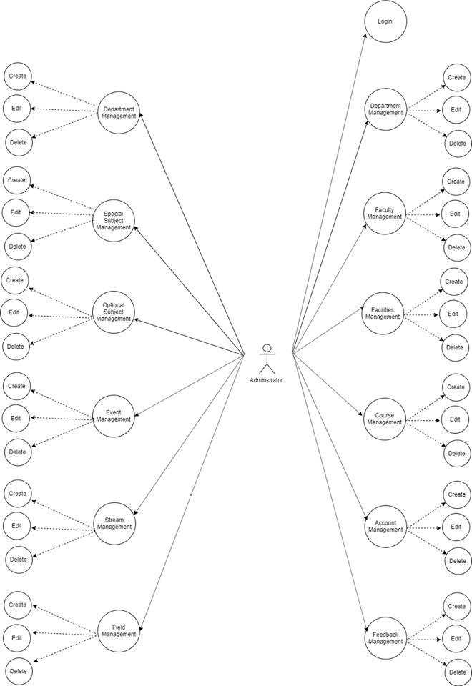

1. Guest Use Case

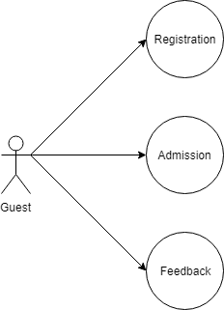

# Entity–Relationship Design

## Entity–Relationship Diagram

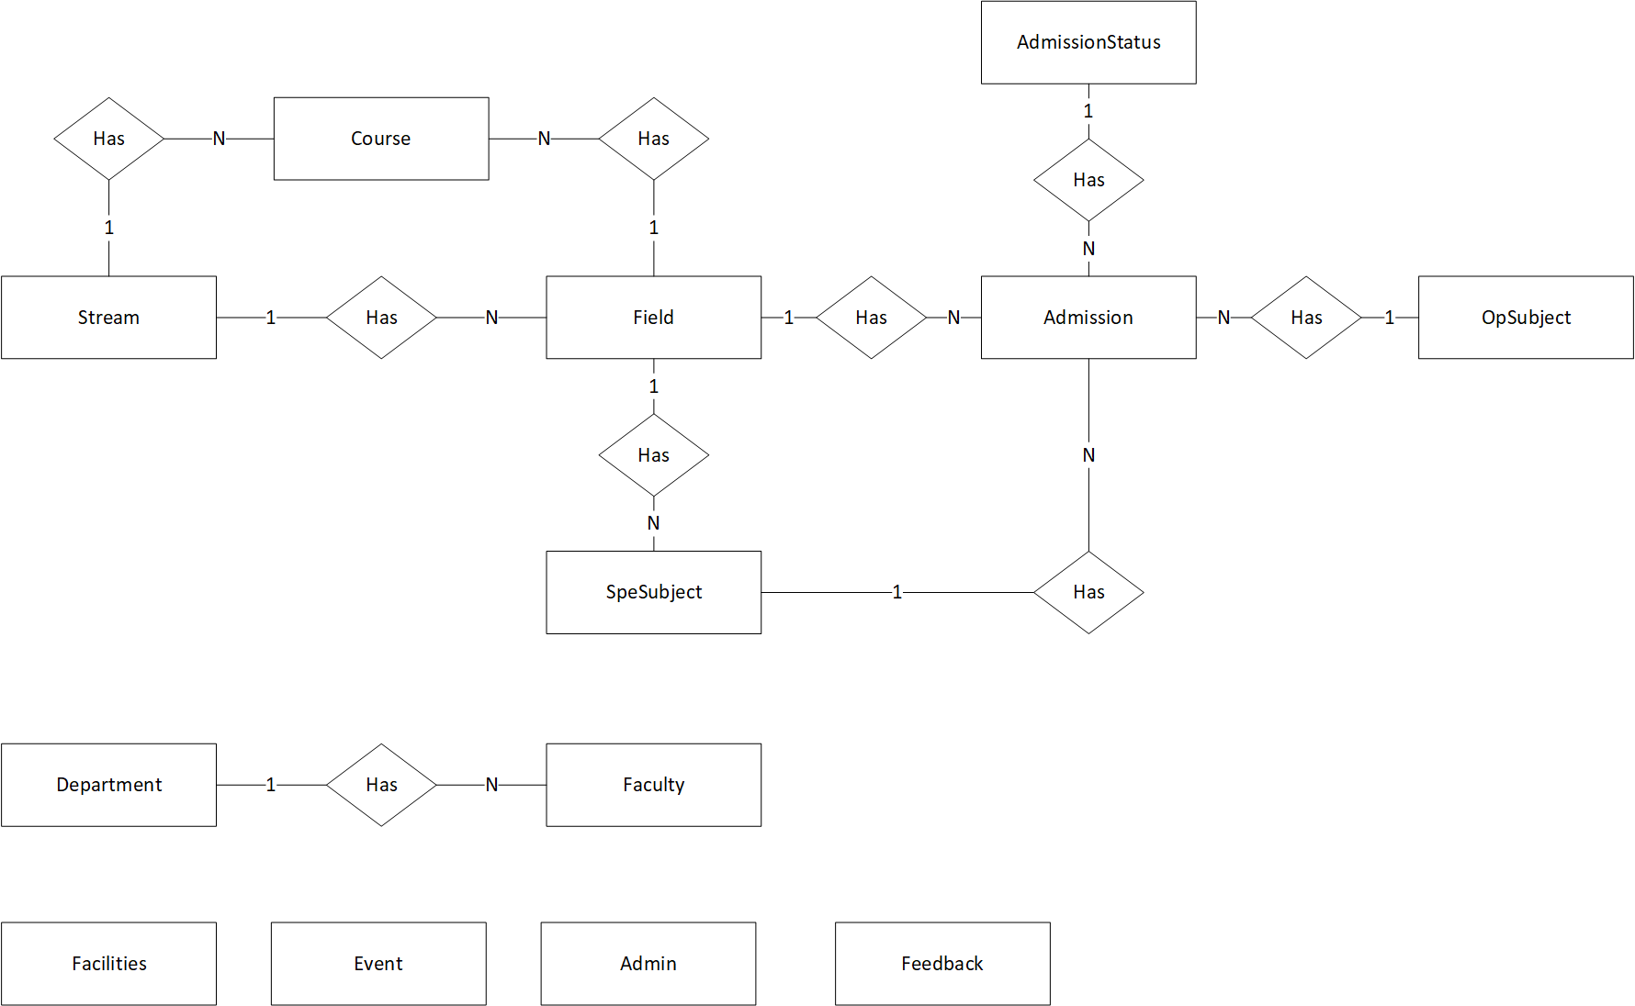

1. Entities and Properties

### 2.1 Admission Entity & Properties

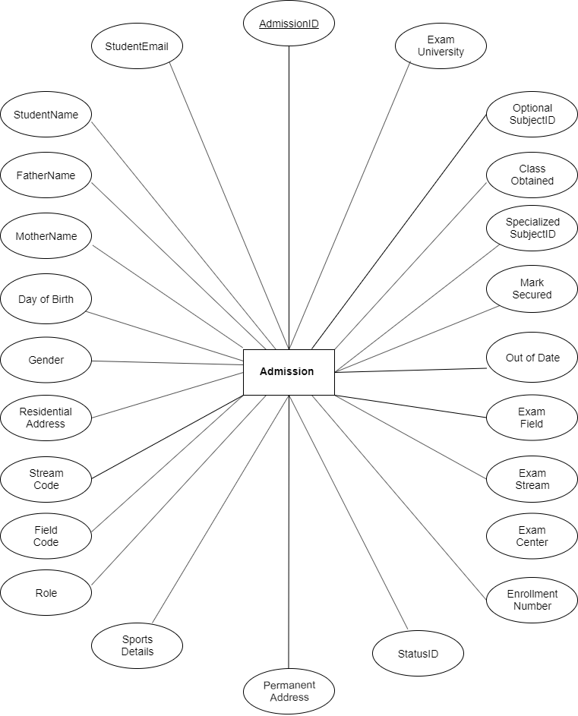

### 2.2 Feedback Entity & Properties

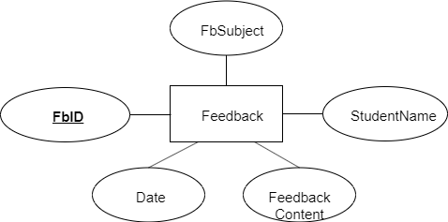

### 2.3 Stream Entity & Properties

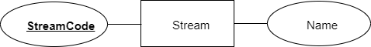

### 2.4 Field Entity & Properties

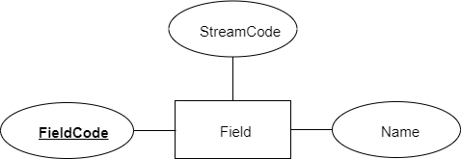

### 2.5 Admin Entity & Properties

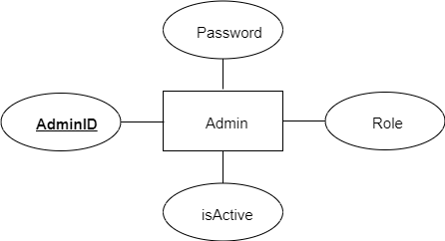

### 2.6 Optional Subject Entity & Properties

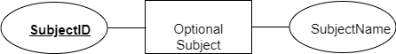

### 2.7 Specialized Subject Entity & Properties

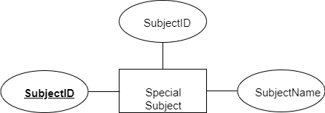

### 2.8 Course Entity & Properties

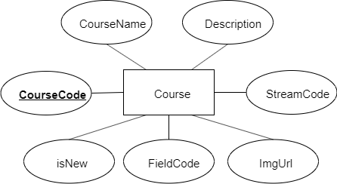

### 2.9 Event Entity & Properties

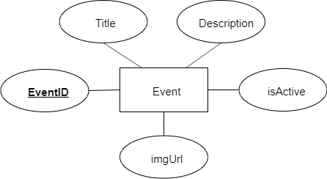

### 2.10 Department Entity & Properties

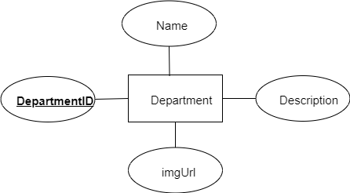

### 2.11 Faculty Entity & Properties

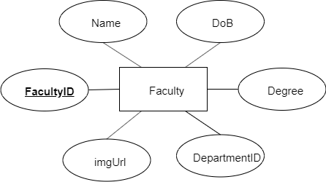

### 2.12 Facility Entity & Properties

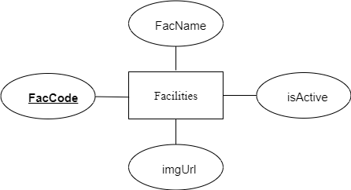

### 2.13 Admission Status Entity & Properties



# **Task sheet review 2**

|  |  |  |  |  |  |
| --- | --- | --- | --- | --- | --- |
| Project Ref. No: 1 | Project Title:  ITM College – Online College Management | Date of Preparation of Activity Plan | | | |
| No. | Task | Actual Start Date | Actual Days | Team Member Name | Status |
| 01 | Architecture & Design of the Project | Jan 17,2021 | 6 | All Members | Completed |
| 02 | Algorithms - Data Flowchart | Vu Duc Huy | Completed |
| 03 | Data Flow Diagram | Huynh Quoc Huy | Completed |
| 04 | Use Case Diagram | Luong Vinh Hien | Completed |
| 05 | ERD | Le Nguyen Minh Ngoc | Completed |
| 06 | Task Sheet | All Members | Completed |

|  |  |
| --- | --- |
| **Date:** | |
| Signature of Instructor:  **Mr. Ngo Phuoc Nguyen** | Signature of Team Leader:  **Vu Duc Huy** |

**REVIEW 3**

# Database Design

1. Database Design Diagram

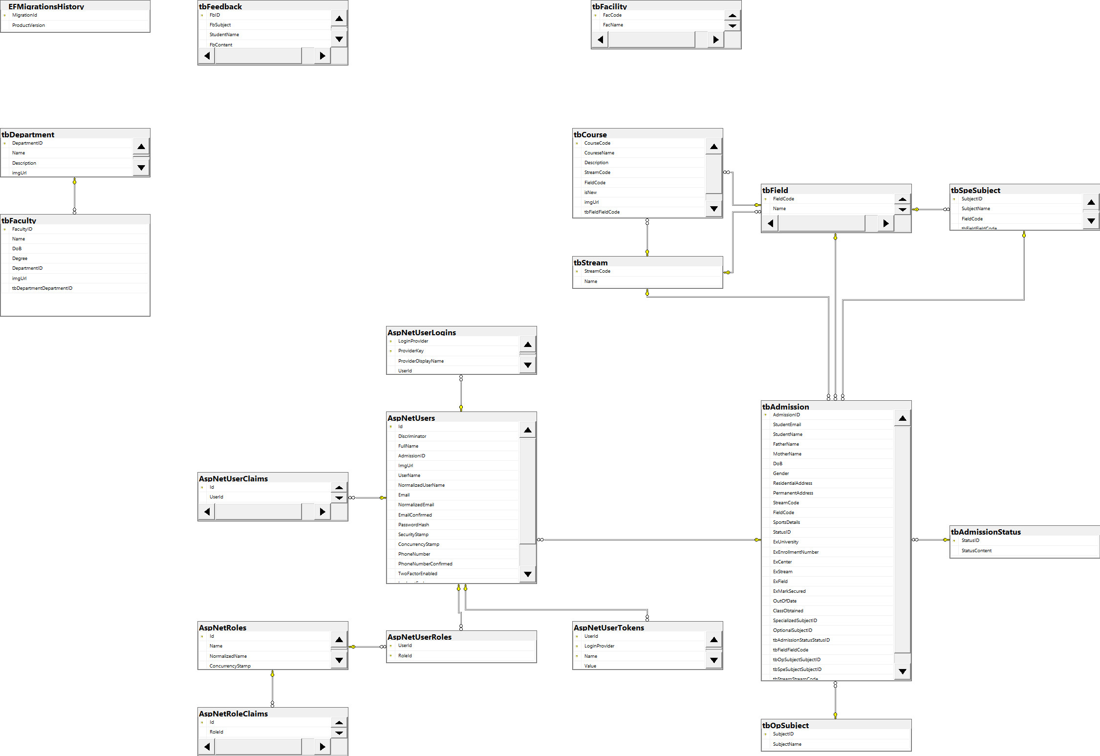

1. Database Structure
   1. Table Feedback

|  |  |  |  |  |  |  |
| --- | --- | --- | --- | --- | --- | --- |
| Field Name | Data Type | Null | Default | Key | Field-Ref | Description |
| FbID | int | No |  | PK |  | Feedback ID |
| FbSubject | Varchar(100) | No |  |  |  | Feedback Subject |
| StudentName | Varchar(50) |  |  |  |  |  |
| FbContent | text | No |  |  |  | Problem Feedback |
| Date | Date | No |  |  |  | The date when feedback submitted |

* 1. Table User

|  |  |  |  |  |  |  |
| --- | --- | --- | --- | --- | --- | --- |
| 1. Field Name | Data Type | Null | Default | Key | Field-Ref | Description |
| ID | Varchar(50) | No |  | PK |  | User ID |
| FullName | Varchar(50) | No |  |  |  | Student FullName |
| AdmissionID | Varchar(50) | No |  | **FK** |  | ID of Amission |
| ImgUrl | Varchar(50) | No |  |  |  | Path of Image |
| UserName | Varchar(50) | No |  |  |  | Student User |
| NormalizedUserName | Varchar(50) | No |  |  |  | NormalizedUserName |
| Email | Varchar(50) | No |  |  |  | Email User |
| NormalizedEmail | Varchar(50) | No |  |  |  | NormalizedUserName |
| EmailConfirmed | bit | No |  |  |  | EmailConfirmed |
| PasswordHash | Varchar(50) | No |  |  |  | PasswordHash |
| SecurityStamp | Varchar(50) | No |  |  |  | SecurityStamp |
| ConcurrencyStamp | Varchar(50) | No |  |  |  | ConcurrencyStamp |
| PhoneNumber | Varchar(50) | No |  |  |  | User phone number |
| PhoneNumberConfirmed | bit | No |  |  |  | Confirmed phone numer |
| TwoFactorEnabled | bit | No |  |  |  | TwoFactorEnabled |
| LockoutEnd | Datetime | No |  |  |  | LockoutEnd |
| LockoutEnabled | bit | No |  |  |  | LockoutEnabled |
| AccessFailedCount | int | No |  |  |  | AccessFailedCount |

2.3 Table Feedback

|  |  |  |  |  |  |  |
| --- | --- | --- | --- | --- | --- | --- |
| Field Name | Data Type | Null | Default | Key | Field-Ref | Description |
| StausID | int | No |  | PK |  | Field ID |
| StatusContent | Varchar(30) | No |  |  |  | Status Content |

2.4 Table Admission

|  |  |  |  |  |  |  |
| --- | --- | --- | --- | --- | --- | --- |
| Field Name | Data Type | Null | Default | Key | Field-Ref | Description |
| AdmissionID | Varchar(50) | No |  | PK |  | Field ID |
| StudentEmail | Varchar(50) | No |  |  |  | Student Email |
| StudentName | Varchar(50) | No |  |  |  | Student Name of Admission |
| FatherName | Varchar(50) | No |  |  |  | Father of Student |
| MotherName | Varchar(50) | No |  |  |  | Mother of Student |
| DoB | date | No |  |  |  | Day of Birth |
| Gender | bit | No |  |  |  | Student Sex |
| ResidentialAddress | text | No |  |  |  | Address |
| PermanentAddress | Text | No |  |  |  | Hometown |
| StreamCode | Varchar(30) | No |  |  |  | Stream Student choose of ITM |
| FieldCode | Varchar(30) | No |  |  |  | Field Student choose of ITM |
| SportsDetails | Varchar(100) | No |  |  |  | Sports talent |
| StatusID | Int | Yes | **0** | **FK** |  | To know the status of Admission (Wait, Accept, Fail) |
| ExUniversiy | Varchar(50) | No |  |  |  | Ex-University |
| ExEnrollmentNumber | Varchar(30) | No |  |  |  | ID of last exam |
| ExCenter | Varchar(50) | No |  |  |  | Center of last exam |
| ExStream | Varchar(50) | No |  | **FK** |  | Ex-Stream |
| ExField | Varchar(50) | No |  | **FK** |  | Ex-Field |
| ExMarkSecured | float | No |  |  |  | Mark of last exam |
| OutOfDate | date | No |  |  |  | Time of last mark expires |
| ClassObtained | Varchar(1) | No |  |  |  | Classifying classes |
| SpecializedSubjectID | Varchar(30) | Yes |  |  |  | Compulsory subject |
| OptionalSubjectID | Varchar(30) | Yes |  |  |  | Optional Subject |

2.5 Table Special Subject

|  |  |  |  |  |  |  |
| --- | --- | --- | --- | --- | --- | --- |
| Field Name | Data Type | Null | Default | Key | Field-Ref | Description |
| SubjectID | Varchar(30) | No |  | PK |  | Field ID |
| SubjectName | Varchar(50) | No |  |  |  | Name of Subject |
| FieldCode | Varchar(30) | No |  | **FK** |  | Name of Field |

2.6 Table Optional Subject

|  |  |  |  |  |  |  |
| --- | --- | --- | --- | --- | --- | --- |
| Field Name | Data Type | Null | Default | Key | Field-Ref | Description |
| SubjectID | Varchar(30) | No |  | PK |  | Field ID |
| SubjectName | Varchar(50) | No |  |  |  | Name of Subject |

2.7 Table Field

|  |  |  |  |  |  |  |
| --- | --- | --- | --- | --- | --- | --- |
| Field Name | Data Type | Null | Default | Key | Field-Ref | Description |
| FieldCode | Varchar(30) | No |  | PK |  | Field ID |
| Name | Varchar(50) | No |  |  |  | Name of Field |
| StreamCode | Varchar(30) | No |  | **FK** |  | Name of Stream of the Field |

2.8 Table Stream

|  |  |  |  |  |  |  |
| --- | --- | --- | --- | --- | --- | --- |
| Field Name | Data Type | Null | Default | Key | Field-Ref | Description |
| StreamCode | Varchar(30) | No |  | PK |  | Field ID |
| Name | Varchar(50) | No |  |  |  | Name of Stream |

* 1. Table Course

|  |  |  |  |  |  |  |
| --- | --- | --- | --- | --- | --- | --- |
| Field Name | Data Type | Null | Default | Key | Field-Ref | Description |
| CourseCode | Varchar(30) | No |  | PK |  | Field ID |
| CourseName | Varchar(50) | No |  |  |  | Name of Course |
| Description | text | No |  |  |  | About the Course |
| StreamCode | Varchar(30) | No |  | **FK** |  | Stream of Course |
| FieldCode | Varchar(30) | No |  | **FK** |  | Field of Course |
| isNew | bit | No |  |  |  | Status of Course |
| imgUrl | Varchar(200) | Yes |  |  |  | Path of Image |

* 1. Table Facilities

|  |  |  |  |  |  |  |
| --- | --- | --- | --- | --- | --- | --- |
| Field Name | Data Type | Null | Default | Key | Field-Ref | Description |
| FacCode | Varchar(30) | No |  | PK |  | Field ID |
| FacName | Varchar(50) | No |  |  |  | Name of Facility |
| isActive | bit | No |  |  |  | Status of Facility |
| imgUrl | Varchar(200) | Yes |  |  |  | Path of Image |

* 1. Table Faculty

|  |  |  |  |  |  |  |
| --- | --- | --- | --- | --- | --- | --- |
| Field Name | Data Type | Null | Default | Key | Field-Ref | Description |
| FacultyID | Varchar(30) | No |  | PK |  | Field ID |
| Name | Varchar(50) | No |  |  |  | Name of Faculty |
| DoB | date | No |  |  |  | Date of Birth |
| Degree | Varchar(100) | No |  |  |  | Degree of Faculty |
| DepartmentID | Varchar(30) | No |  | **FK** |  | Department ID |
| imgUrl | Varchar(200) | Yes |  |  |  | Path of Image |

* 1. Table Department

|  |  |  |  |  |  |  |
| --- | --- | --- | --- | --- | --- | --- |
| Field Name | Data Type | Null | Default | Key | Field-Ref | Description |
| DepartmentID | Varchar(30) | No |  | PK |  | Field ID |
| Name | Varchar(50) | No |  |  |  | Name of Department |
| Description | text | No |  |  |  | About Department |

# GUI Design – Front-end:

1. Home page:



|  |  |  |  |  |  |  |
| --- | --- | --- | --- | --- | --- | --- |
| Navigation | | | | | | |
| No. | Name | Type | Validation | Event | Description | Status |
| 1 | Home | Hyberlink |  | Click | URL to Home | Enable |
| 2 | Admission | Hyberlink |  | Click | URL to Admission | Enable |
| 3 | Admission Status | Hyberlink |  | Click | URL to check Status | Enable |
| 4 | Courses | Hyberlink |  | Click | URL to Courses | Enable |
| 5 | Department | Hyberlink |  | Click | URL to Departments | Enable |
| 6 | Facilities | Hyberlink |  | Click | URL to Facilities | Enable |
| 7 | Faculty | Hyberlink |  | Click | URL to Faculties | Enable |
| 8 | Contact | Hyberlink |  | Click | URL to Contact | Enable |
| 9 | Login | Hyberlink |  | Click | URL to Login | Enable |
| 10 | Creat new Account | Hyberlink |  | Click | URL to Register | Enable |

1. Courses:



1. Admission:

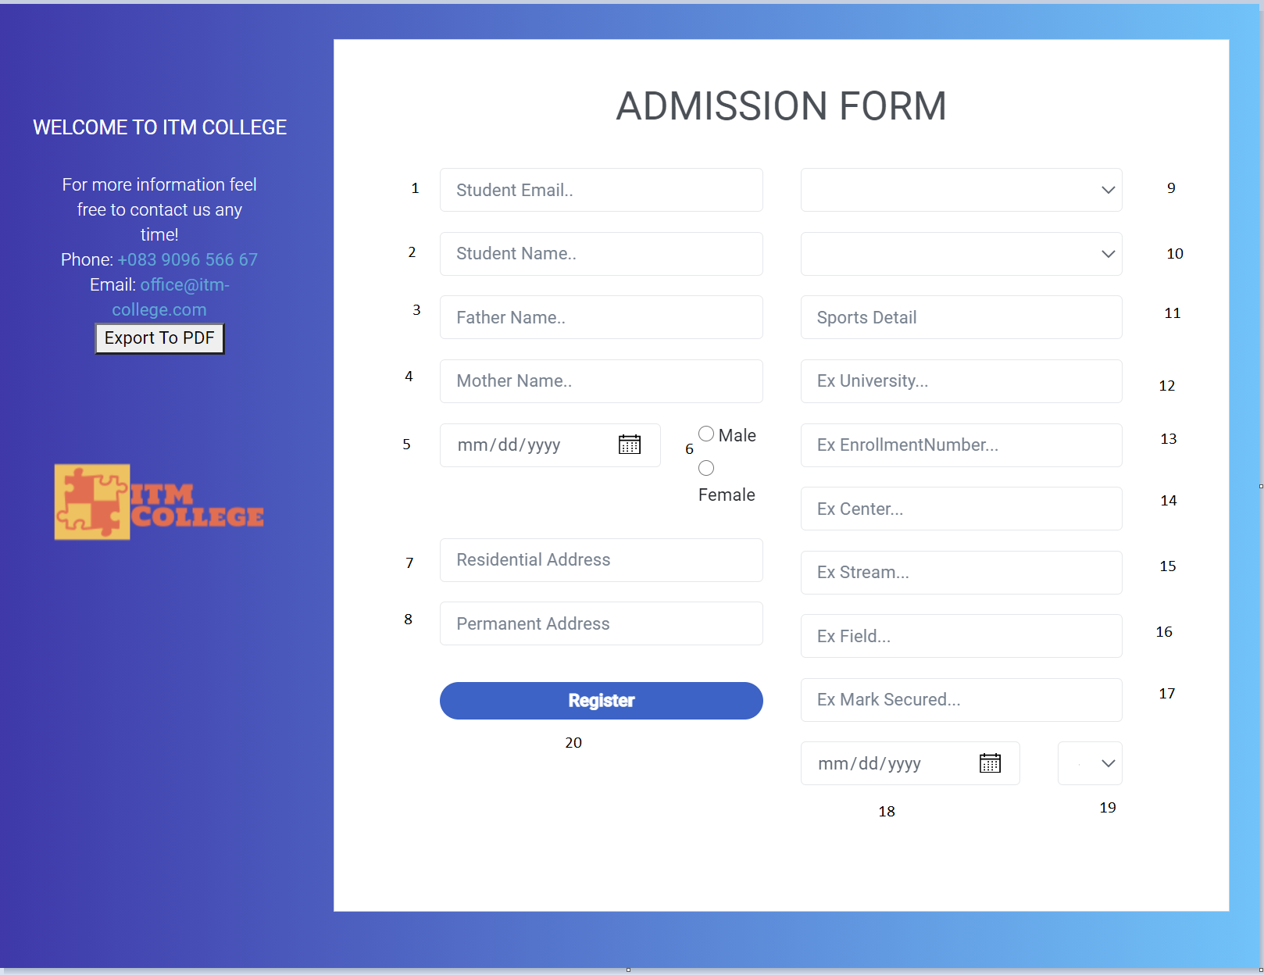

|  |  |  |  |  |  |  |
| --- | --- | --- | --- | --- | --- | --- |
| Admission Form | | | | | | |
| No | Name | Type | Validation | Event | Description | Status |
| 1 | StudentEmail | Text box |  | Input | Input student email | Enable |
| 2 | StudentName | Text box |  | Input | Input student name | Enable |
| 3 | FatherName | Text box |  | Input | Input father name | Enable |
| 4 | MotherName | Text box |  | Input | Input mother name | Enable |
| 5 | DoB | Text box |  | Input | Input date of birth | Enable |
| 6 | Gender | Radio |  | Click | Input gender | Enable |
| 7 | Residential Adress | Text box |  | Input | Input residential address | Enable |
| 8 | Permanent Adress | Text box |  | Input | Input permanent address | Enable |
| 9 | tbStream.Name | Text box |  | Select | Input stream name | Enable |
| 10 | tbField.Name | Text box |  | Select | Input field name | Enable |
| 11 | SportsDetails | Text box |  | Input | Input sports | Enable |
| 12 | ExUniversity | Text box |  | Input | Input previous university | Enable |
| 13 | ExEnrollmentNumber | Text box |  | Input | Input enrollment number (Previous Exam) | Enable |
| 14 | ExCenter | Text box |  | Input | Input center name (Previous Exam) | Enable |
| 15 | ExStream | Text box |  | Input | Input stream (Previous Exam) | Enable |
| 16 | ExField | Text box |  | Input | Input field  (Previous Exam) | Enable |
| 17 | ExMarkSecured | Text box |  | Input | Input mark secured  (Previous Exam) | Enable |
| 18 | OutOfDate | Text box |  | Input | Input out of date of previous exam | Enable |
| 19 | ClassObtained | Text box |  | Select | Input class obtained  (Previous Exam) | Enable |
| 20 | btnApply | Button |  | Click | Submit admission form | Enable |

* Some code review:

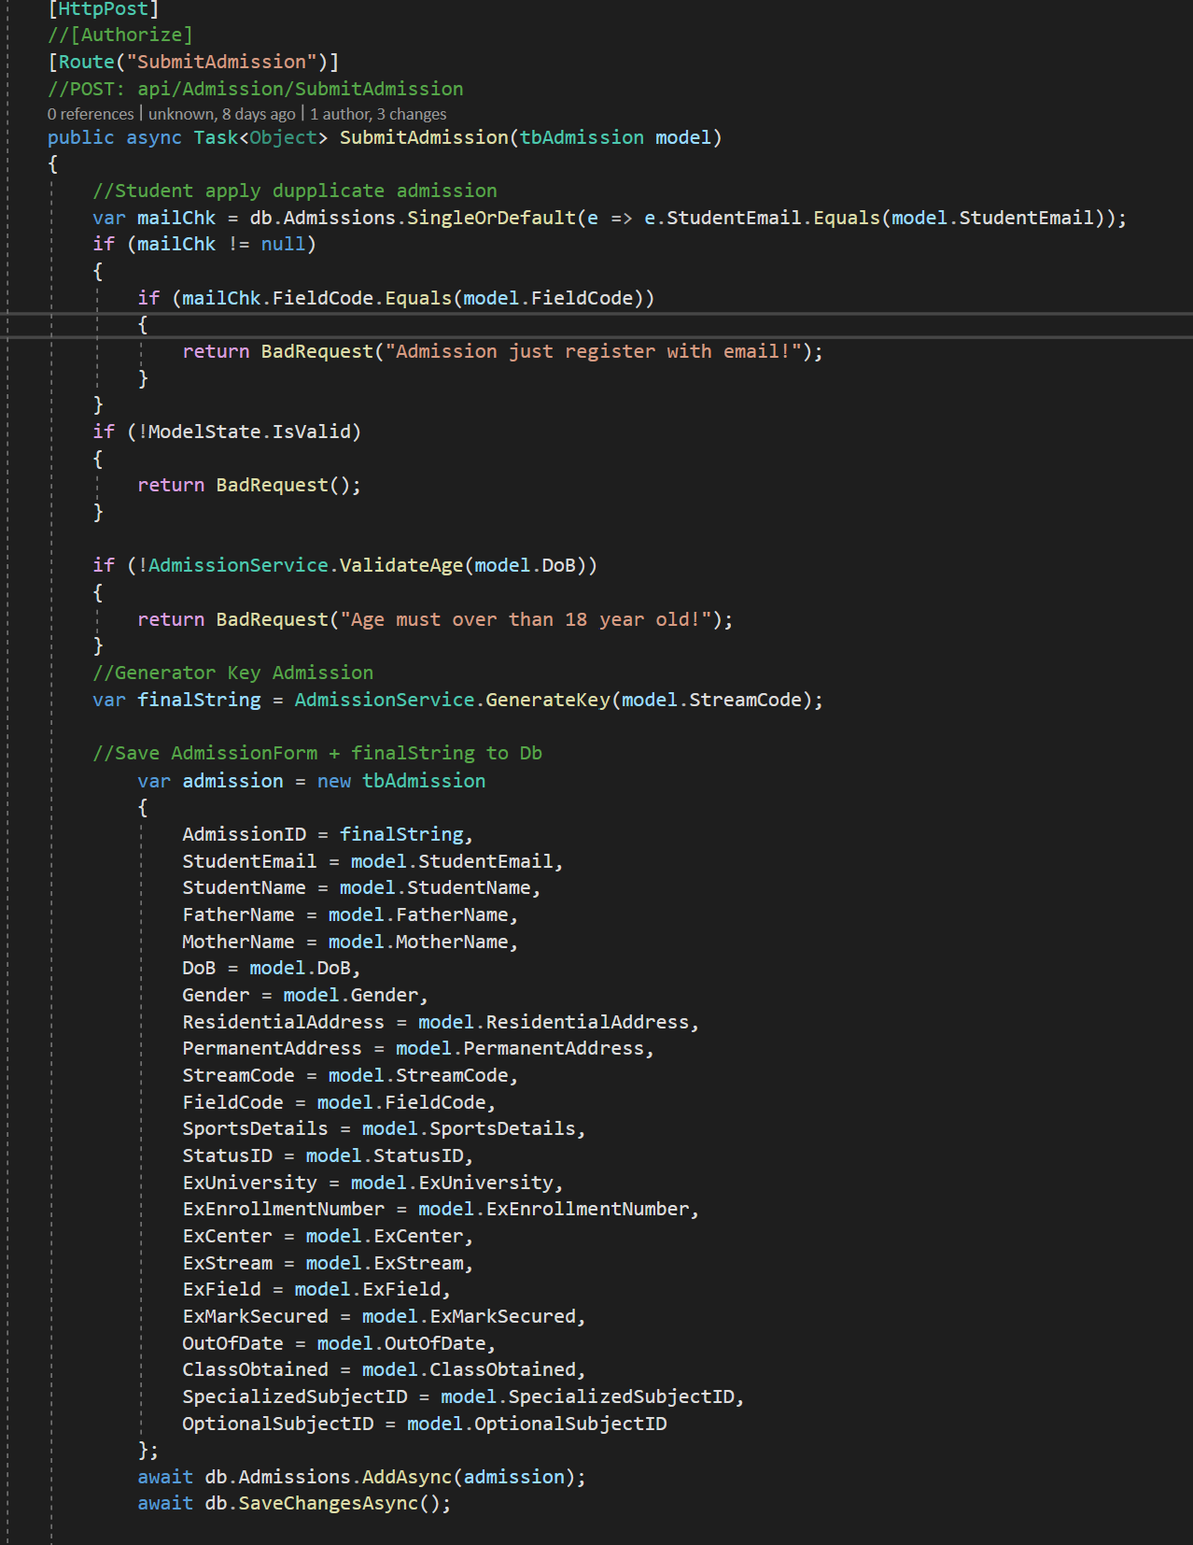

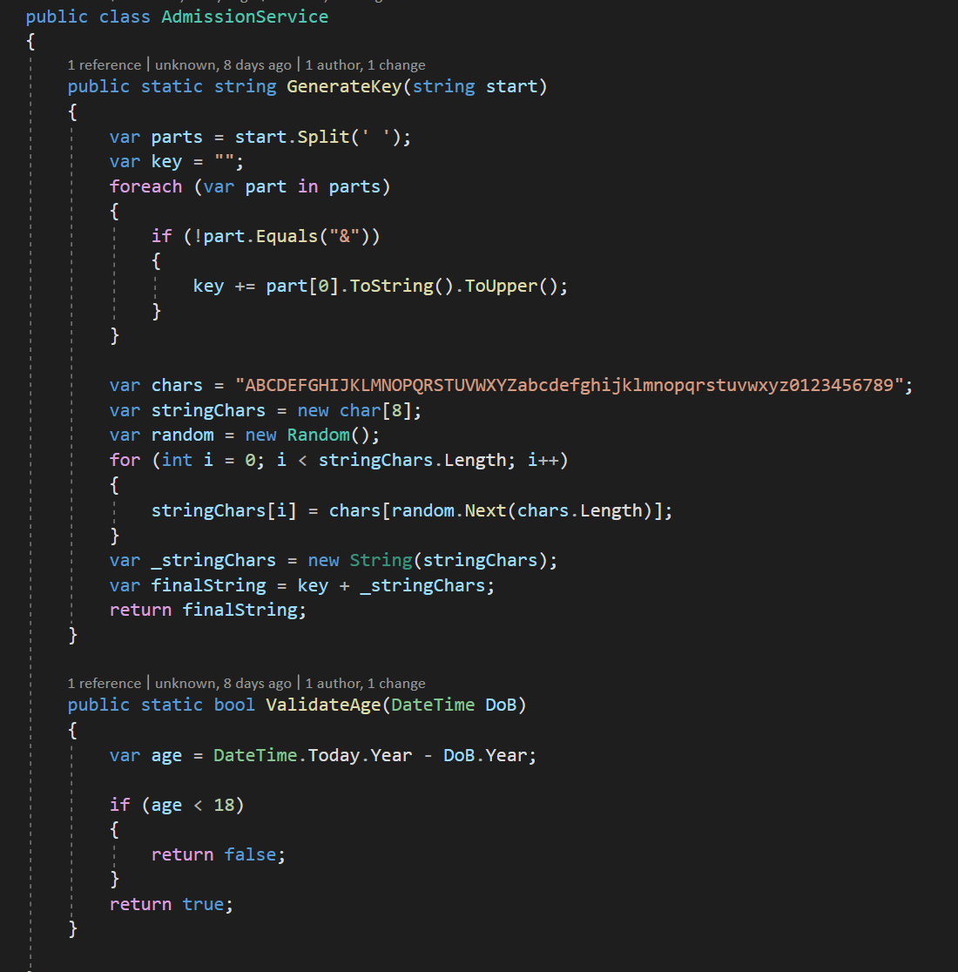

Get Admission key after submit Admission 



|  |  |  |  |  |  |  |
| --- | --- | --- | --- | --- | --- | --- |
| AdmissionCheckForm | | | | | | |
| No | Name | Type | Validation | Event | Description | Status |
| 1 | Admission Id | Text box | **Not Null** | Input | Input Admission Id | Enable |
| 2 | Check | Button |  | Click | Submit | Enable |

When Admission approved, you can choose Special Subject and Optional Subject:

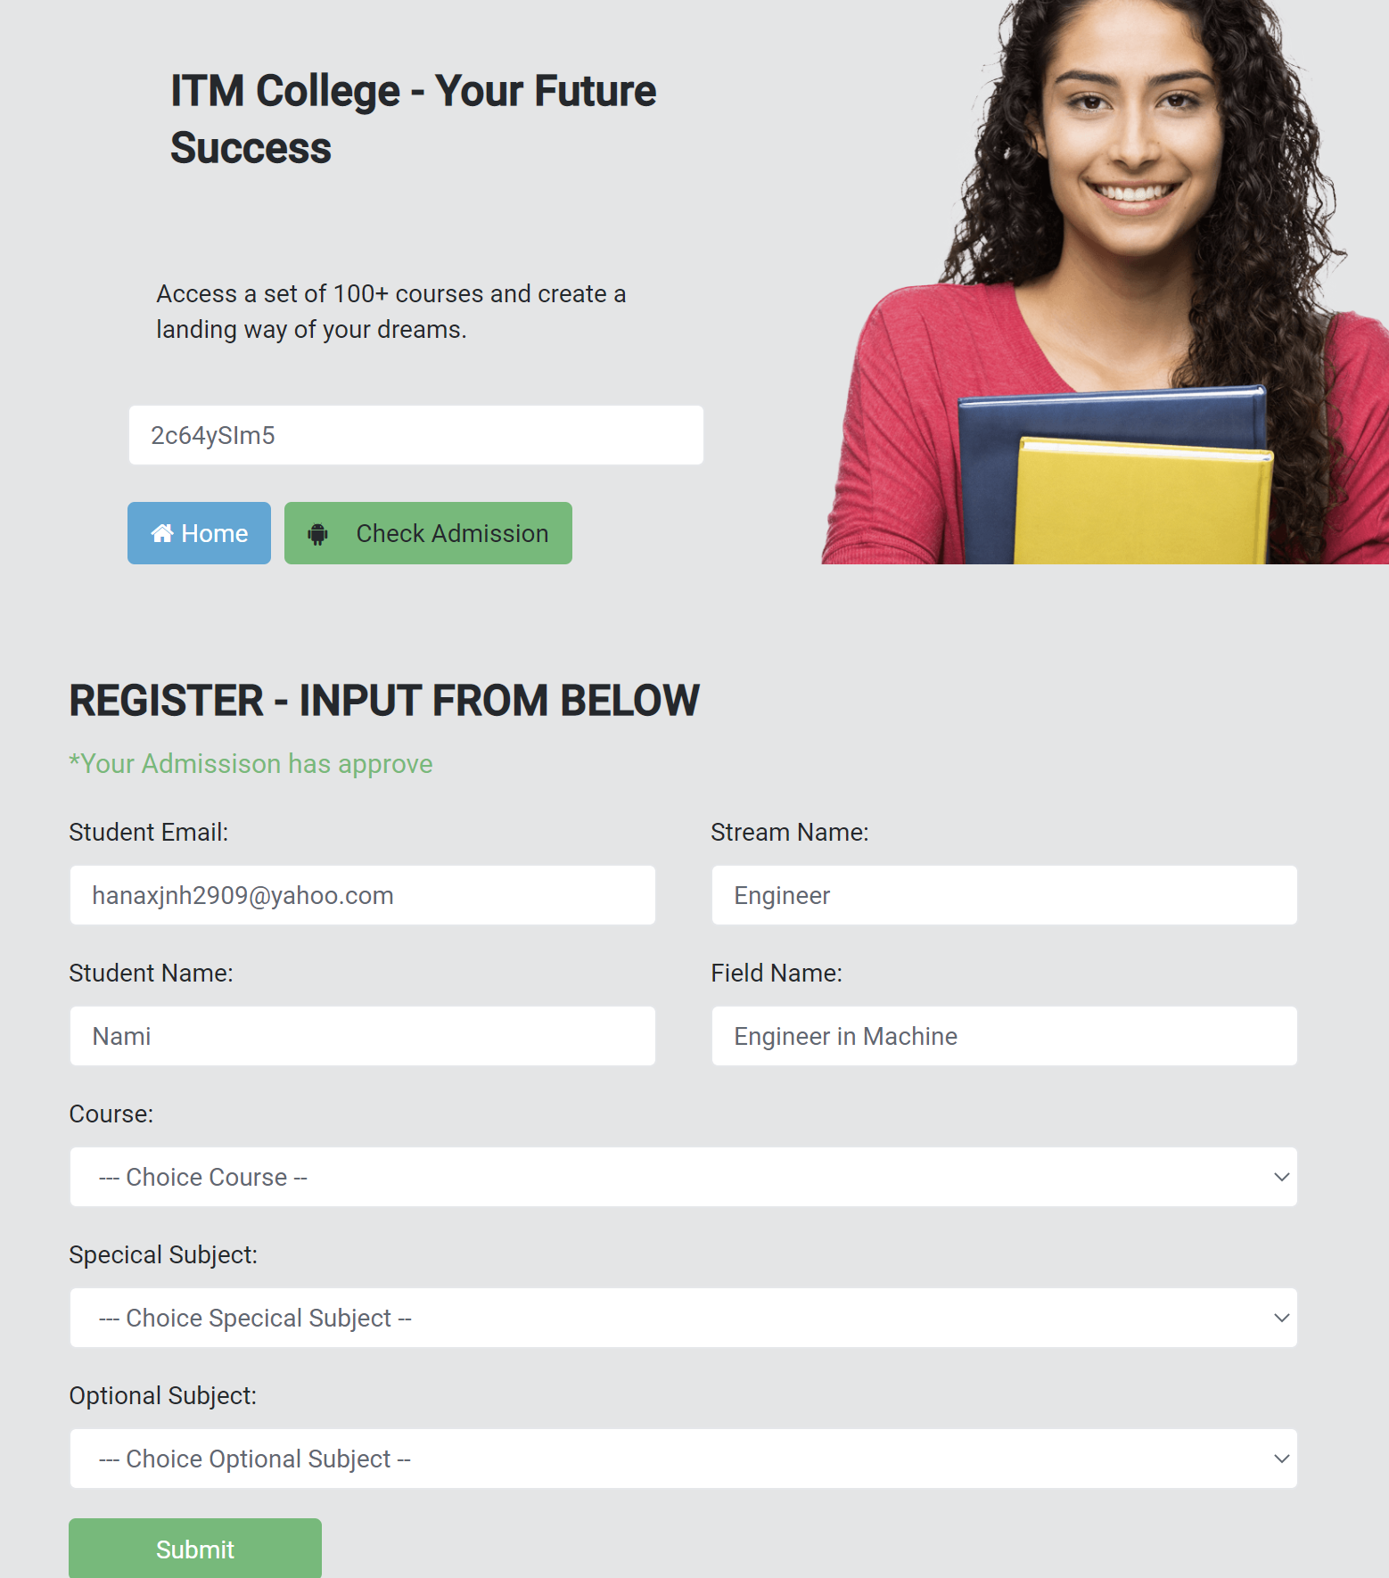

1. Department:

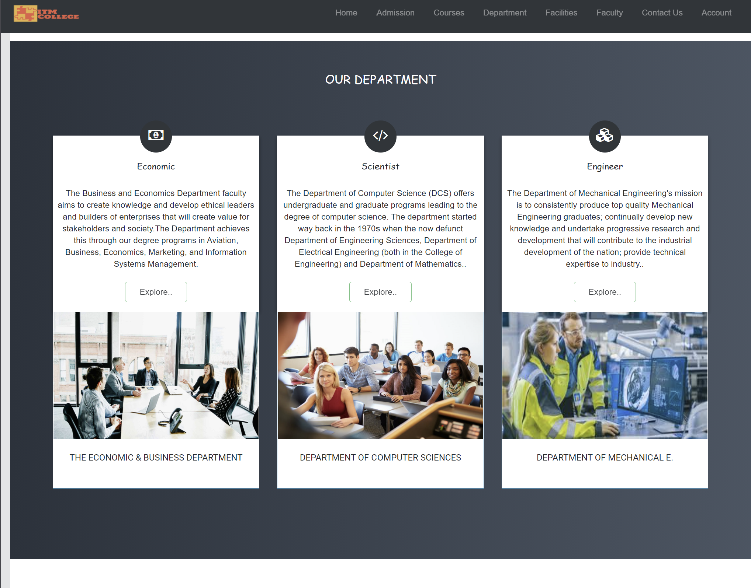

1. Faculty:

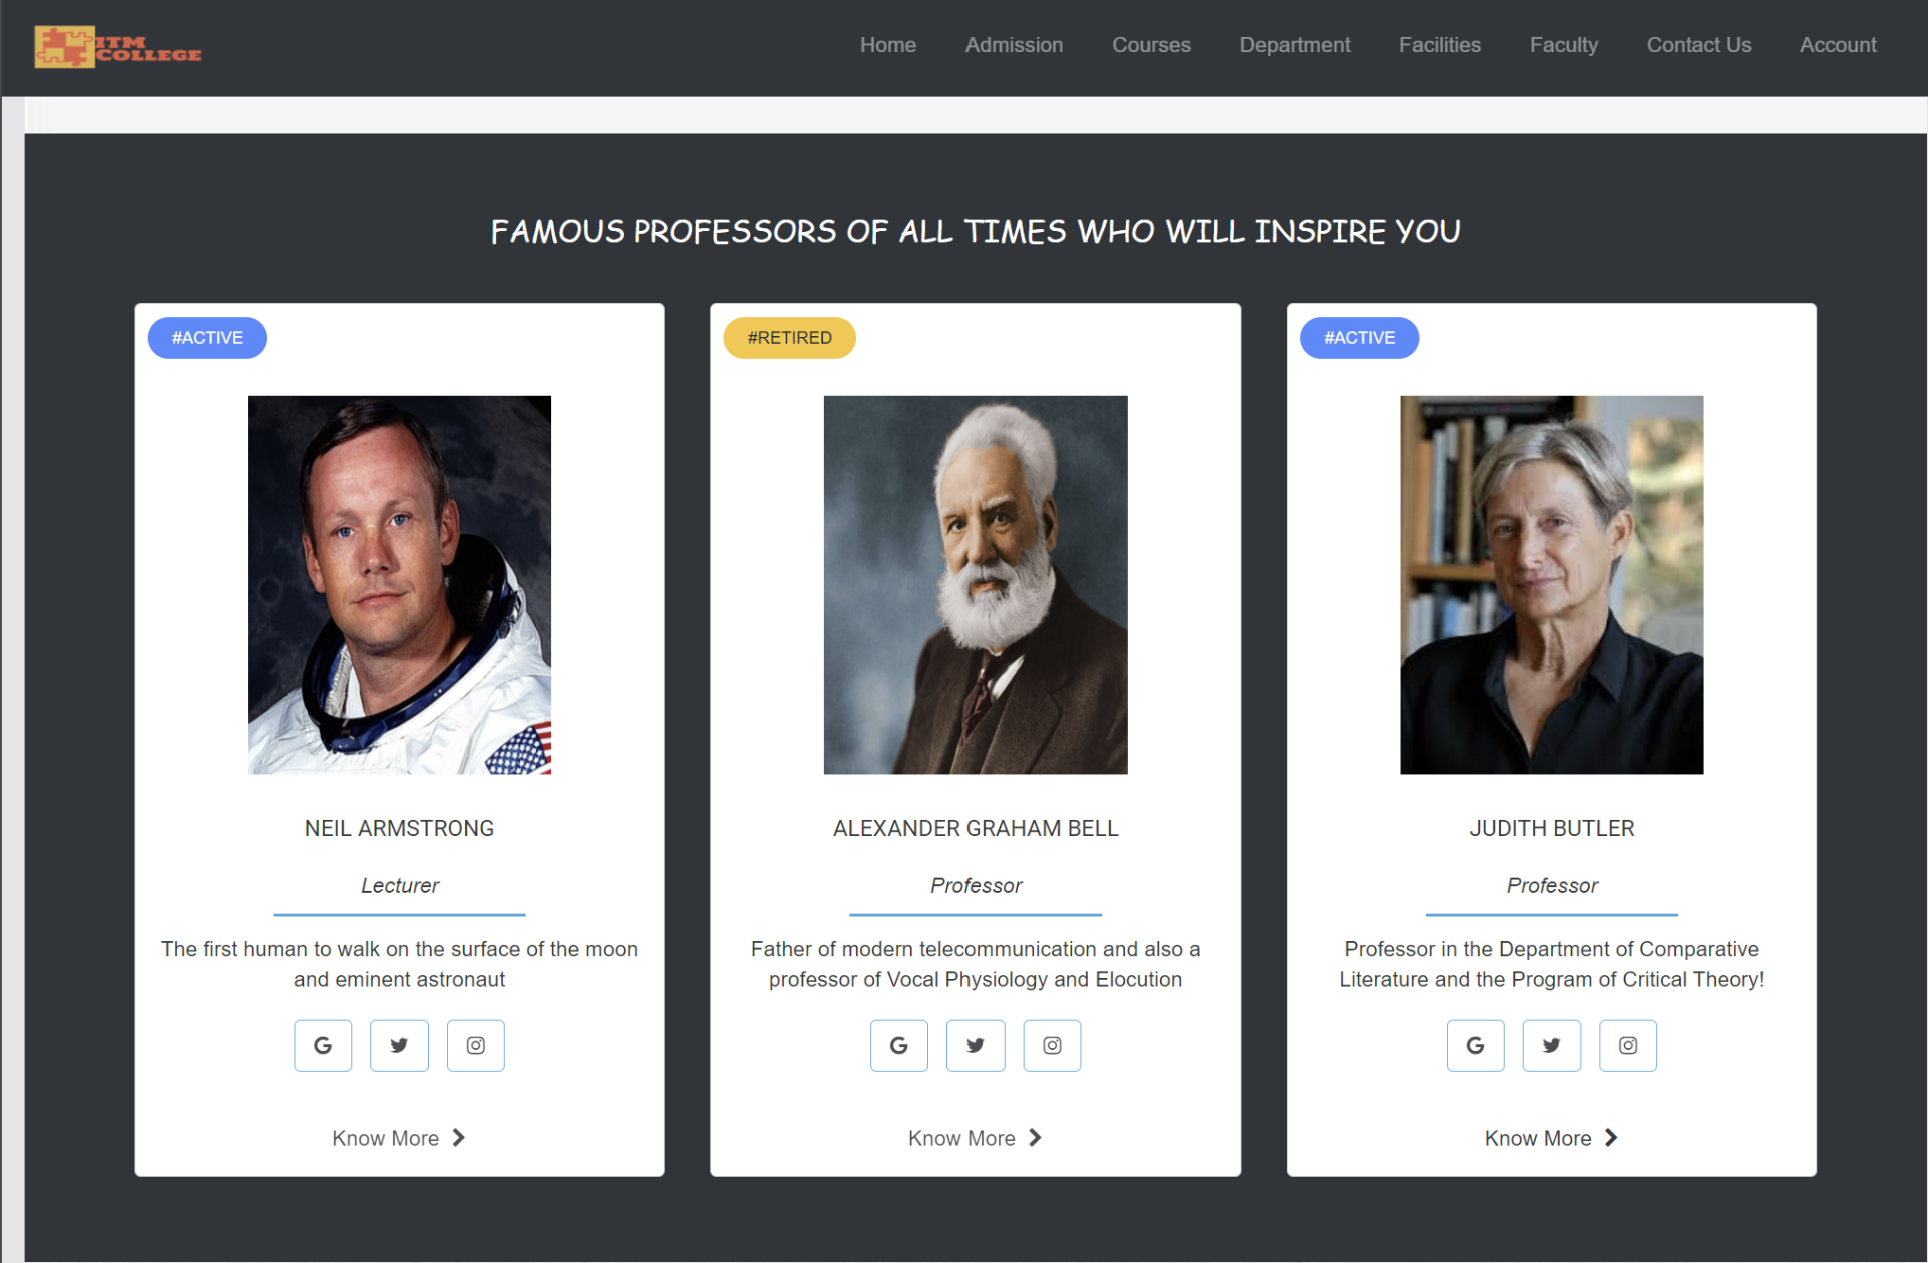

1. Facilities:

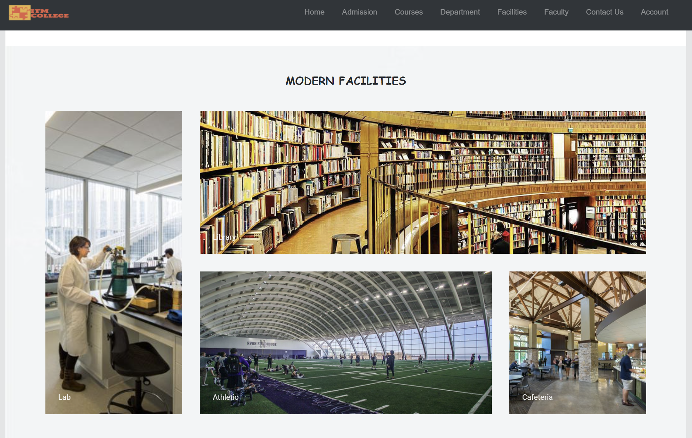

1. Contact Us(Feedback)

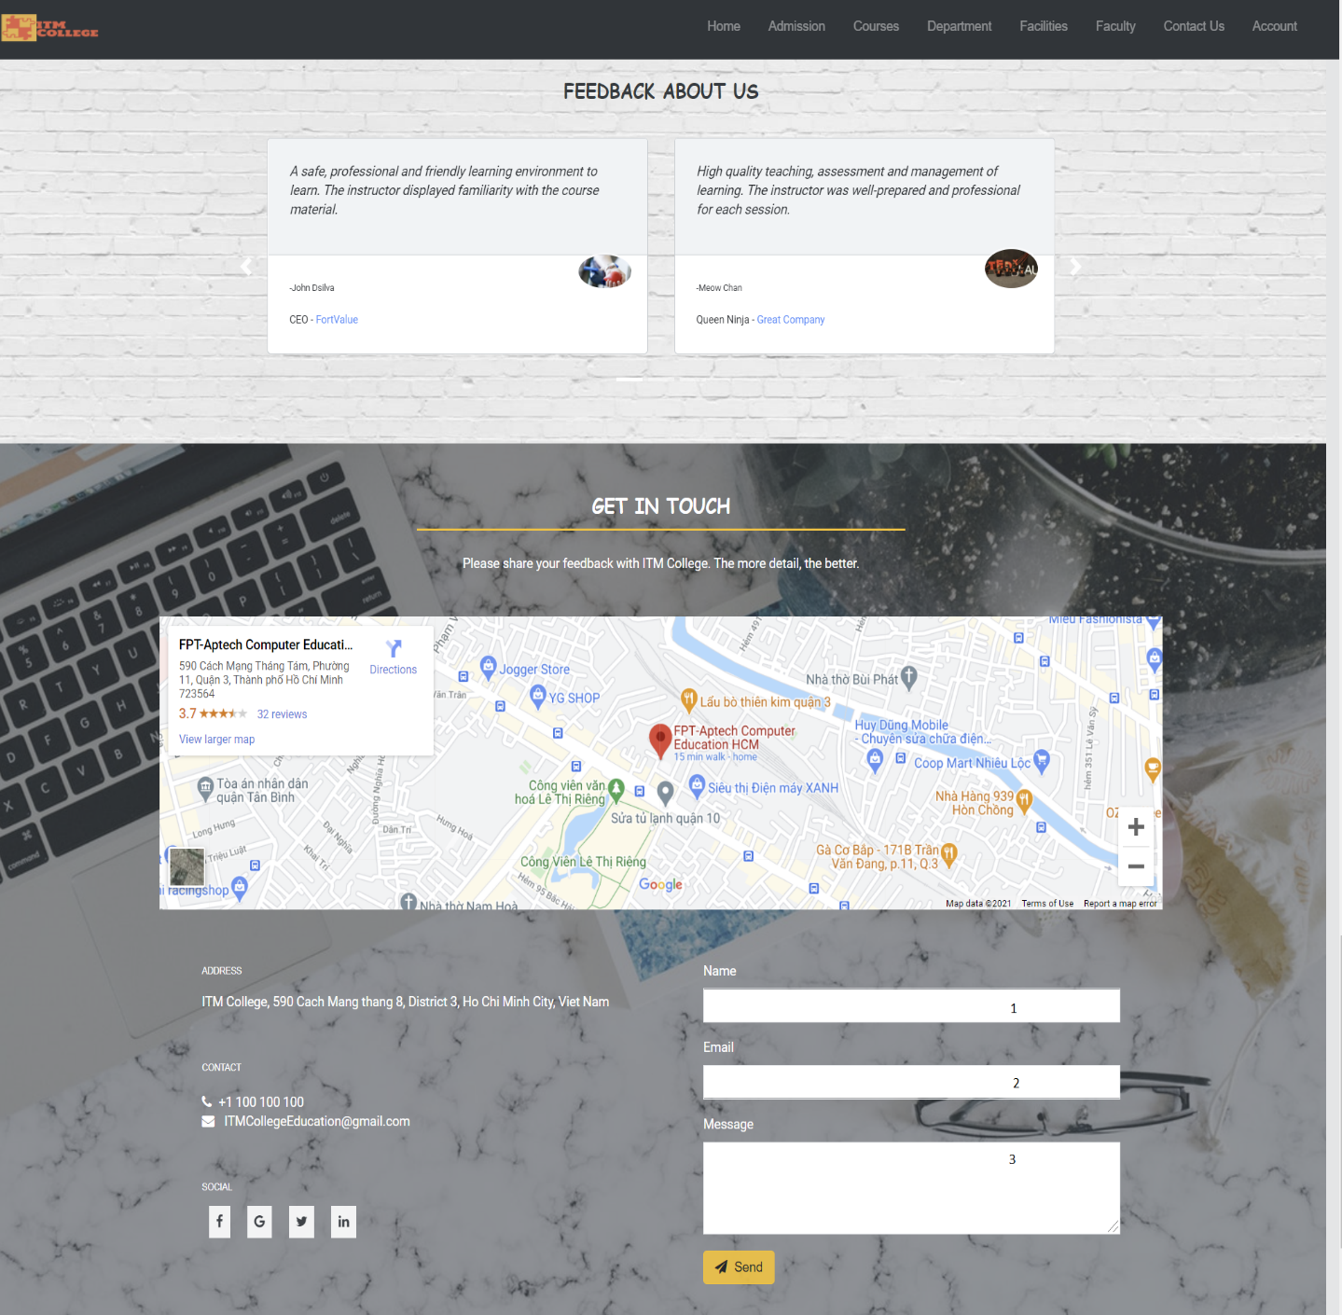

|  |  |  |  |  |  |  |
| --- | --- | --- | --- | --- | --- | --- |
| Feedback Form | | | | | | |
| No | Name | Type | Validation | Event | Description | Status |
| 1 | Name | Text box | **Not Null** | Input | Input name/username | Enable |
| 2 | Email | Text box | **Not null** | input | Input Email | Enable |
| 3 | Message | Text box | **Not null** | Input | Input feedback content | Enable |
| 4 | Send | button |  | click | Button for submit form | Enable |

1. Register

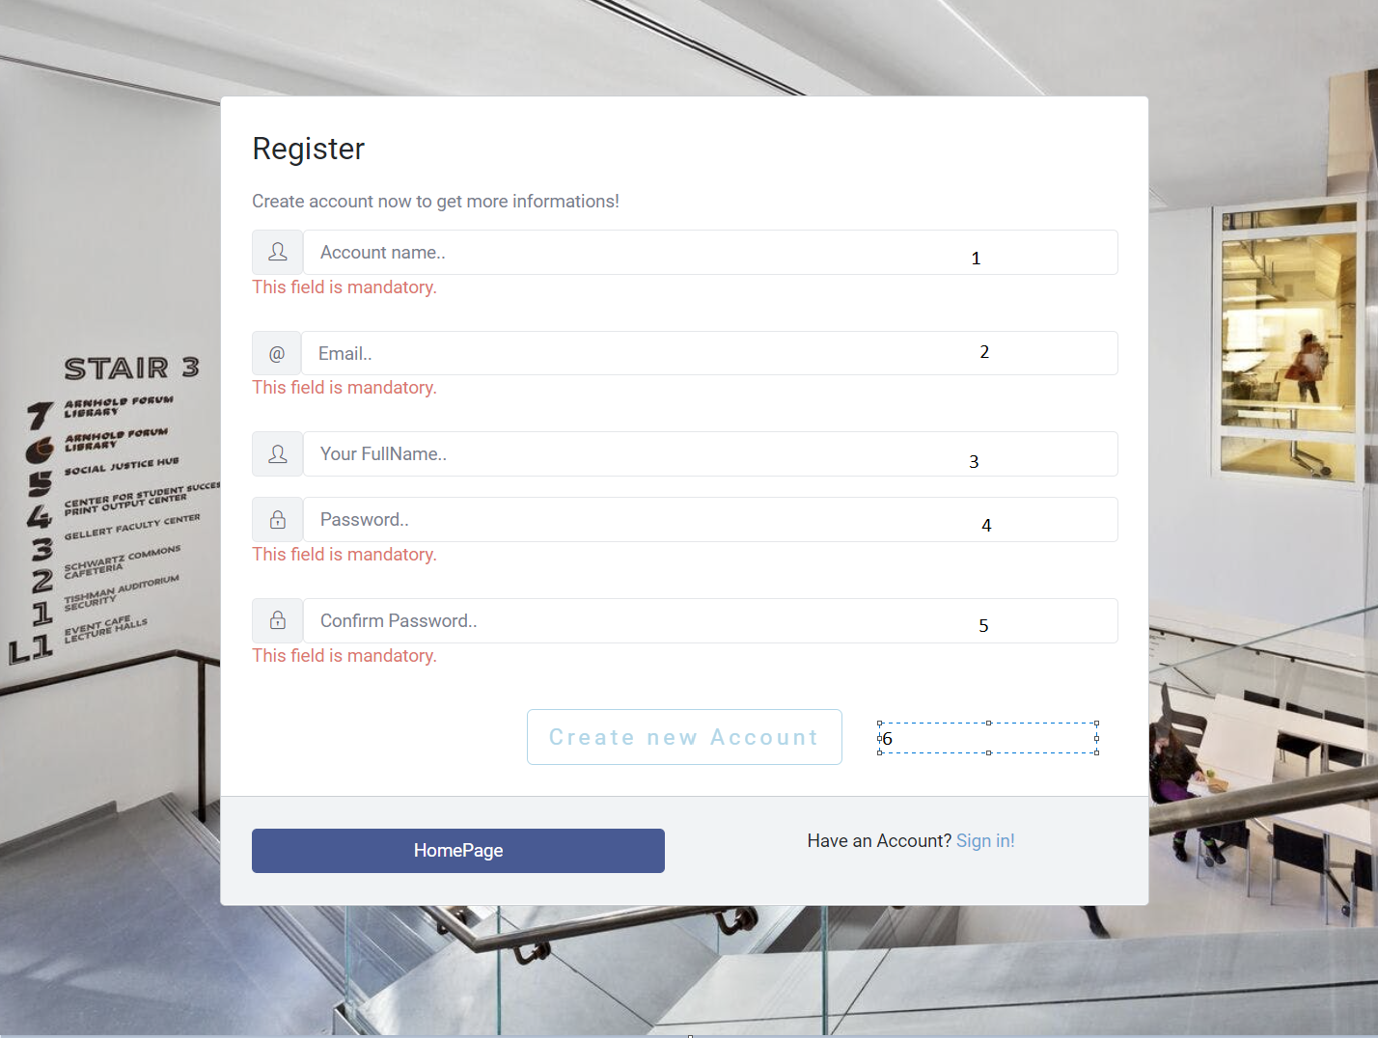

|  |  |  |  |  |  |  |
| --- | --- | --- | --- | --- | --- | --- |
| Registration Form | | | | | | |
| No | Name | Type | Validation | Event | Description | Status |
| 1 | username | Text box | **Required,**  **Unique** |  | Input User Name | Enable |
| 2 | Email | Text box | **Required,**  **Unique** |  | Input Email | Enable |
| 3 | FullName | Text box |  |  | Input Full Name | Enable |
| 4 | Password | Text box | **Required** |  | Input Password | Enable |
| 5 | ConfirmPassword | Text box | **Required** |  | Input Confirm Password | Enable |
| 6 | Create new Account | Button |  |  | Submit Form | Enable |

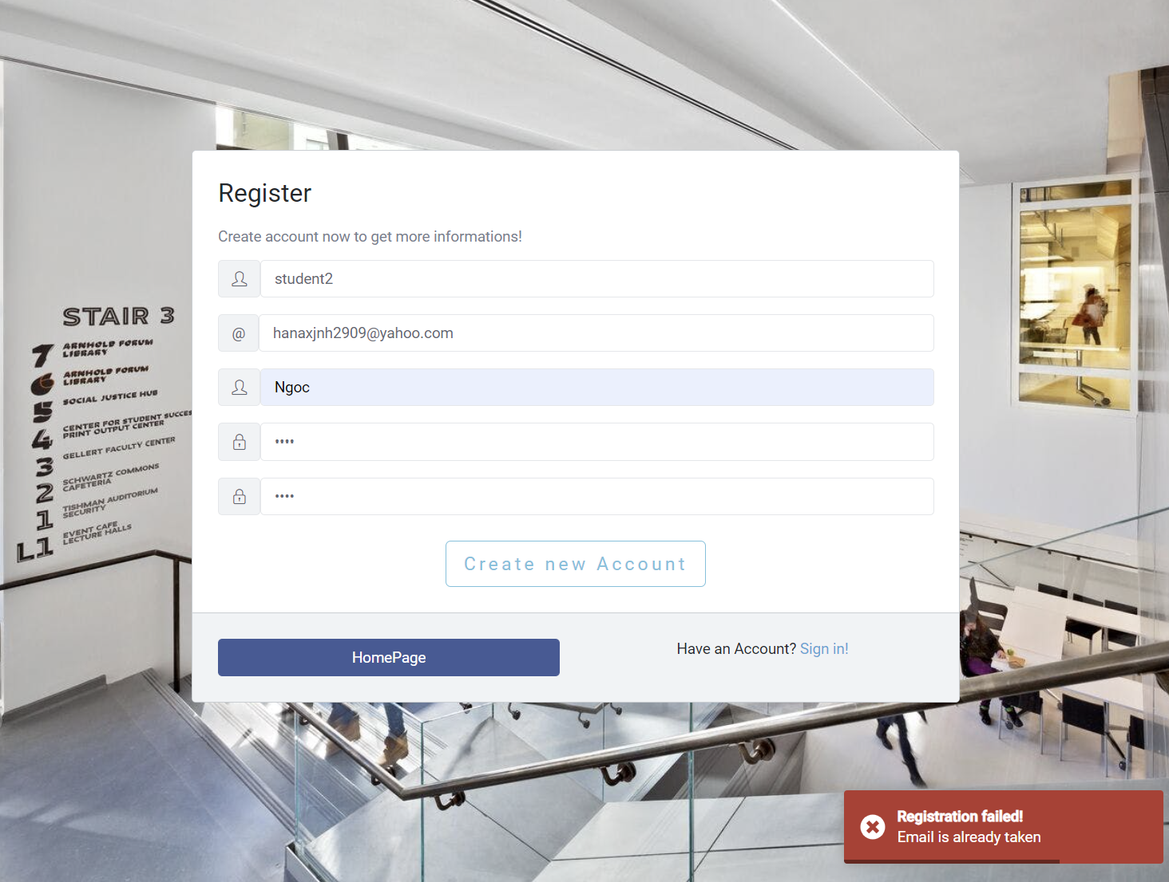

* Some code review: (with Angular)

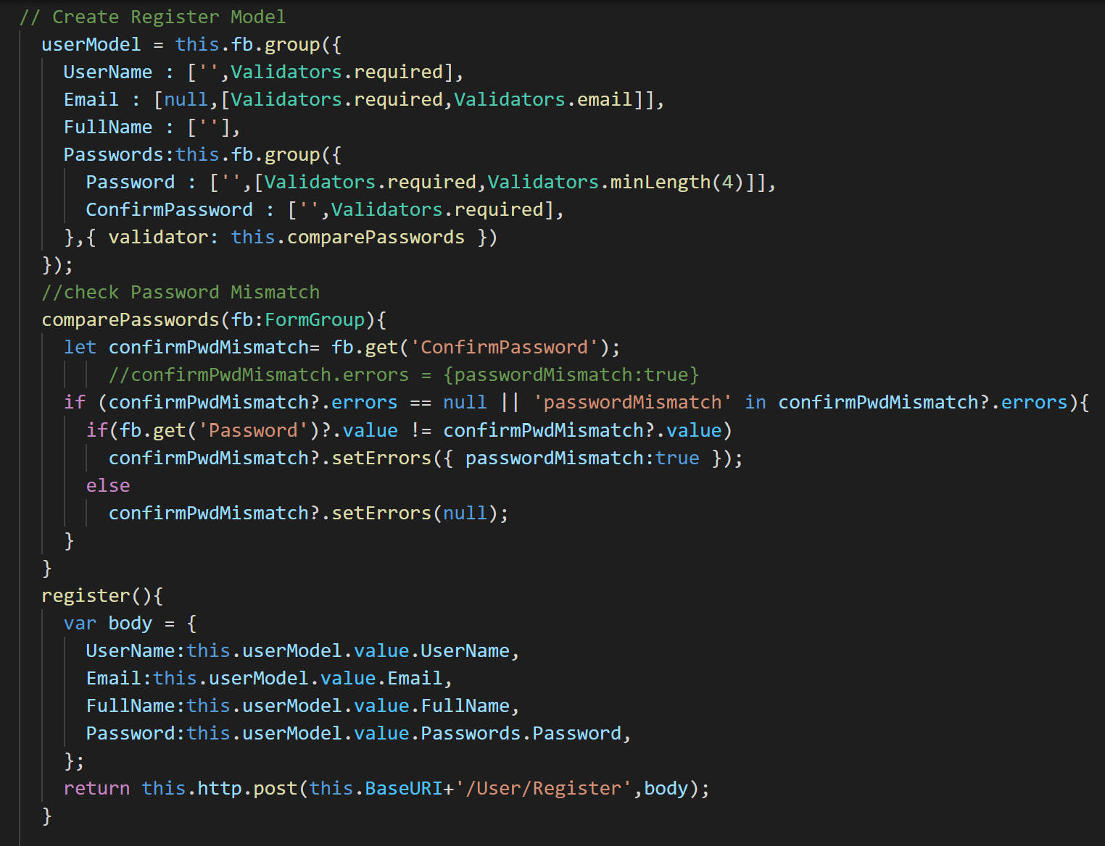

1. Login

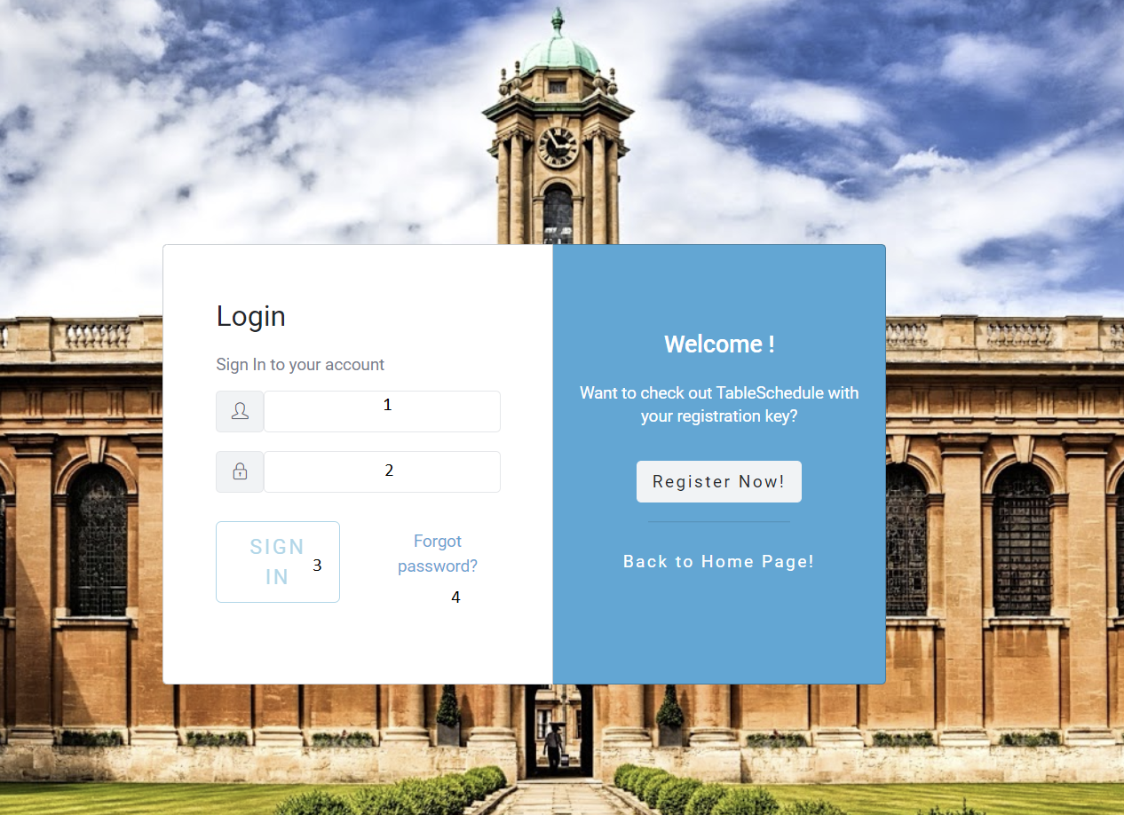

|  |  |  |  |  |  |  |
| --- | --- | --- | --- | --- | --- | --- |
| Login Form | | | | | | |
| No | Name | Type | Validation | Event | Description | Status |
| 1 | UserName | input |  | input | Input username | Enable |
| 2 | Password | input |  | input | Input password | Enable |
| 3 | Sign in | button |  | click | Submit Form | Enable |
| 4 | Forgot password | Hyberlink |  | click | To ForgotPassword | Enable |

* Some code review:

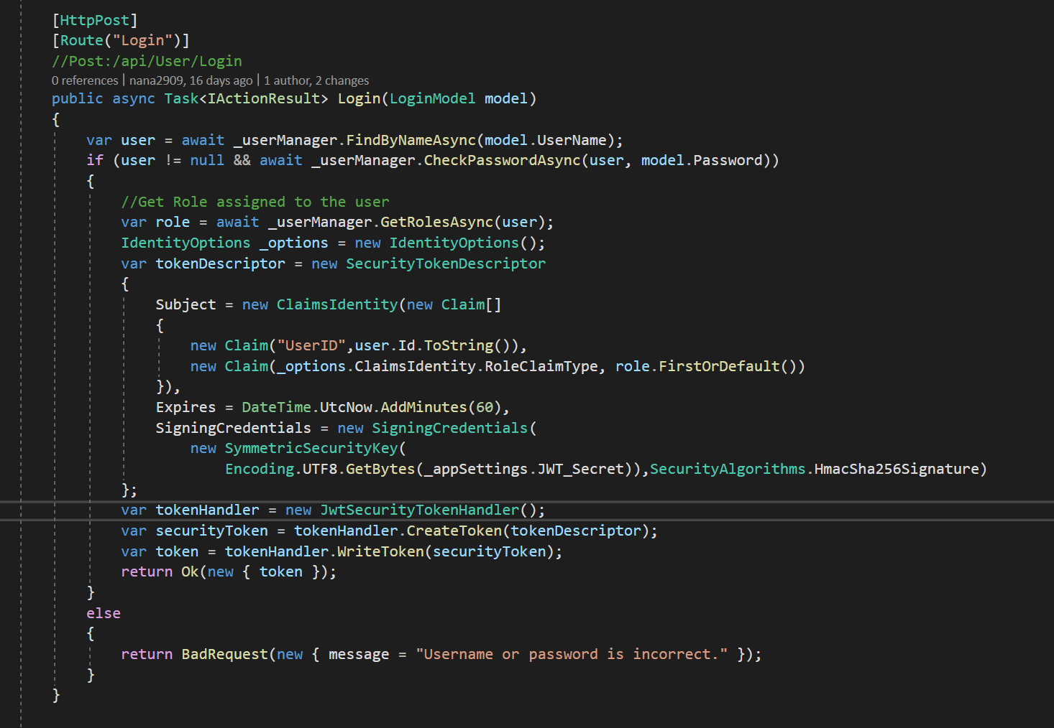

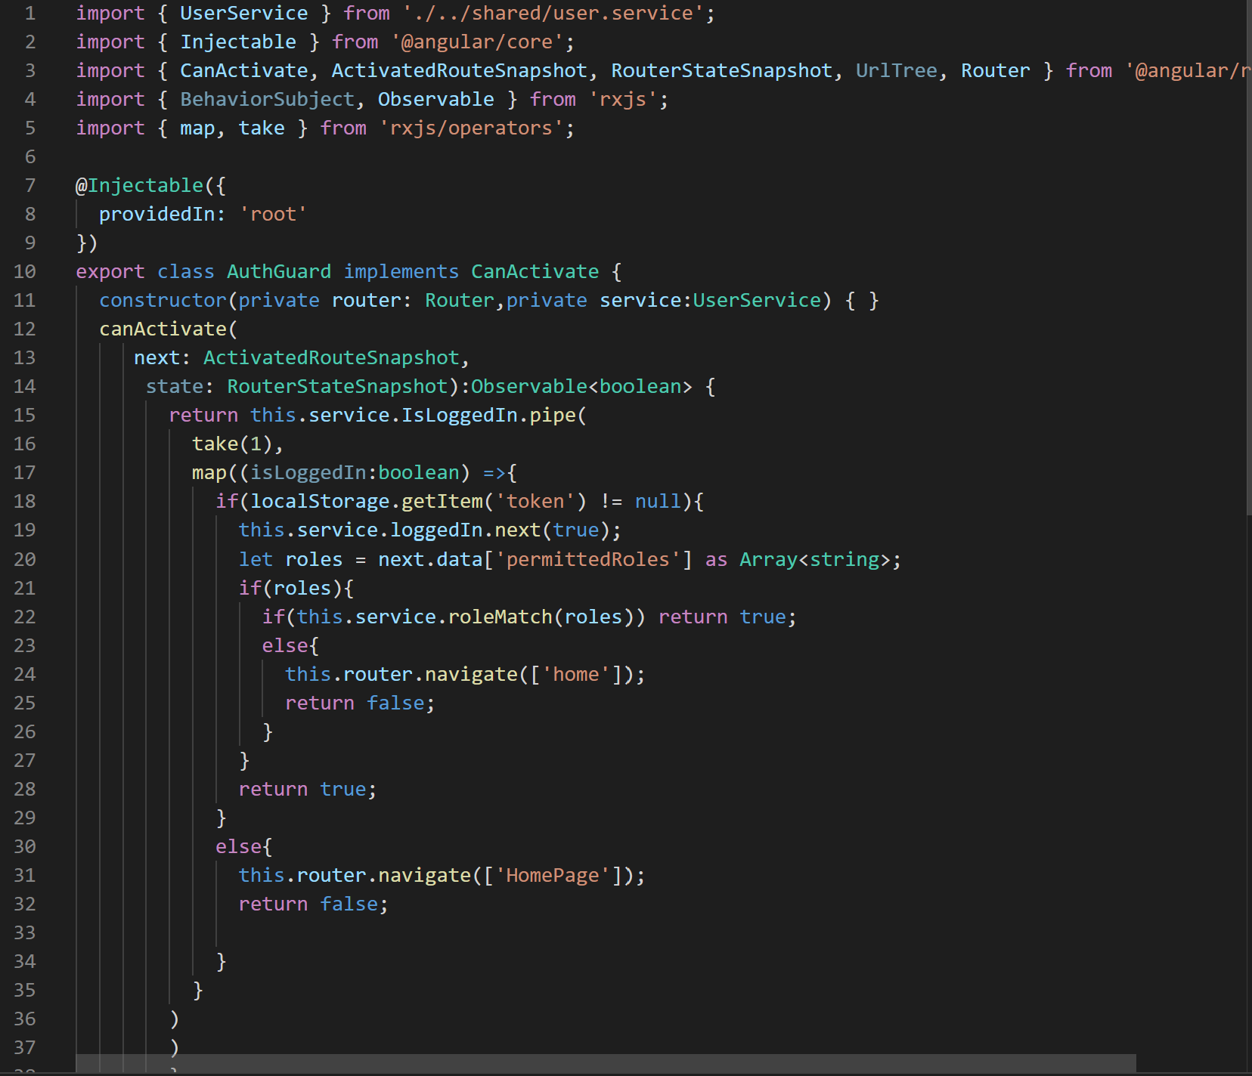

1. Forgot Password

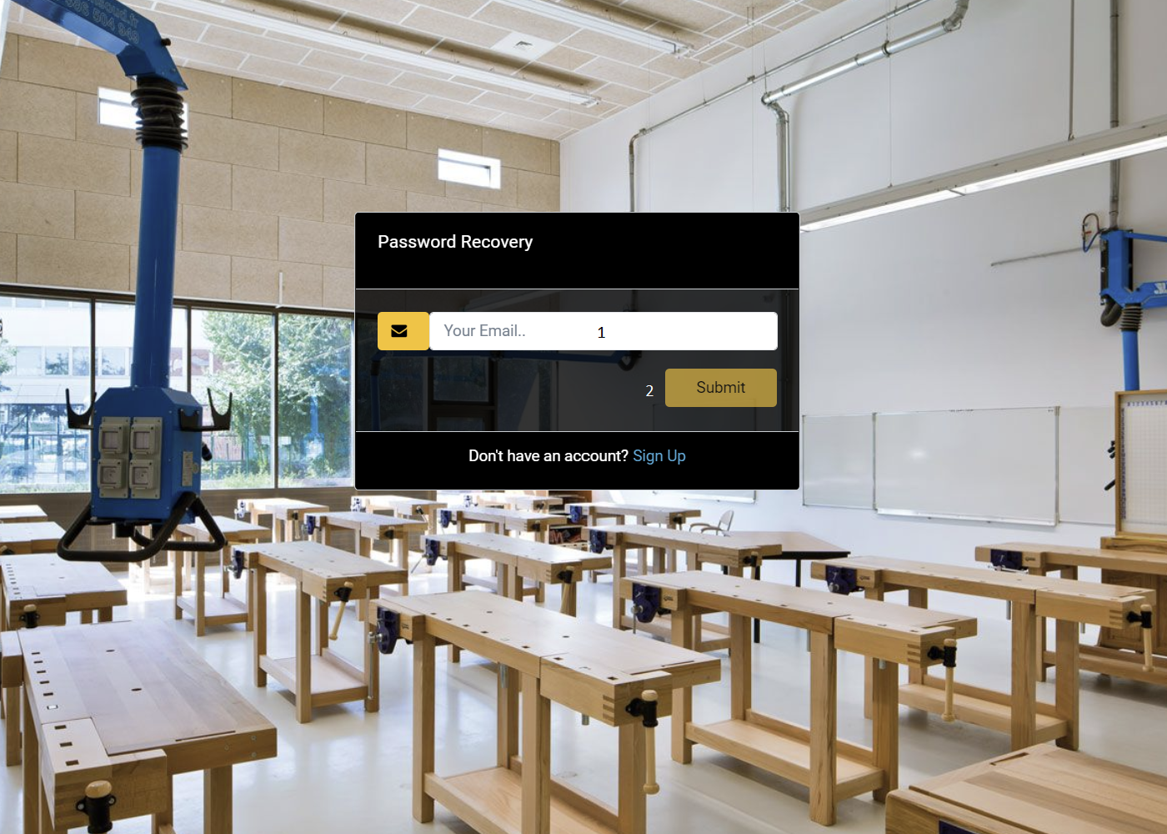

|  |  |  |  |  |  |  |
| --- | --- | --- | --- | --- | --- | --- |
| Forgot Password Form | | | | | | |
| No | Name | Type | Validation | Event | Description | Status |
| 1 | Email | input |  | input | Input Email | Enable |
| 2 | Submit | button |  | click | Submit Form | Enable |

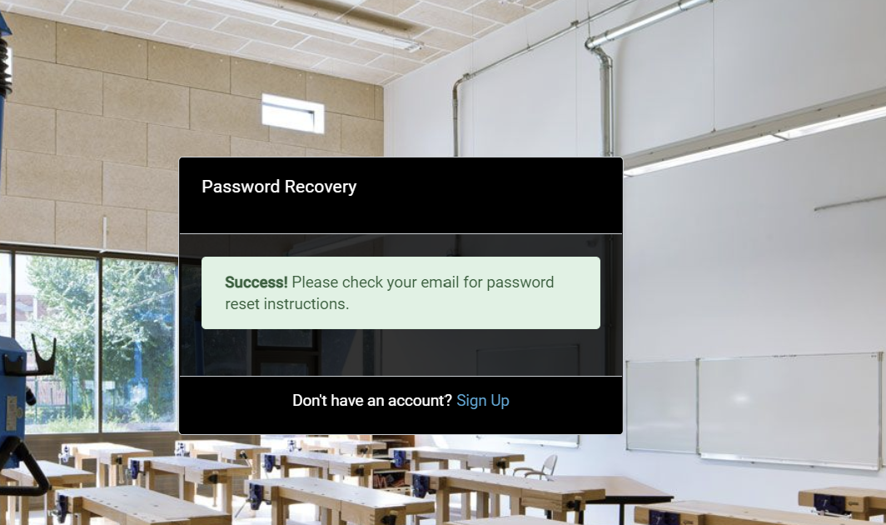

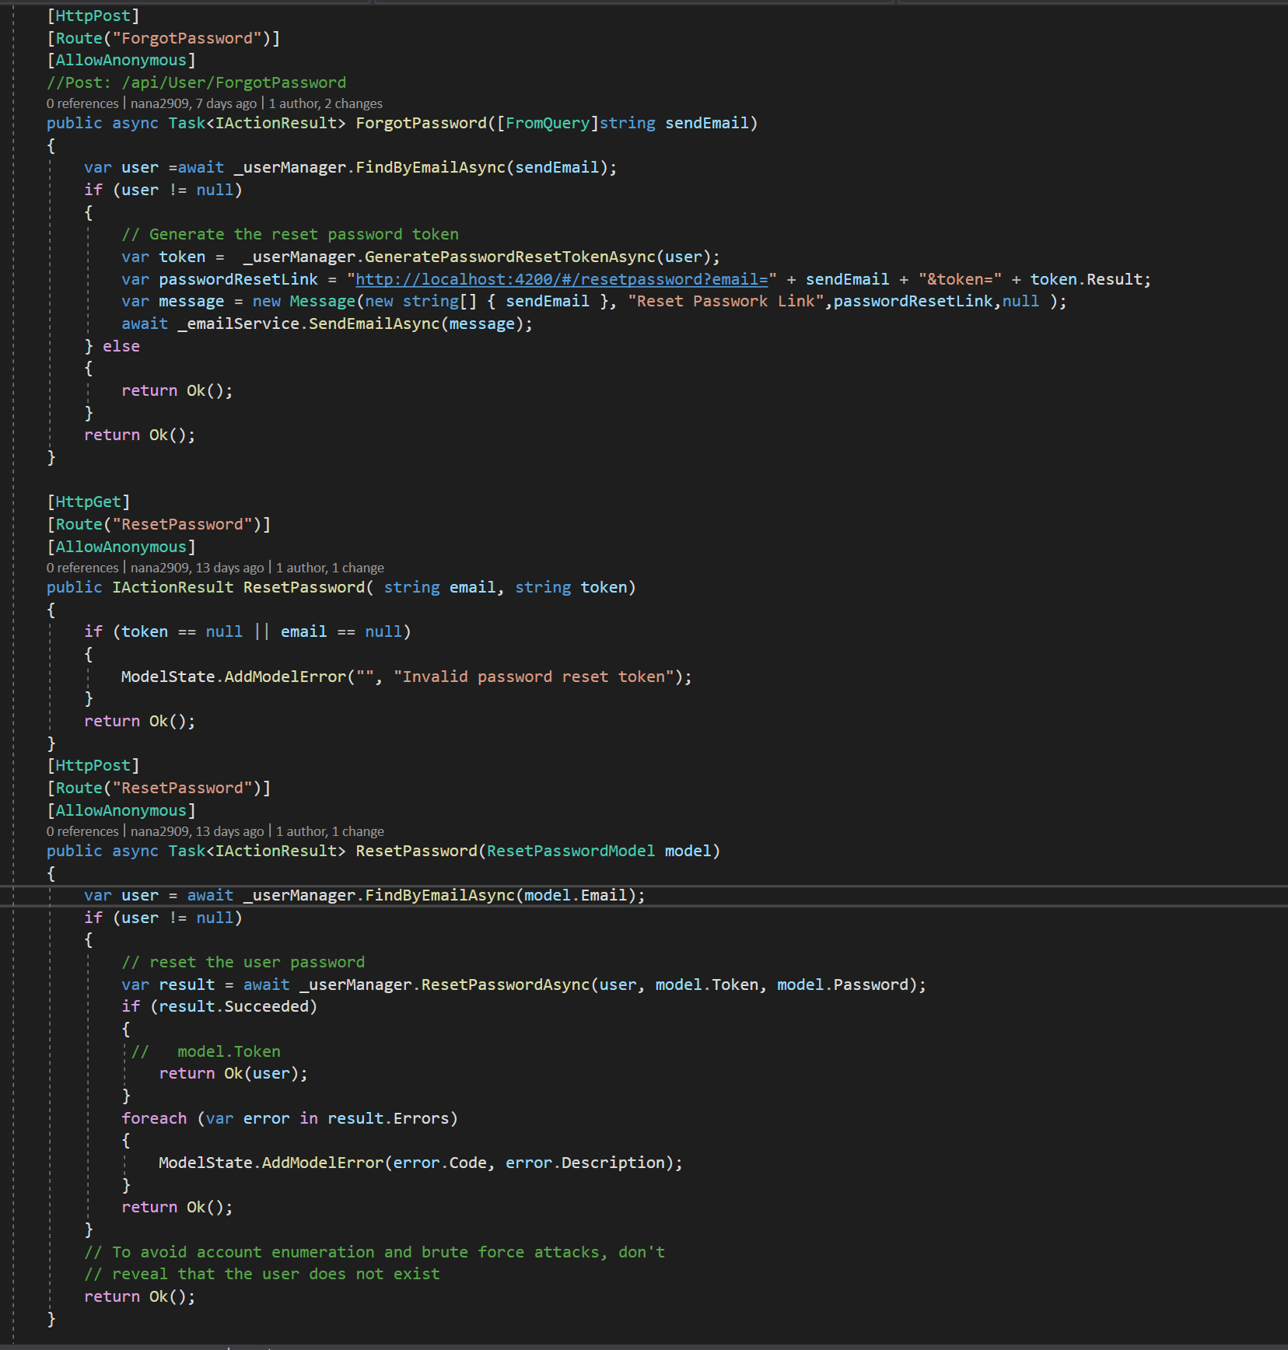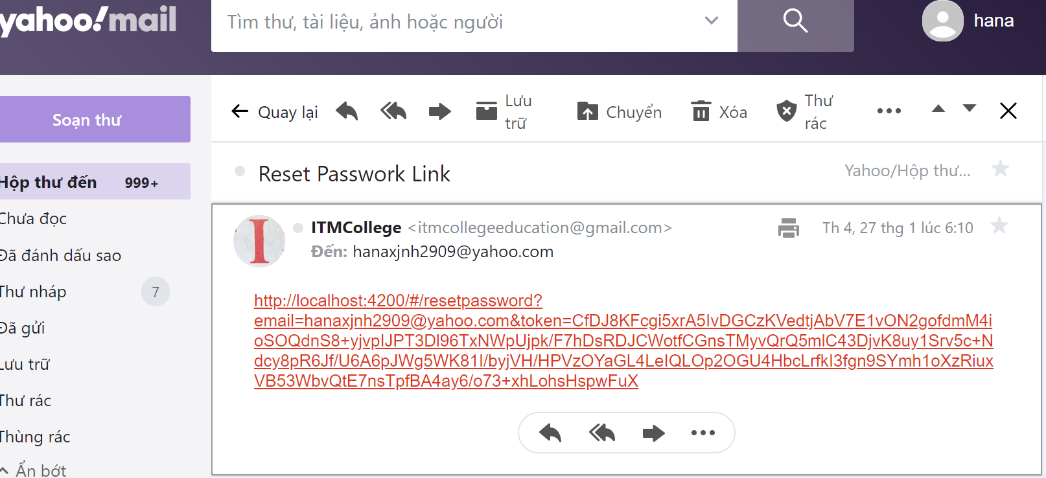

1. Reset Password Form

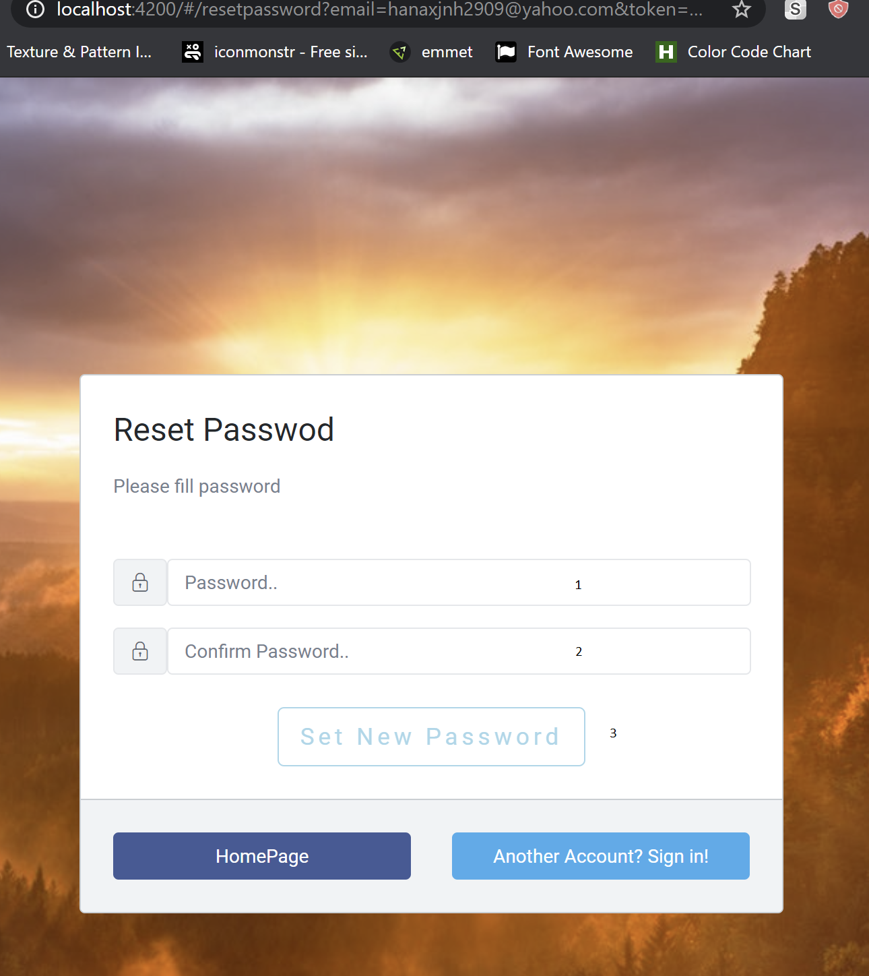

|  |  |  |  |  |  |  |
| --- | --- | --- | --- | --- | --- | --- |
| Reset Password Form | | | | | | |
| No | Name | Type | Validation | Event | Description | Status |
| 1 | Password | input |  |  | Input password | Enable |
| 2 | ConfirmPassword | Input |  |  | Input password | Enable |
| 3 | Set New Password | button |  | click | Submit Form | Enable |

1. User

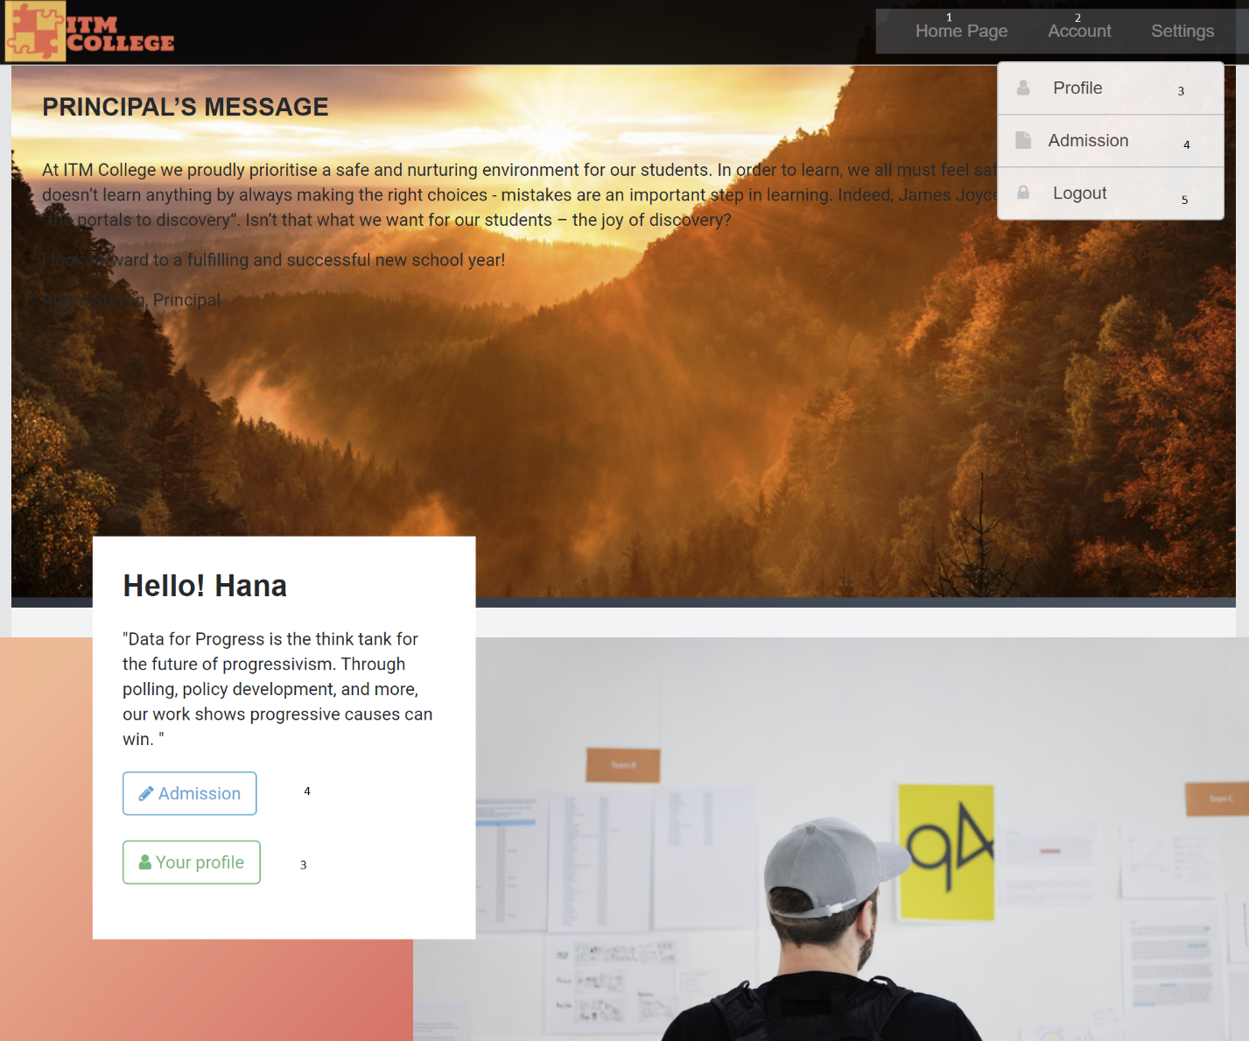

|  |  |  |  |  |  |  |
| --- | --- | --- | --- | --- | --- | --- |
| Navigation | | | | | | |
| No | Name | Type | Validation | Event | Description | Status |
| 1 | Homepage | Hyberlink |  | click | Url to HomePage | Enable |
| 2 | Account | Hyberlink |  | click | Url to UserPage | Enable |
| 3 | Admission | Hyberlink |  | click | Url to Admission Page | Enable |
| 4 | UserProfile | Hyberlink |  | click | Url to Profile Page | Enable |
| 5 | Log Out | Hyberlink |  | click | Log Out | Enable |

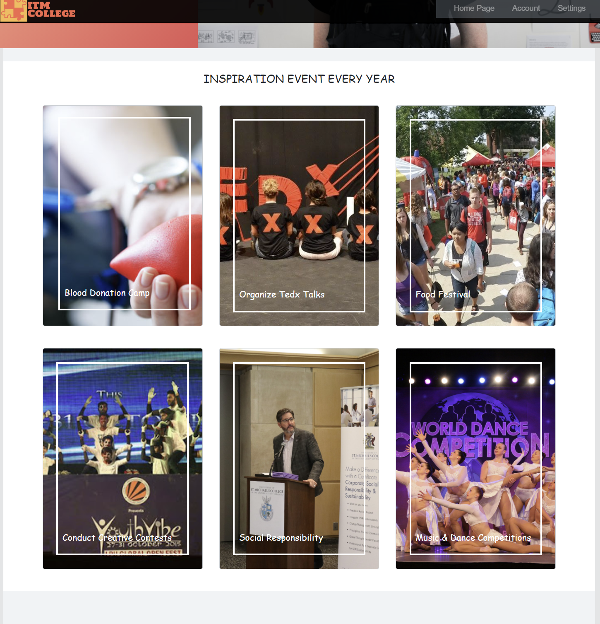

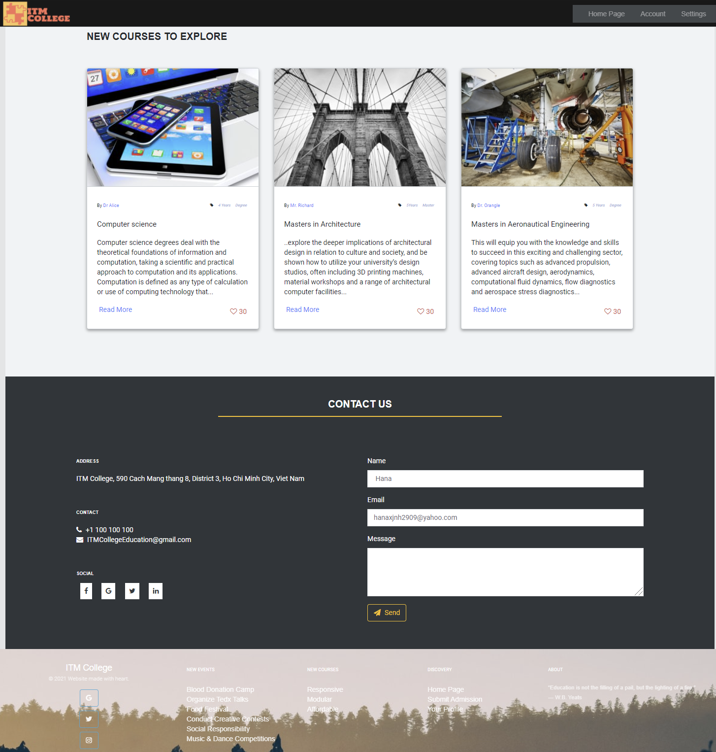

### 12.1 User Profile

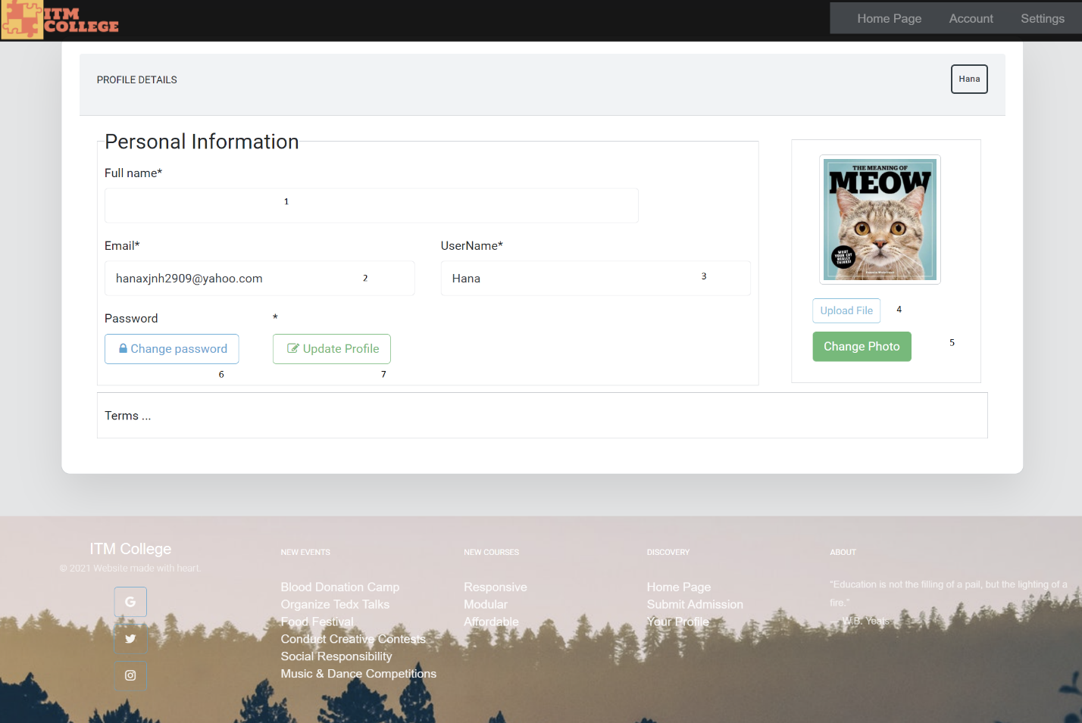

|  |  |  |  |  |  |  |
| --- | --- | --- | --- | --- | --- | --- |
| Navigation | | | | | | |
| No | Name | Type | Validation | Event | Description | Status |
| 1 | FullName | Input |  |  | Show FullName | Disable |
| 2 | Email | Input |  |  | Show Email | Disable |
| 3 | Username | Input |  |  | Show UserName | Disable |
| 4 | Upload photo | Input |  | click | Upload Image to server | Enable |
| 5 | Change Photo | Button |  | click | Confirm to change image | Enable |
| 6 | Change password | HyperLink |  | click | Modal ChangePassword | Enable |
| 7 | Update profile | HyperLink |  | click | Modal UpdateUser | Enable |

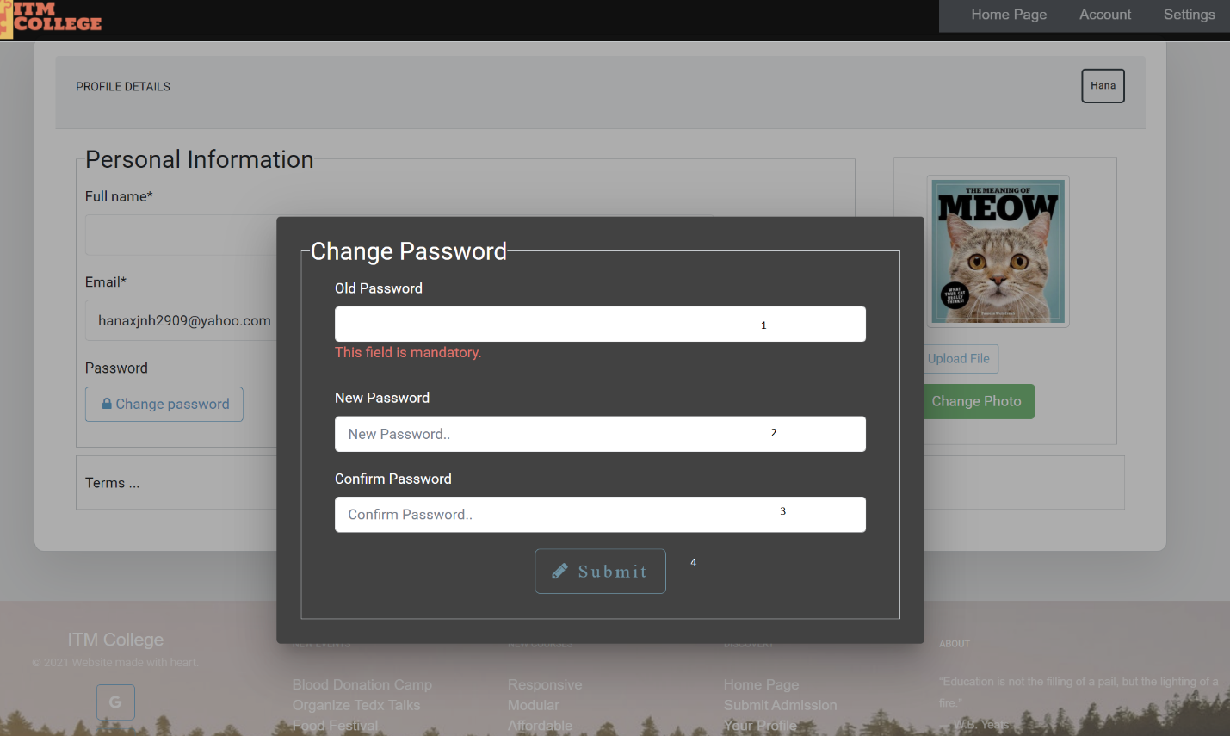

|  |  |  |  |  |  |  |
| --- | --- | --- | --- | --- | --- | --- |
| Form Change Password | | | | | | |
| No | Name | Type | Validation | Event | Description | Status |
| 1 | Old Password | Input |  |  |  | Enable |
| 2 | New Password | Input |  |  |  | Enable |
| 3 | Password Confirm | Input |  |  |  | Enable |
| 4 | Submit | click |  | click | Submit to change pw | Enable |

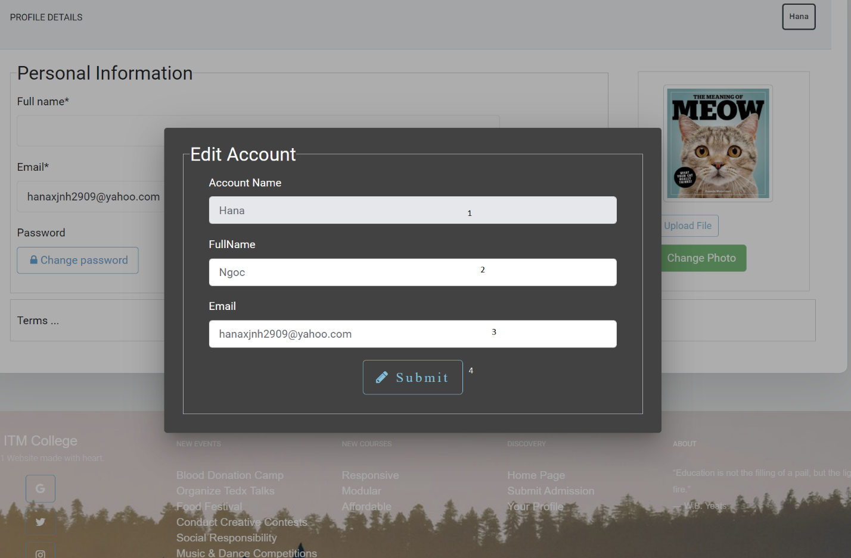

|  |  |  |  |  |  |  |
| --- | --- | --- | --- | --- | --- | --- |
| Form UpdateUser | | | | | | |
| No | Name | Type | Validation | Event | Description | Status |
| 1 | username | Input |  |  | User’s username | disable |
| 2 | fullname | Input |  |  | Update Full Name | Enable |
| 3 | Email | Input |  |  | Update email | Enable |
| 4 | Submit | button |  | click | Submit update | Enable |

* 1. User Admission

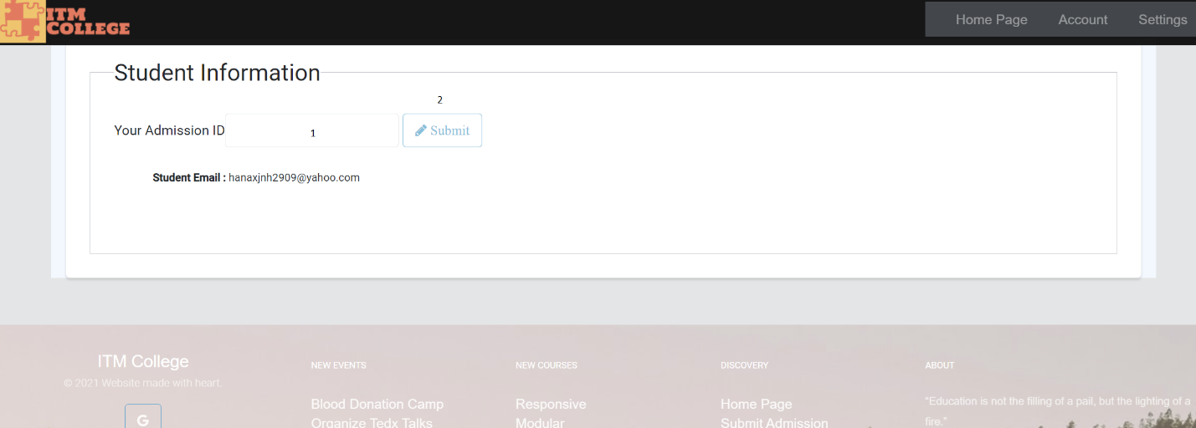

|  |  |  |  |  |  |  |
| --- | --- | --- | --- | --- | --- | --- |
| Form Submit Admission | | | | | | |
| No | Name | Type | Validation | Event | Description | Status |
| 1 | Admission ID | Input | Match Email, Admission Status Accepted |  | User’s Admission | disable |
| 2 | Submit | click |  | click | Submit | Enable |

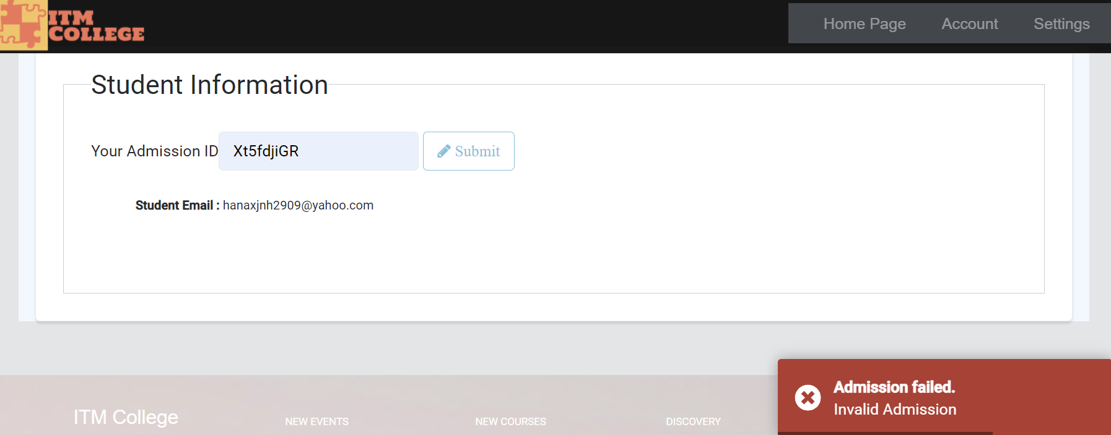

* 1. After Submit Admission successfully

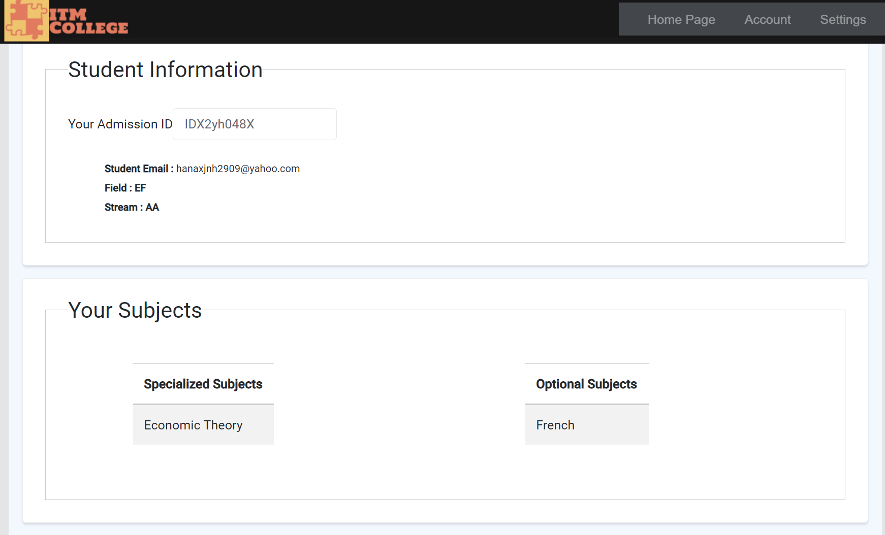

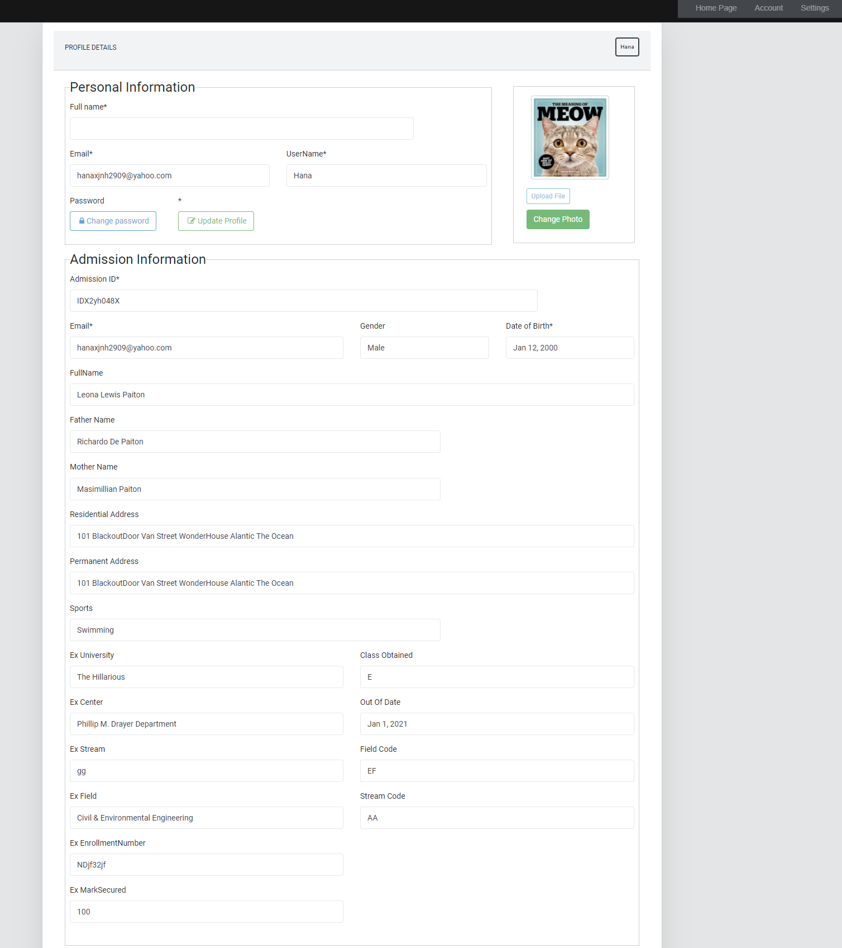

|  |  |  |  |  |  |  |
| --- | --- | --- | --- | --- | --- | --- |
| Registration Form | | | | | | |
| No | Name | Type | Validation | Event | Description | Status |
| 1 | StudentEmail | Text box |  |  | Display student email | Disable |
| 2 | StudentName | Text box |  |  | Display student name | Disable |
| 3 | FatherName | Text box |  |  | Display father name | Disable |
| 4 | MotherName | Text box |  |  | Display mother name | Disable |
| 5 | DoB | Text box |  |  | Display date of birth | Disable |
| 6 | txtGender | Text |  |  | Display gender | Disable |
| 7 | Residential Adress | Text box |  |  | Display residential address | Disable |
| 8 | Permanent Adress | Text box |  |  | Display permanent address | Disable |
| 9 | tbStream.Name | Text box |  |  | Display stream name | Disable |
| 10 | tbField.Name | Text box |  |  | Display field name | Disable |
| 11 | SportsDetails | Text box |  |  | Display sports | Disable |
| 12 | ExUniversity | Text box |  |  | Display previous university | Disable |
| 13 | ExEnrollmentNumber | Text box |  |  | Display previous enrollment number | Disable |
| 14 | ExCenter | Text box |  |  | Display center name (previous exam) | Disable |
| 15 | ExStream | Text box |  |  | Display previous exam’s stream | Disable |
| 16 | ExField | Text box |  |  | Display previous exam’s field | Disable |
| 17 | ExMarkSecured | Text box |  |  | Display previous exam’s mark | Disable |
| 18 | OutOfDate | Text box |  |  | Display out of date of previous exam | Disable |
| 19 | ClassObtained | Text box |  |  | Display previous exam’s class obtained | Disable |
| 20 | SpecializedSubjectID | Dropdown List |  | Select option | Select specialized subject | Enable |
| 21 | OptionalSubjectID | Dropdown List |  | Select option | Select optional subject | Enable |

# Gui Design-Back end

1. Admin Login

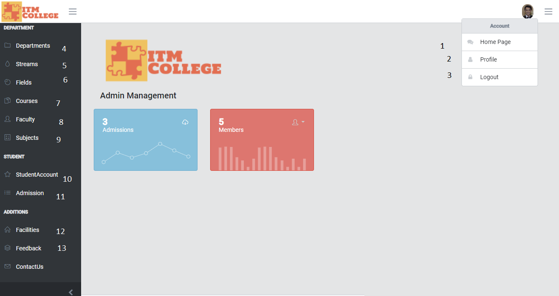

|  |  |  |  |  |  |  |
| --- | --- | --- | --- | --- | --- | --- |
| Navigation | | | | | | |
| No | Name | Type | Validation | Event | Description | Status |
| 1 | HomePage | HyperLink |  |  | Url to HomePage | Enable |
| 2 | Profile | HyperLink |  |  | Url to Page User | Enable |
| 3 | Log Out | Button |  | **Click** | Logout Admin – Delete Token | Enable |
| 4 | Departments | HyperLink |  |  | Url to Departments | Enable |
| 5 | Streams | HyperLink |  |  | Url to Streams | Enable |
| 6 | Fields | HyperLink |  |  | Url to Fields | Enable |
| 7 | Courses | HyperLink |  |  | Url to Courses | Enable |
| 8 | Faculty | HyperLink |  |  | Url to Faculty | Enable |
| 9 | Subjects | HyperLink |  |  | Url to Subjects | Enable |
| 10 | StudentAccount | HyperLink |  |  | Url to StudentAccount | Enable |
| 11 | Admission | HyperLink |  |  | Url to Admission | Enable |
| 12 | Facilities | HyperLink |  |  | Url to Facilities | Enable |
| 13 | Feedback | HyperLink |  |  | Url to Feedback | Enable |

1. Course Management
2. Course List

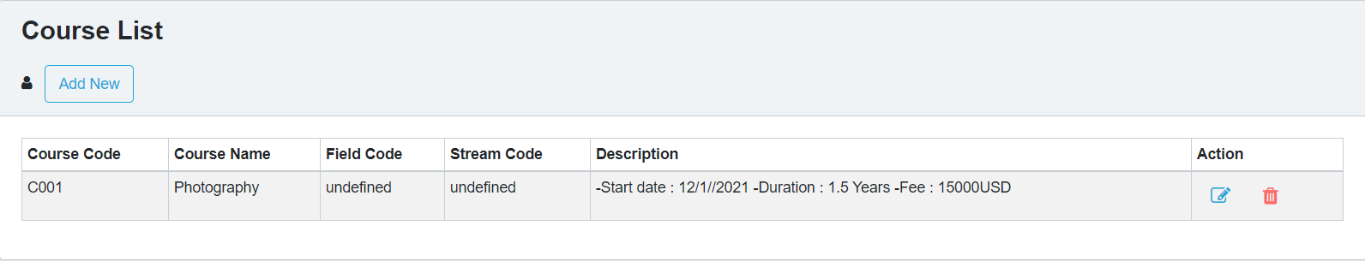

|  |  |  |  |  |  |  |
| --- | --- | --- | --- | --- | --- | --- |
| Course List | | | | | | |
| No. | Name | Type | Validation | Event | Description | Status |
| 1 | Add New | Hyberlink |  | Click | Create new Course | Enable |
| 2 | btnEdit | Button |  | Click | Edit Course | Enable |
| 3 | btnDelete | Button |  | Click | Delete Course | Enable |

* Some code review
* Get Course List

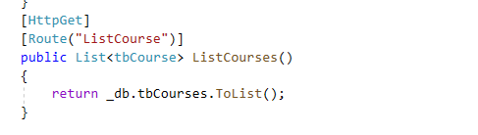

1. Course Add

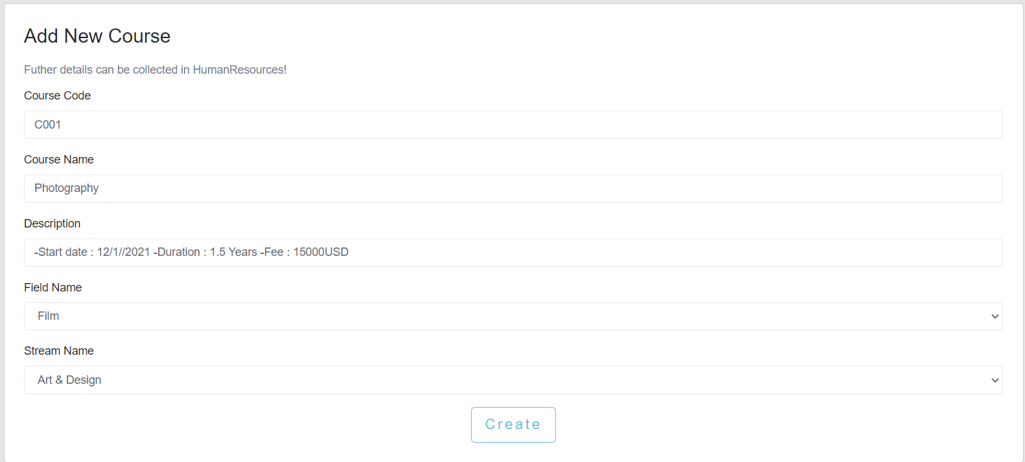

|  |  |  |  |  |  |  |
| --- | --- | --- | --- | --- | --- | --- |
| Create Course Post | | | | | | |
| No. | Name | Type | Validation | Event | Description | Status |
| 1 | CourseCode | TextField | 0 <= Length <= 30 | Input | Input Course ID | Enable |
| 2 | Course Name | TextField | 0 <= Length <= 50 | Input | Input Course Name | Enable |
| 3 | Description | TextField |  | Input | About Course | Enable |
| 4 | Stream Name | Dropdown |  | Click | Choose Stream for Course | Enable |
| 5 | Field Name | Dropdown |  | Click | Choose Field for Course | Enable |
| 6 | btnCreate | Button |  | Click | Submit form Create | Enable |

* Some code review
* Add Course

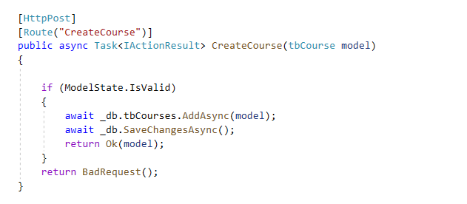

1. Course Edit

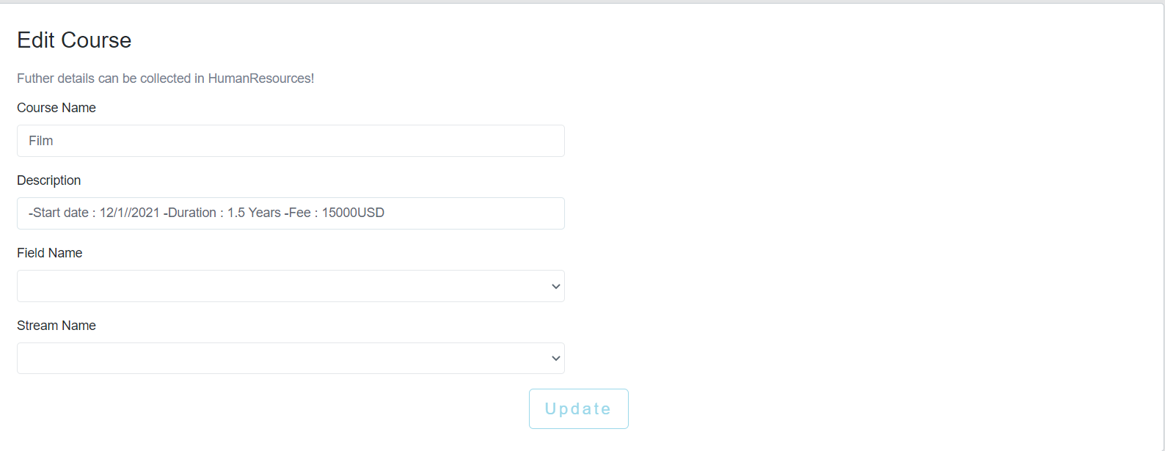

|  |  |  |  |  |  |  |
| --- | --- | --- | --- | --- | --- | --- |
| Edit Course Post | | | | | | |
| No. | Name | Type | Validation | Event | Description | Status |
| 1 | Course Name | TextField | 0 <= Length <= 50 | Input | Input Course Name | Enable |
| 2 | Description | TextField |  | Input | About Course | Enable |
| 3 | Stream Name | Dropdown |  | Click | Choose Stream for Course | Enable |
| 4 | Field Name | Dropdown |  | Click | Choose Field for Course | Enable |
| 5 | btnUpdate | Button |  | Click | Submit form Edit | Enable |

* Some code review

Edit Course

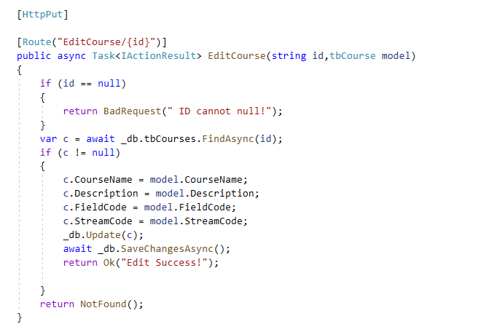

1. Field Management
2. Field list

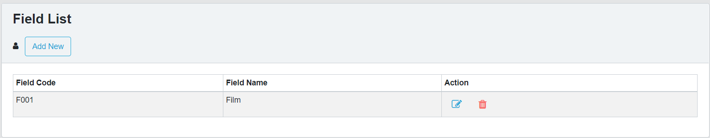

|  |  |  |  |  |  |  |
| --- | --- | --- | --- | --- | --- | --- |
| Field List | | | | | | |
| No. | Name | Type | Validation | Event | Description | Status |
| 1 | Add New | Hyberlink |  | Click | Create new Field | Enable |
| 3 | btnEdit | Button |  | Click | Edit Field | Enable |
| 4 | btnDelete | Button |  | Click | Delete Field | Enable |

* Some code review
* Get Field List

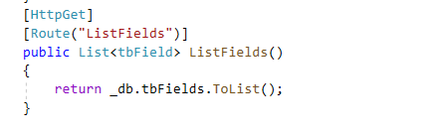

1. Field Add

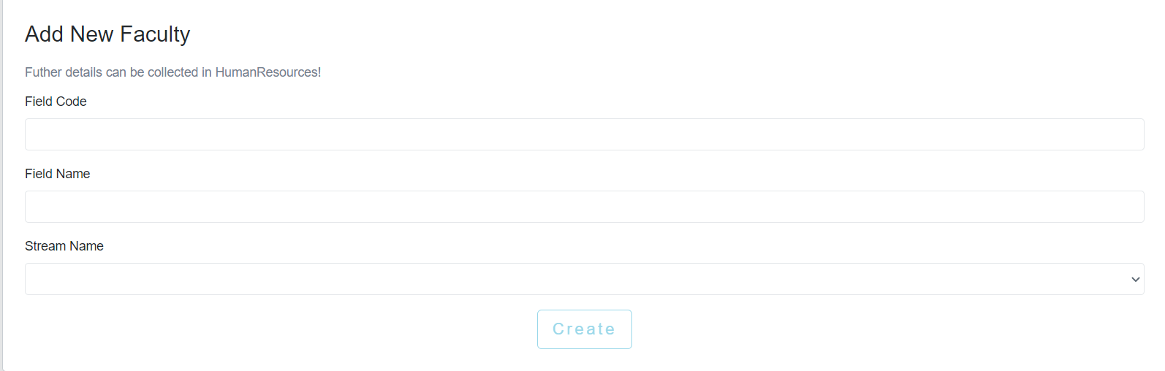

* Some code review
* Add Field

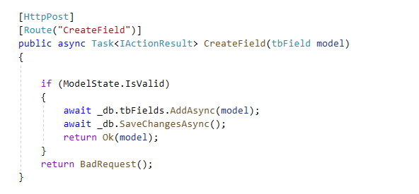

1. Field Edit

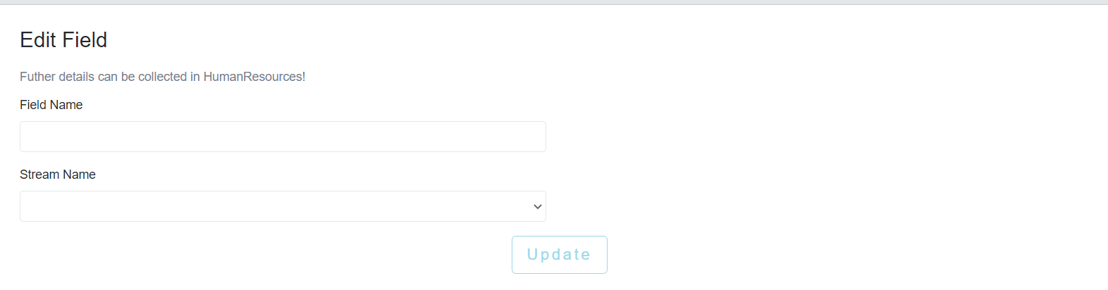

|  |  |  |  |  |  |  |
| --- | --- | --- | --- | --- | --- | --- |
| Edit Field Post | | | | | | |
| No. | Name | Type | Validation | Event | Description | Status |
| 1 | Field Name | TextField | 0 <= Length <= 50 | Input | Input Field Name | Enable |
| 2 | Stream Name | Dropdown |  | Click | Choose Stream for Course | Enable |
| 3 | btnUpdate | Button |  | Click | Submit form Edit | Enable |

1. Subject Management
2. Subject List

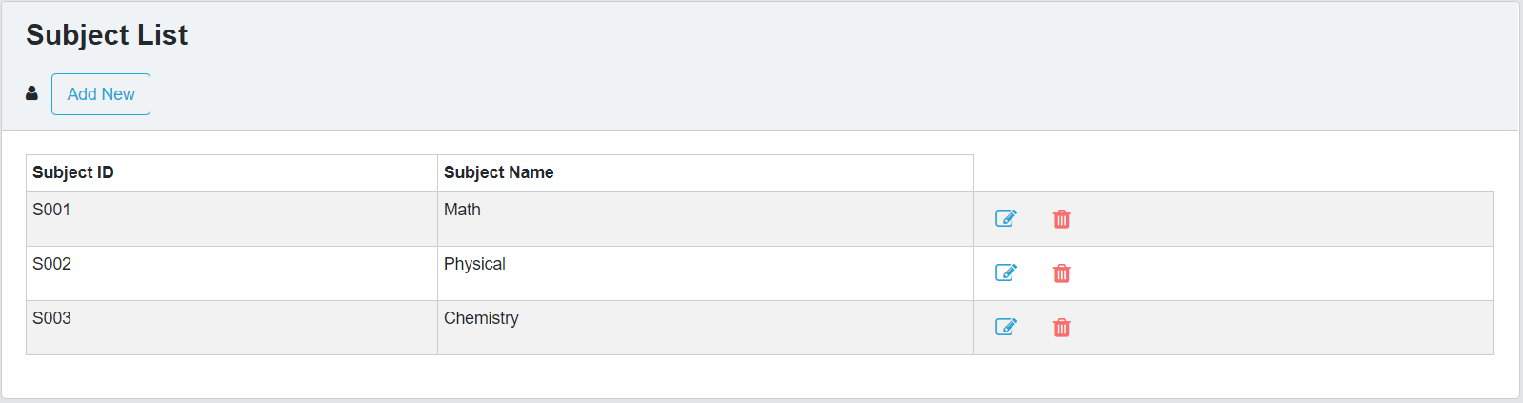

|  |  |  |  |  |  |  |
| --- | --- | --- | --- | --- | --- | --- |
| Subject List | | | | | | |
| No. | Name | Type | Validation | Event | Description | Status |
| 1 | Add New | Hyberlink |  | Click | Create new Subject | Enable |
| 2 | btnEdit | Button |  | Click | Edit Subject | Enable |
| 3 | btnDelete | Button |  | Click | Delete Subject | Enable |

* Some code review
* Get Subject List

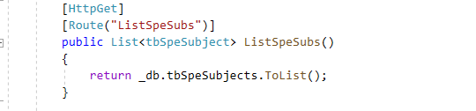

1. Subject Add

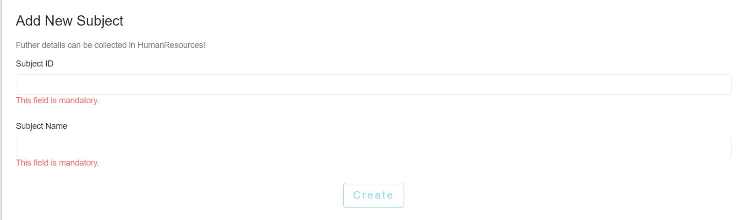

|  |  |  |  |  |  |  |
| --- | --- | --- | --- | --- | --- | --- |
| Create Course Post | | | | | | |
| No. | Name | Type | Validation | Event | Description | Status |
| 1 | Subject Code | TextField | 0 <= Length <= 30 | Input | Input Subject ID | Enable |
| 2 | Subject Name | TextField | 0 <= Length <= 50 | Input | Input Subject Name | Enable |
| 3 | btnCreate | Button |  | clieck | Submit form Create | Enable |

* Some code review
* Add Subject

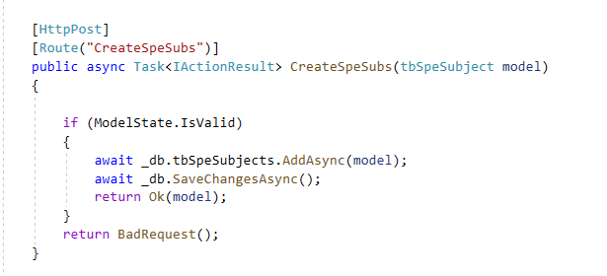

1. Subject Edit

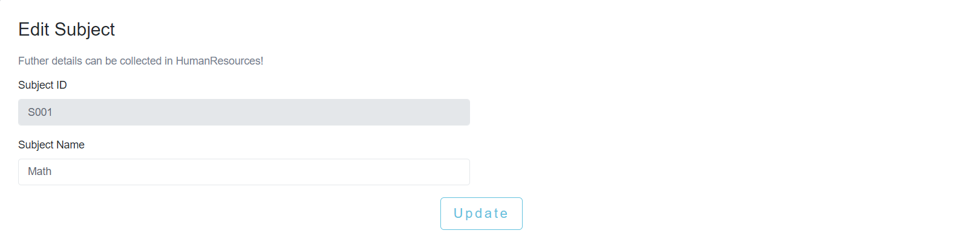

|  |  |  |  |  |  |  |
| --- | --- | --- | --- | --- | --- | --- |
| Edit Field Post | | | | | | |
| No. | Name | Type | Validation | Event | Description | Status |
| 1 | Subject Name | TextField | 0 <= Length <= 50 | Input | Input Subject Name | Enable |
|  |  |  |  |  |  |  |
| 2 | btnUpdate | Button |  | Click | Submit form Edit | Enable |

* Some code review
* Edit Subject

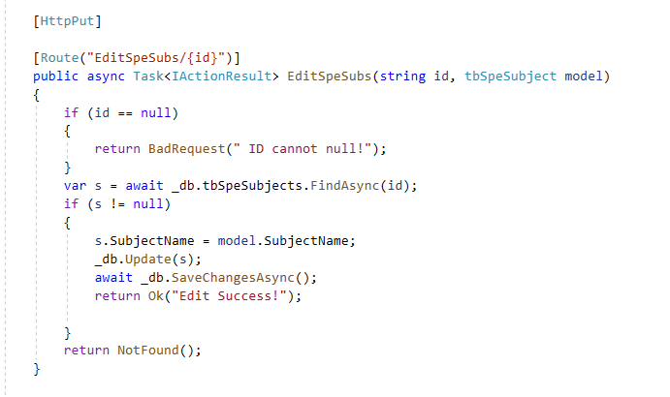

1. Faculty Management
2. Faculty Add

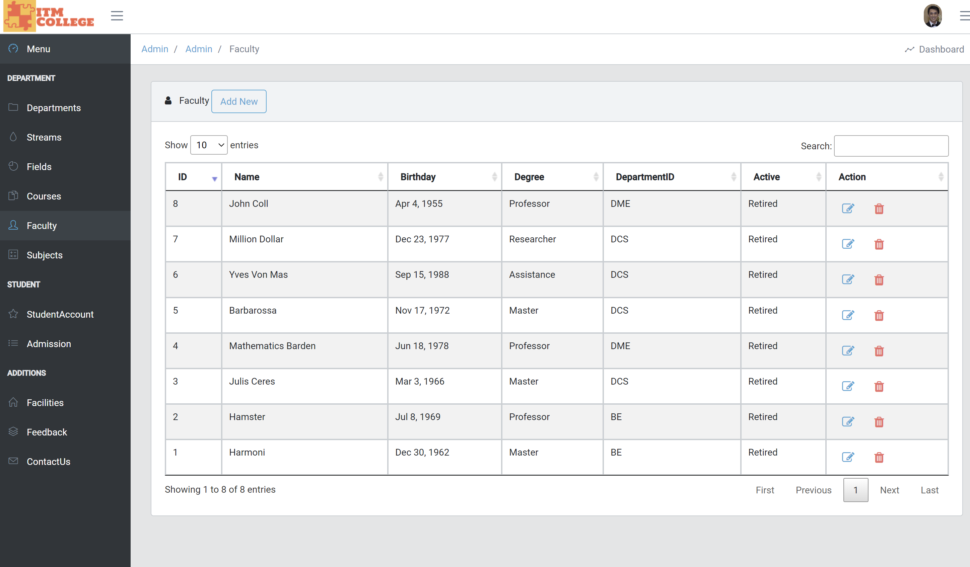

1. Faculty Add

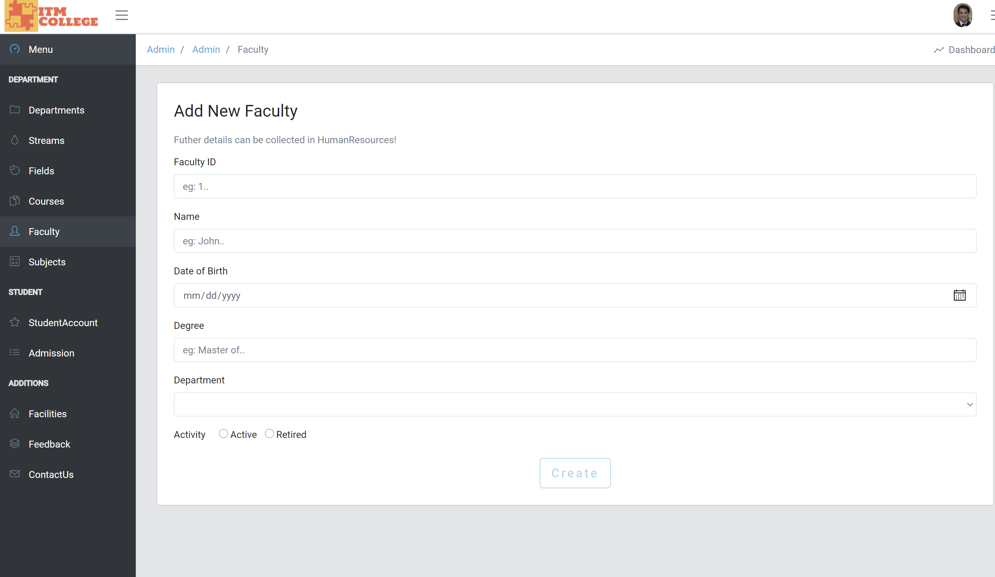

1. Faculty Edit

(Upload Profile optional)

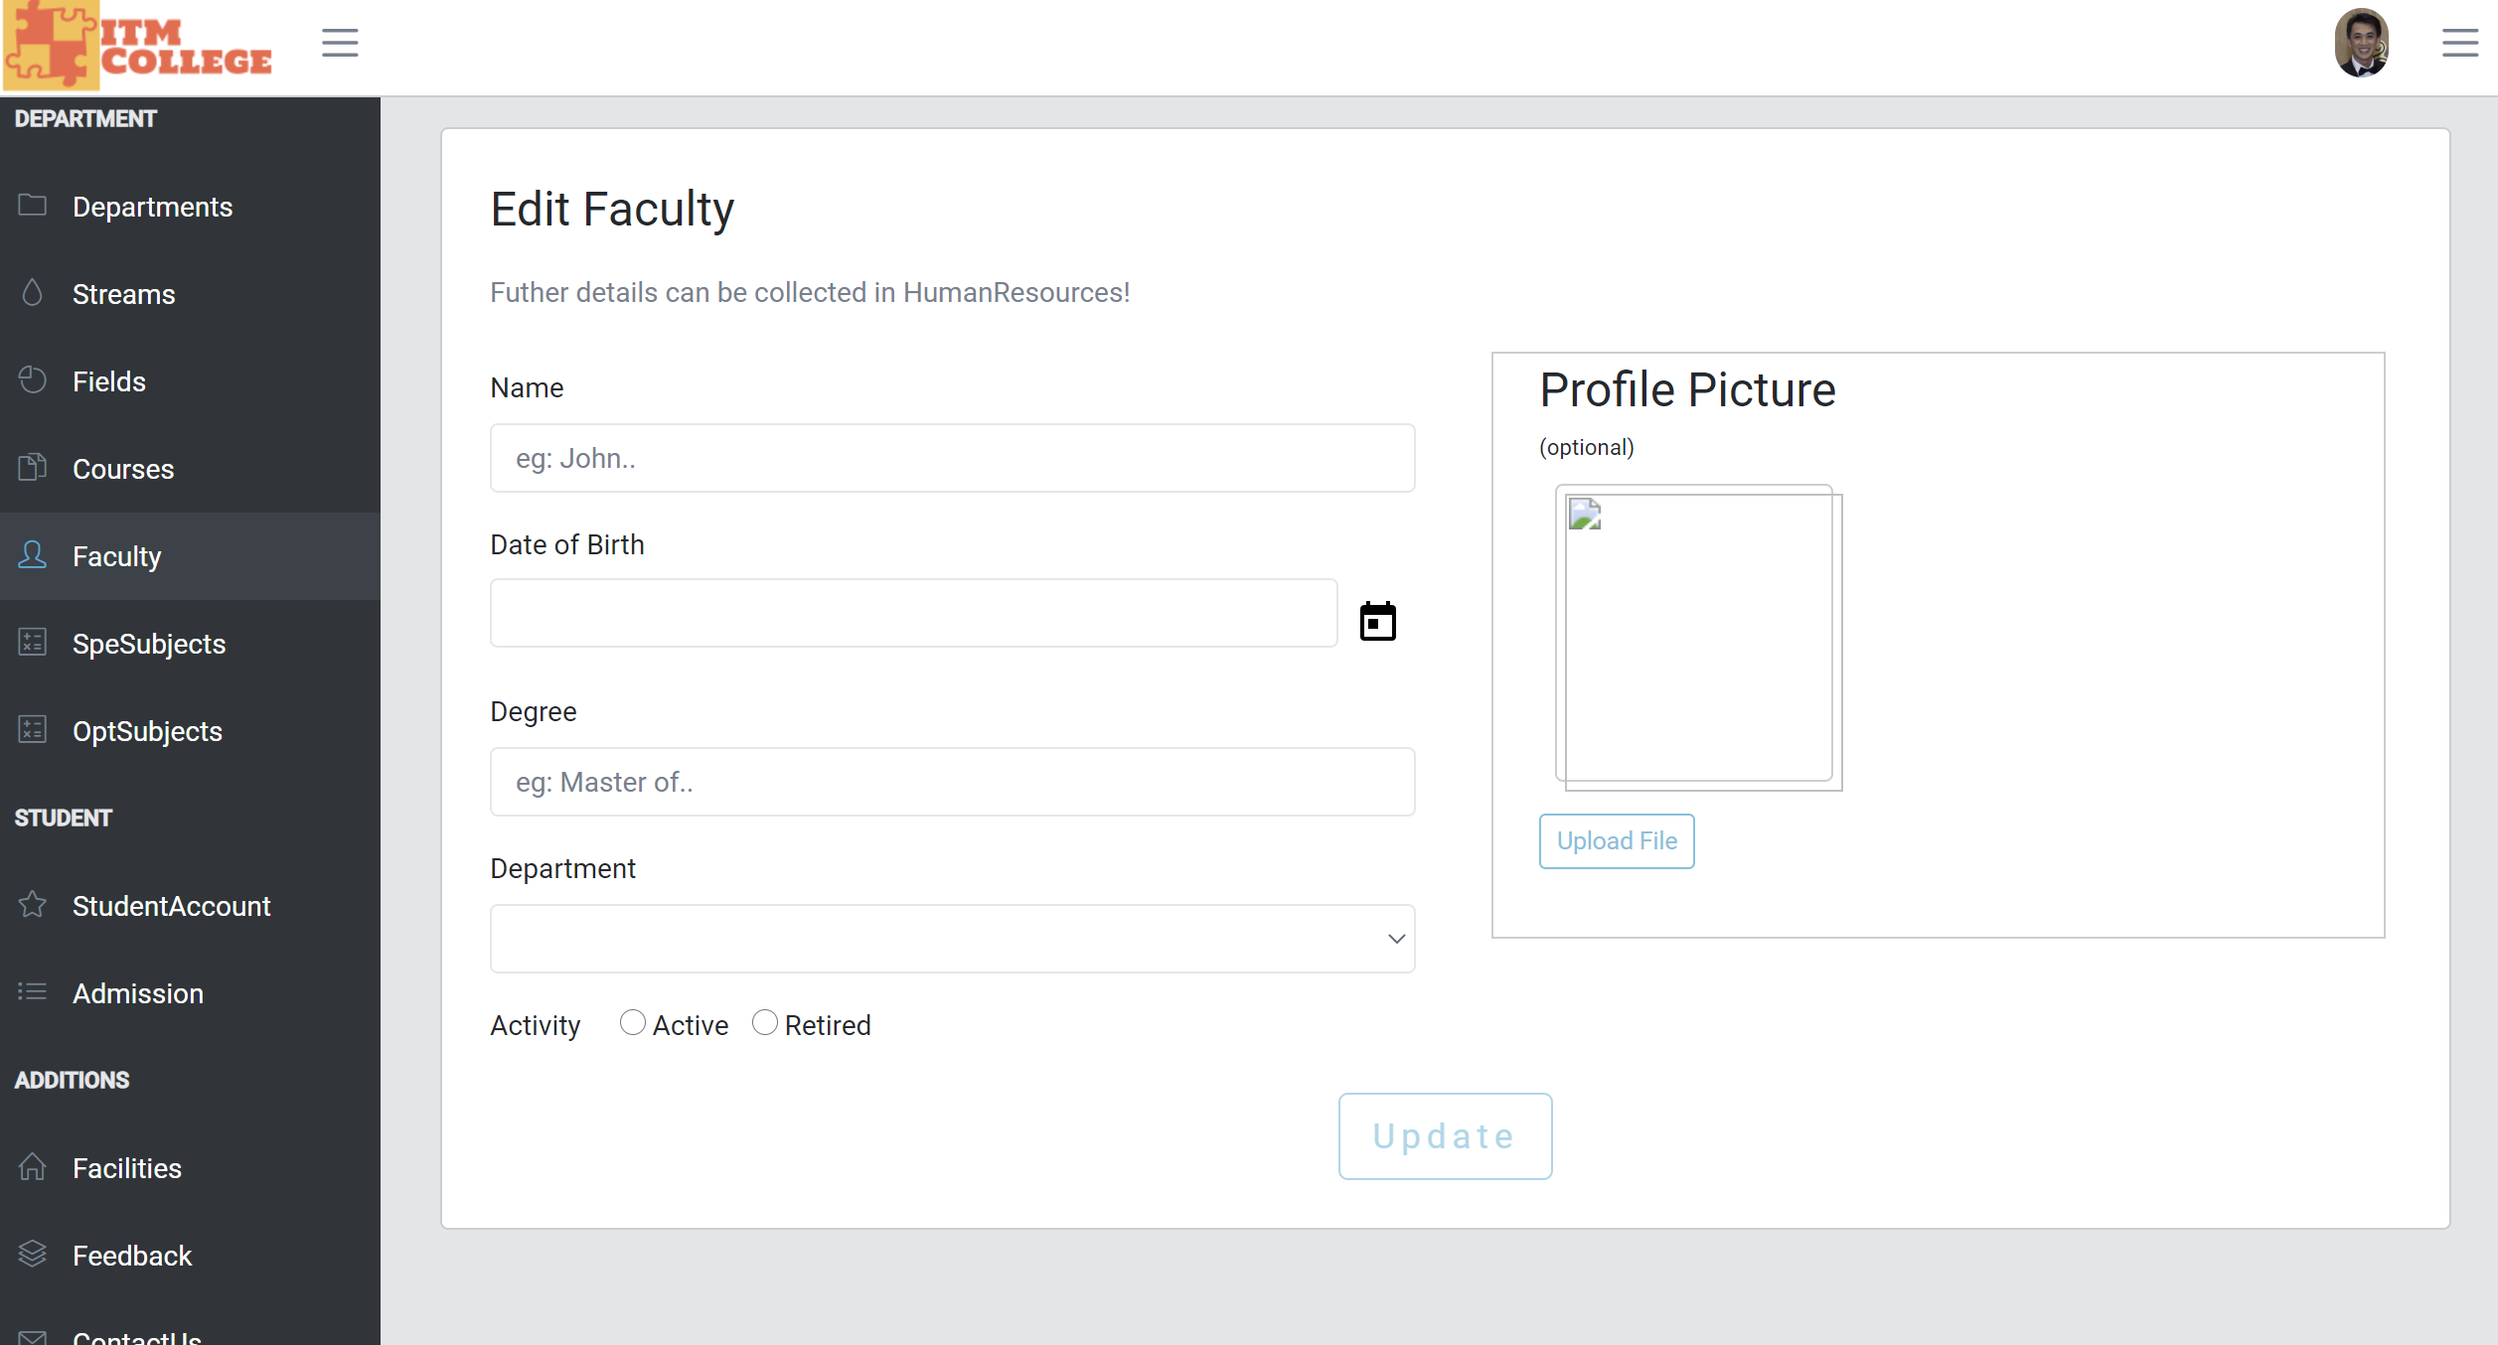

1. Department Management
2. Department List

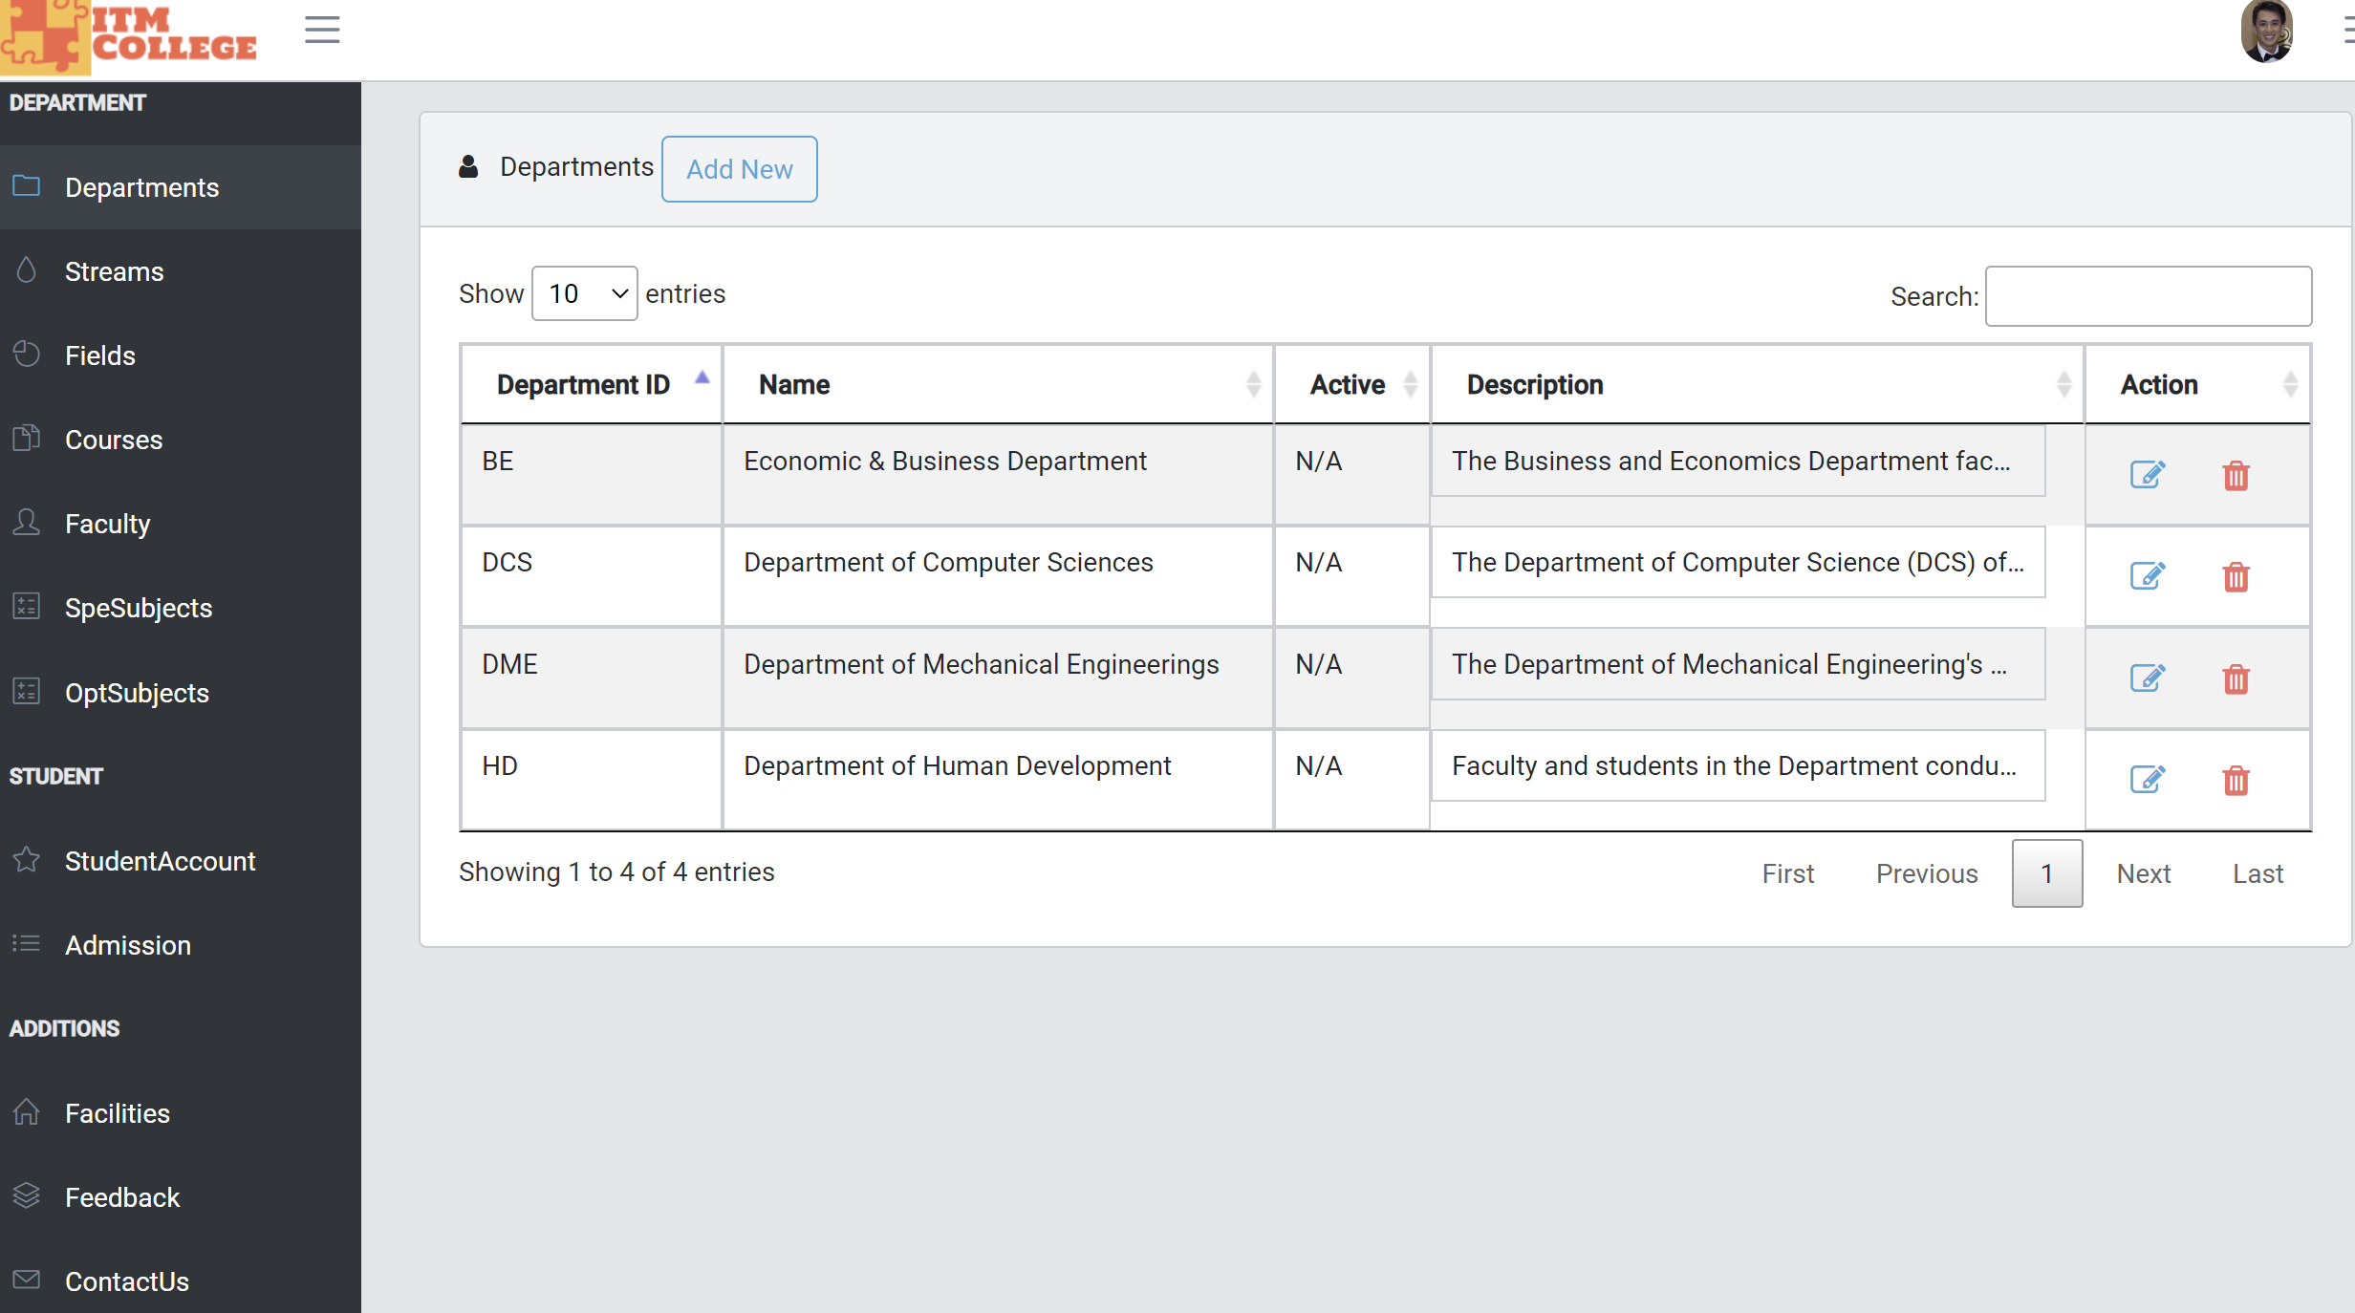

1. Department Add

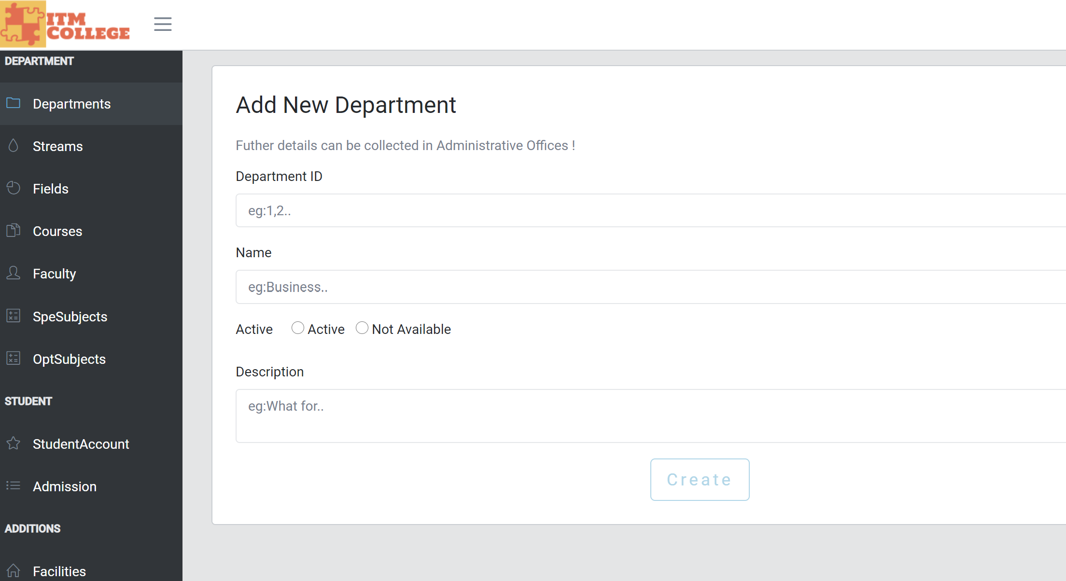

1. Department Edit
2. Facilities Management
3. Facilities List

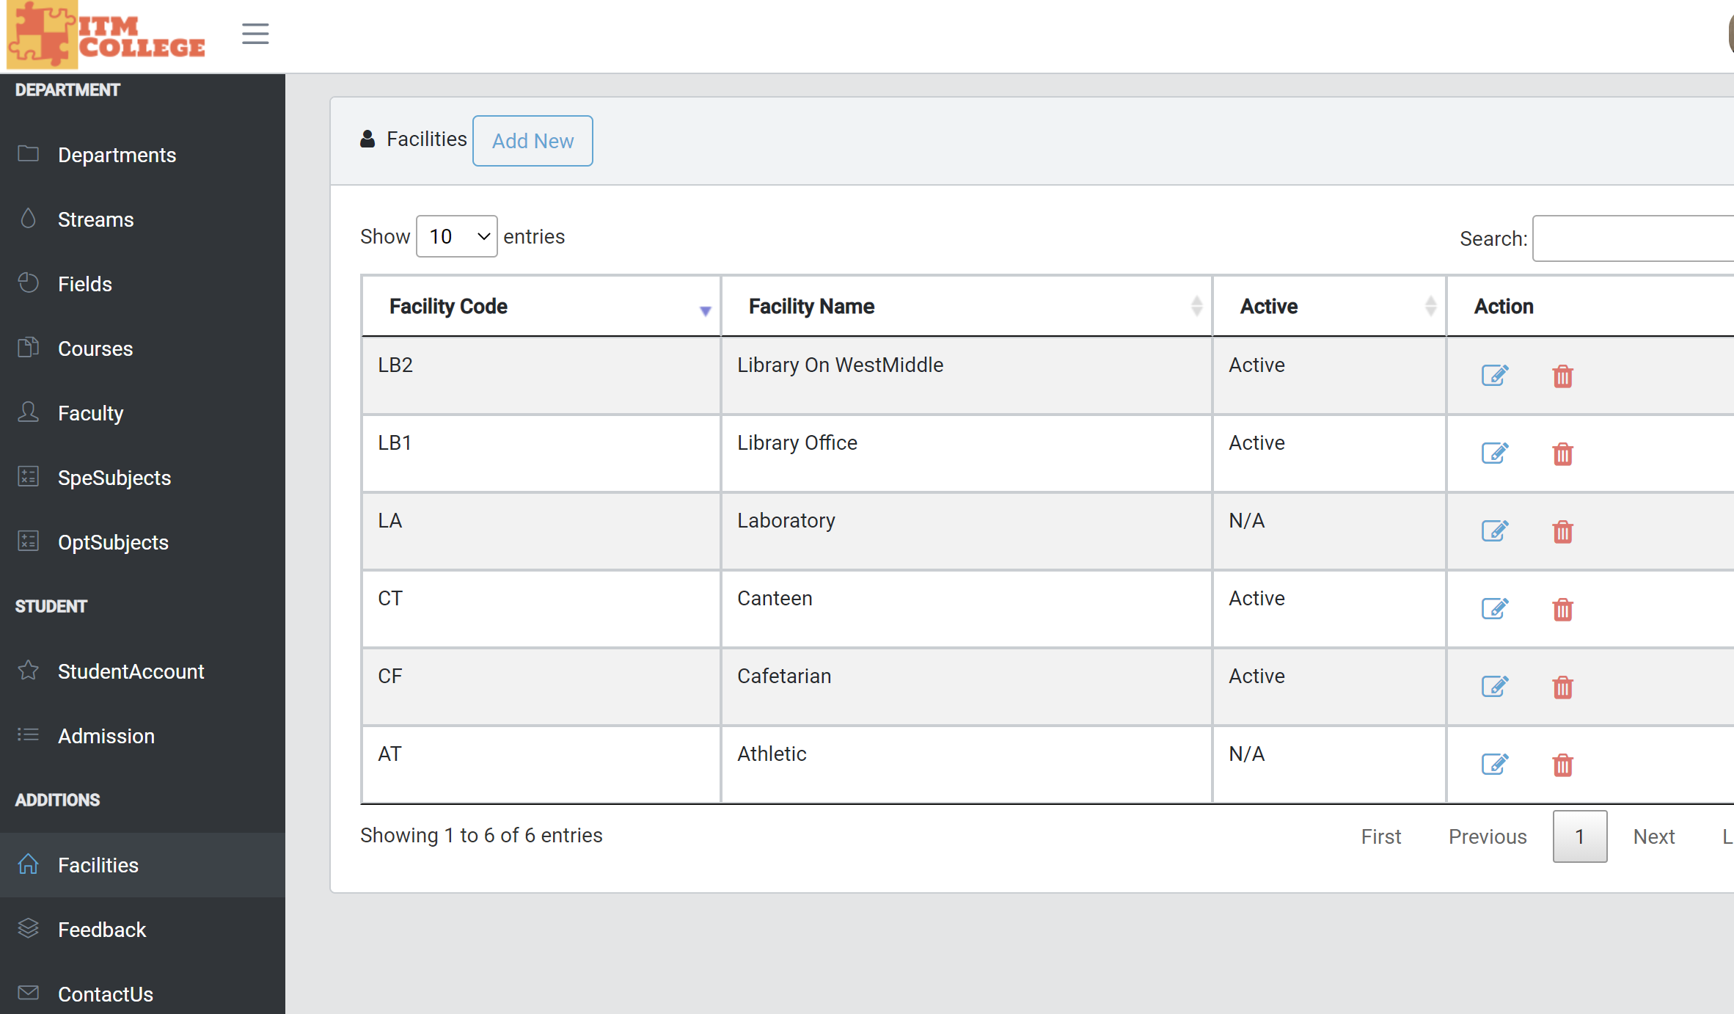

1. Facilities Add

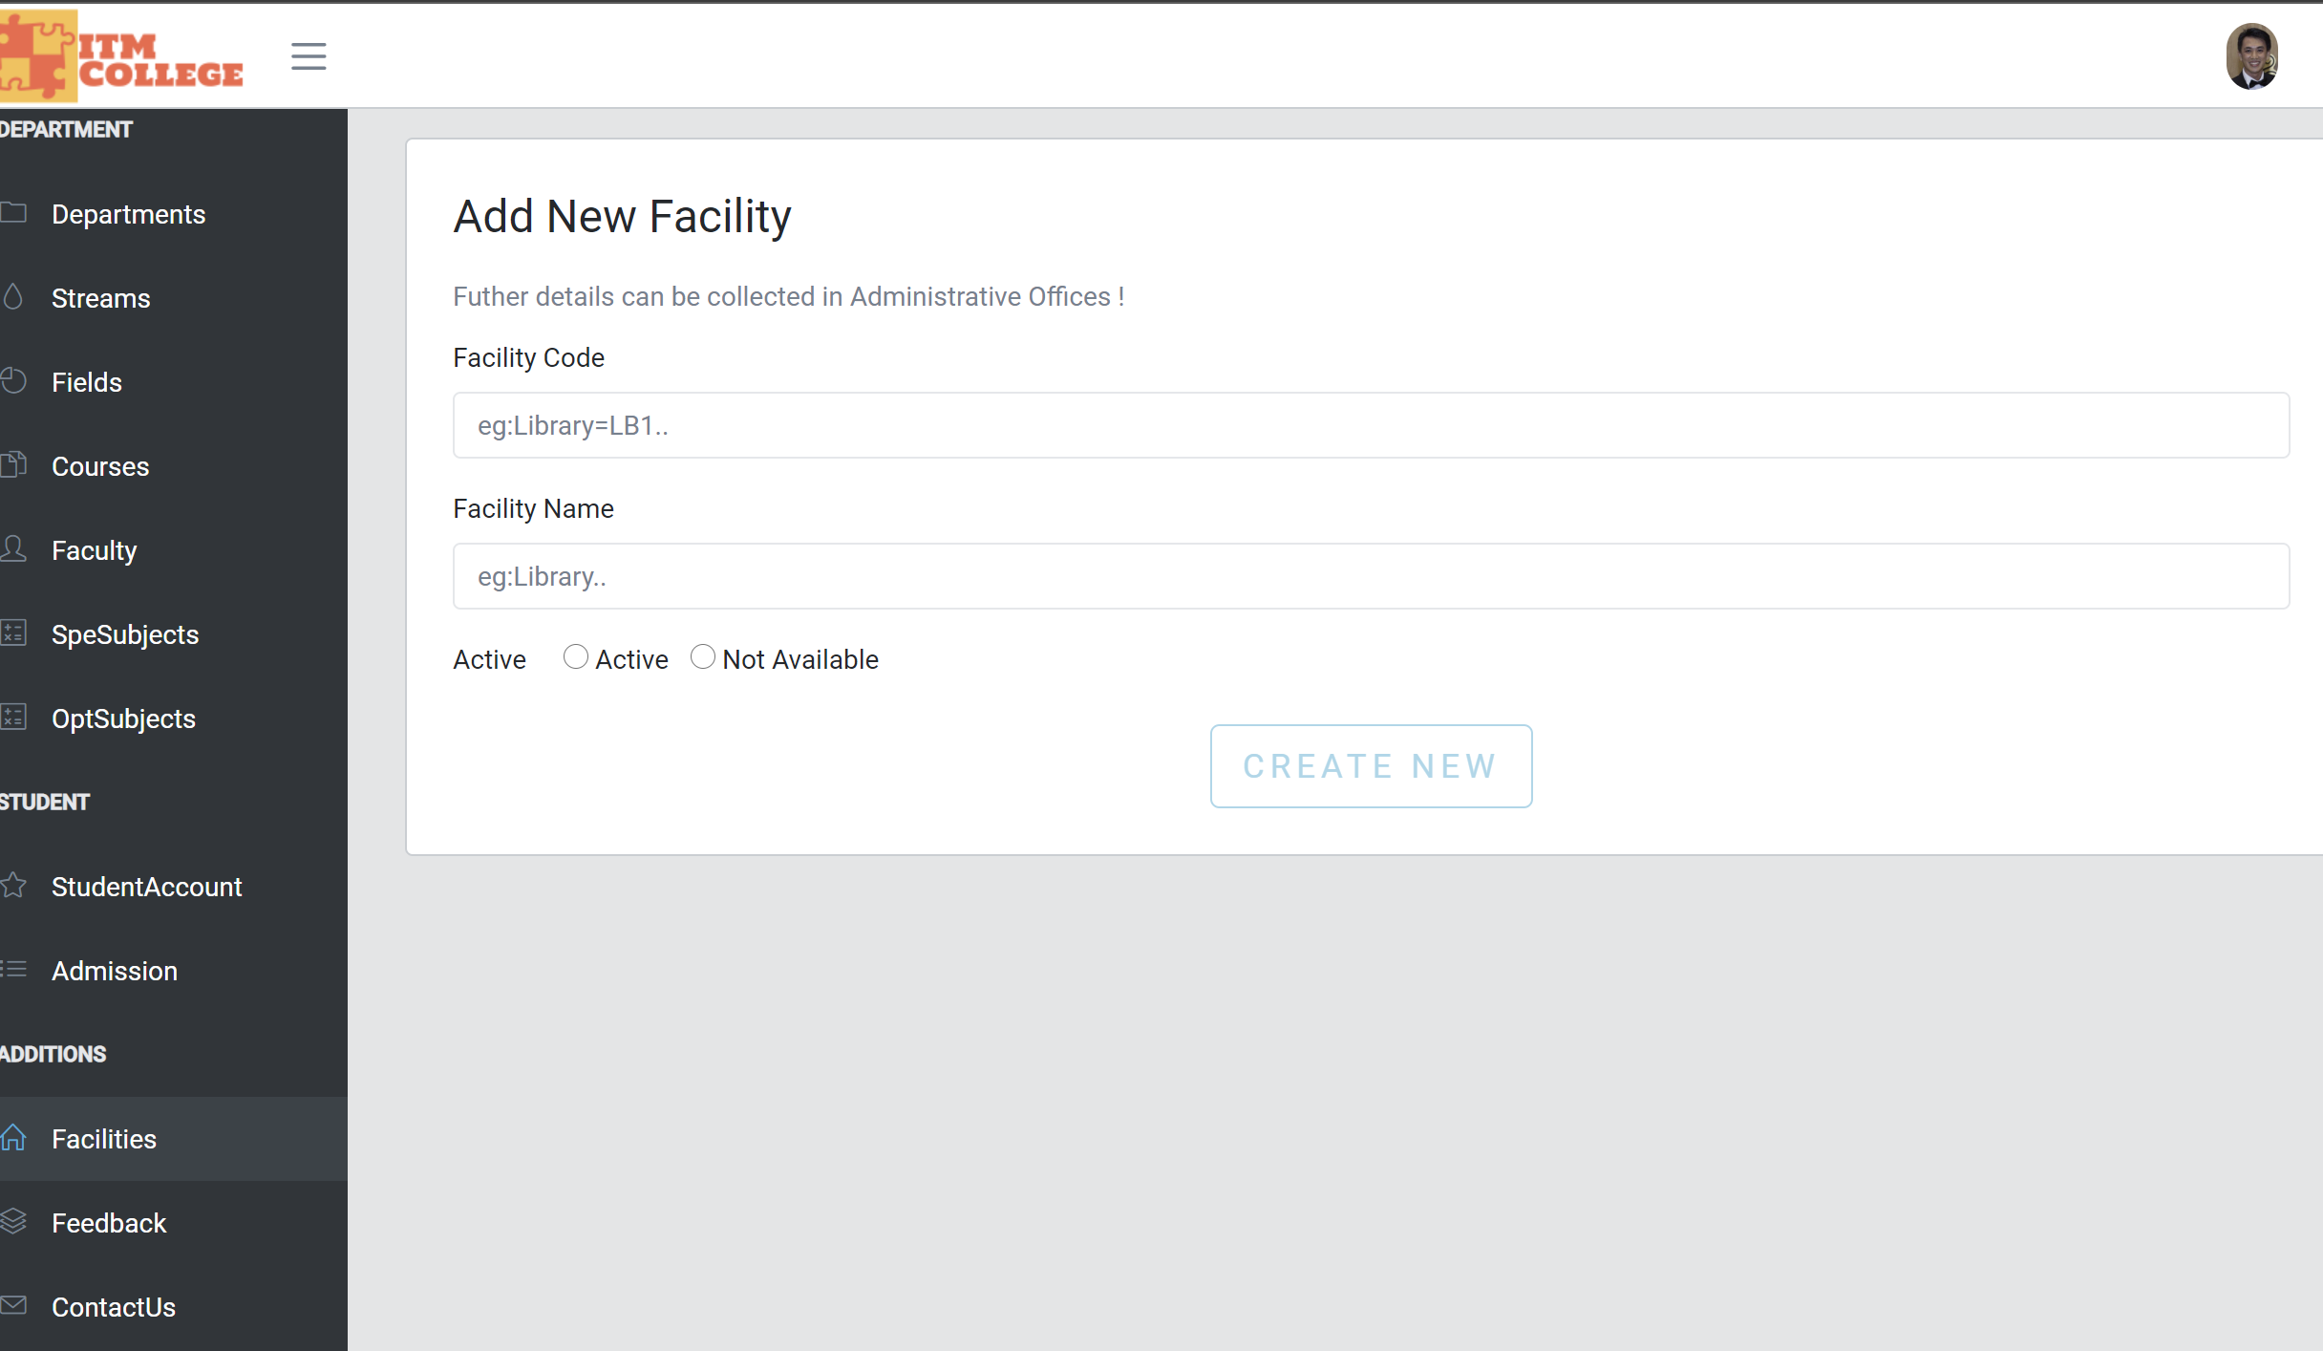

1. Facilities Edit

(Upload Profile optional)

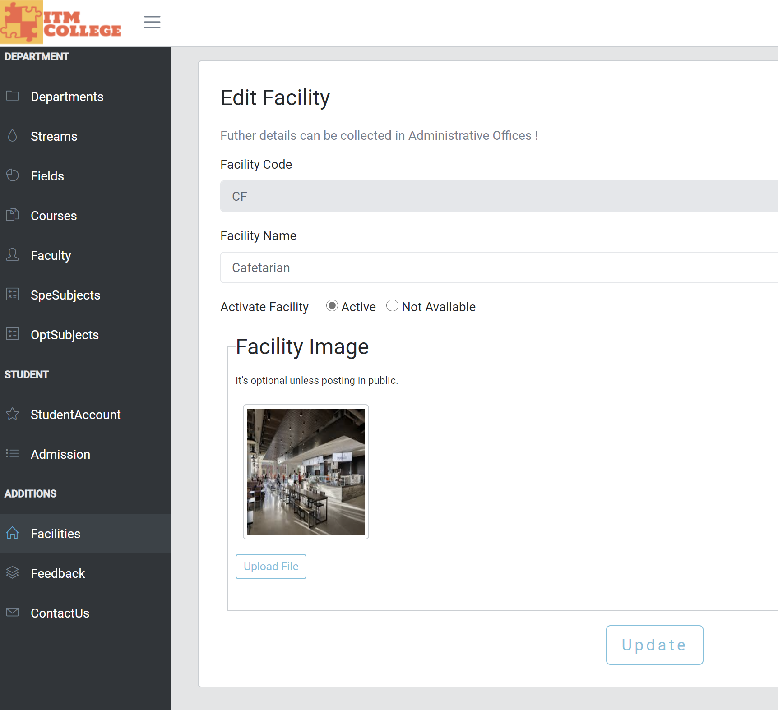

1. Student Account Management
2. Account List (user)

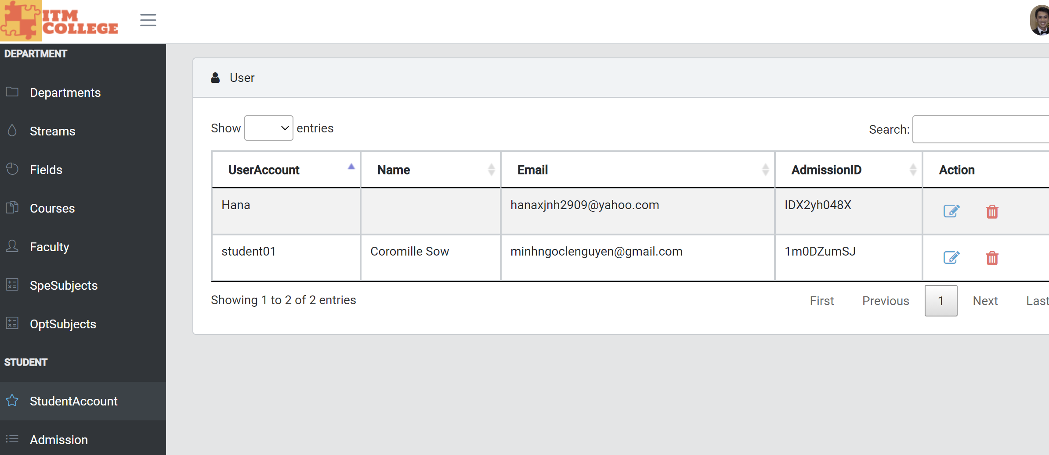

1. Account Edit

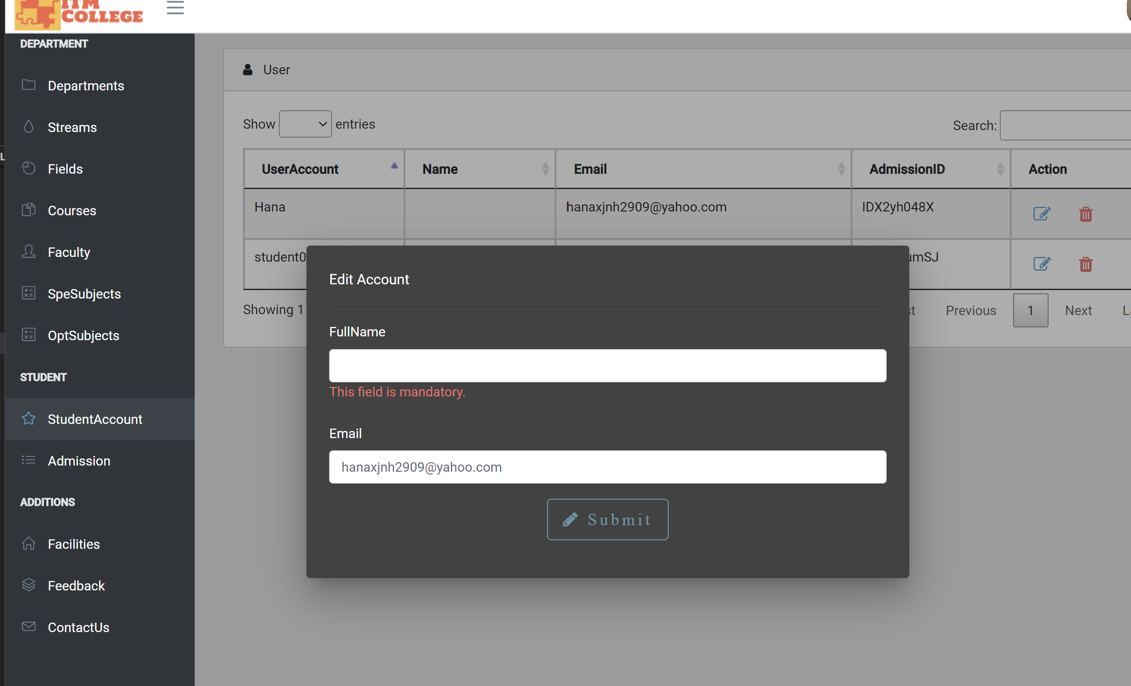

# **Task sheet review 3**

|  |  |  |  |  |  |
| --- | --- | --- | --- | --- | --- |
| Project Ref. No: 1 | Project Title:  ITM College – Online College Management | Date of Preparation of Activity Plan | | | |
| No. | Task | Actual Start Date | Actual Days | Team Member Name | Status |
| 01 | Database Diagram | Jan 23,2021 | 6 | Vu Duc Huy | Completed |
| 02 | Database Structure | Luong Vinh Hien | Completed |
| 03 | GUI Design Front-End | Le Nguyen Minh Ngoc | Completed |
| 04 | GUI Design Back-End | Huynh Quoc Huy | Completed |

|  |  |
| --- | --- |
| **Date:** | |
| Signature of Instructor:  **Mr. Ngo Phuoc Nguyen** | Signature of Team Leader:  **Vu Duc Huy** |